Document control
Applicant reference number 301351326 FRNSW reference number FRN24/1288
Ver. | Author | Organisation | Status | Date
01 | Sebastian Roache | Stantec Australia Pty Ltd | Initial submission | 24/04/2024
02 | Zhigang Wang | FRNSW (BFS24/2341 #35038) | Comment on V01 | 14/05/2024

Applicant

Agreement
As the applicant, I confirm the following:
          - I agree to pay Fire and Rescue NSW (FRNSW) the charges set out in Clause 46 of the Fire Brigades Regulation 2014 (see Section 10).
          - I agree to forward with this application the following documentation for FRNSW to review and provide advice on the assessment methods and acceptance criteria proposed for the given performance solution:
 Copy of proposed building plans and specifications
(e.g. relevant floor plans, elevations, site plan, section views, hydrant plan and schematic)
 BCA report or letter from an accredited certifier that identifies all non-compliances (if available)
 CFD/zone modelling inputs form (if applicable) (available on FRNSW website)
 Performance solution summary table (available on FRNSW website)

Name of fire engineer | Stephen King | Registration number | BDC04982
Company name | Stantec Australia Pty Ltd
Fire engineer’s phone no. | 0437 289 246
Fire engineer’s email | stephen.king@stantec.com

Remittance advice information
Invoices will be issued based on the information provided below:
ASIC company name | ELOURA DEVELOPMENTS LAKEMBA PTY LTD
Australian business number | 52 658 404 034 | Trading name |  | ELOURA DEVELOPMENTS LAKEMBA PTY LTD
Remittance contact name | HASSAN AYACHE
Remittance street address | 61-65 ROBERTS ROAD, GREENACRE NSW 2190
Remittance email address | invoices@eloura.com.au
Remittance phone number | + 61 2 999 1378 |  | Remittance fax number |  | N/A
Purchase order ref. no. | If applicable |  | Project code ref. no. |  | If applicable
Project leader contact name | ERTAC TURK
Project leader contact email | e.turk@eloura.com.au

Consultation

Stakeholders
Role | Name and BPB number | Organisation and phone | Email address
BCA consultant | Enter name  Registration number | Enter organisation name  Phone no. | Enter email address
Certifier | Josh Curan  BDC 2679 | AED Consulting  (02) 9571 8433 | josh@aedconsulting.com.au
Developer/Builder | Anthony Habkouk | Eloura  (02) 8999 1378 | a.habkouk@eloura.com.au
Architect | Mink yu Lim | Team2 Architects  (02) 9437 3166 | minkyu@team2.com.au
Fire Engineer | Stephen King  BDC04982 | Stantec  (02) 8484 7000 | Stephen.king@stantec.com
FRNSW reviewers | Insp John Marzol  Engineer Zhigang Wang | Fire and Rescue NSW  02 9742 7434 | firesafety@fire.nsw.gov.au

Meeting details
Record the details of any meetings undertaken with FRNSW on the project.
Meetings undertaken | Type of Meeting | Meeting Date | Attendees
N/A | N/A | N/A | N/A

Project details

Premises
Premises name | Croydon Street Apartments
Primary street address | 5-7, 7a & 9 Croydon Street
Secondary street address | Secondary street address (if applicable)
Premises suburb | Lakemba NSW 2195
Lot and DP numbers | LOT 1 DP 974686, LOT 2 DP 971844, LOT B DP 365853, LOT B DP 357959, LOT A DP 357959, LOT A1 DP 372287
Is the premises considered a significant development or a unique building (e.g. Sydney Football Stadium, Sydney Opera House, Crown Towers, etc.)? |  | No

Proposed works
 New building Applicable NCC: NCC 2022
 Refurbishment of an existing building
 Extension of an existing building For existing buildings:
 Change in use within an existing building Approximate year of construction: N/A
Other: (provide details) Building code when constructed: N/A

What is the proposed approval pathway?:
 Complying Development Certificate (CDC)  Construction Certificate (CC)  Crown works
 Voluntary upgrade  Other: (provide details)

How many performance solution issues are proposed in this FEBQ? 22
How many Performance Requirements are being assessed? 10
Do any of the Performance Solutions proposed pertain to works already constructed on site? No
N/A
Are any of the solutions proposed as a result of:
An issue of a notice of intention to issue a fire order on the subject premise | No
An issue of a fire order on the subject premise | No
An audit of the existing building that has identified an existing non-compliance | No
Not being able to sign off an annual fire safety statement | No
(provide details)
Additional Questions
Does the proposal include a reduction in water supply to the fire hydrant or sprinkler system? | No
Does the proposal relate to fire hydrant system flows and/or pressures? | No
Would the DtS provisions require the provision of an active fire safety system that is not proposed as part of the performance solution (i.e. is the performance solution deleting an active fire safety system)? | No
If the proposal includes a waste management facility, does it comply with the current FRNSW Fire Safety in Waste Facilities Fire safety guideline? | No
Has there been any previous IFSR submission(s) under Part 3 Division 3 of the Environmental Planning and Assessment (Development Certification and Fire Safety) Regulation 2021 pertaining to this development? | No
Will the premises likely be subject to a fire safety study, risk assessment or dangerous goods study? No
Note: Any study/risk assessment should be completed prior to submitting this FEBQ and should be attached to this application.
Have all departures from the deemed-to-satisfy (DtS) provisions of the National Construction Code (NCC) been identified for this proposed design (i.e. a BCA report or letter from an accredited certifier)? Yes
Note: Any advice given is subject to all non-compliances being identified. Any new DtS departures identified, including any from the certifier determining the application for construction certificate, may affect FRNSW advice in respect to this performance solution.
Identify if any previous performance solution applies to the building:
N/A – New Development
Identify if any application has been/will be submitted for a fire safety exemption under Clause 188 of the Environmental Planning and Assessment Regulation 2000 or under Section 111 of the Environmental Planning and Assessment (Development Certification and Fire Safety) Regulation 2021:
None known.
Identify if the premises is or will be subject to any development application (DA) conditions or special regulatory approvals (e.g. BPB conditions, ministerial conditions, crown building works):
Note: FRNSW will not comment on existing buildings subject to voluntary upgrade or change of use prior to the issuing of any DA conditions of consent, or conditions of an existing consent have been modified (i.e section 4.55 of Environmental Planning and Assessment Act 1979). Comment will also not be provided if an order has been issued unless the Council agrees. The Council may seek advice during the DA review.
None known.

Description of building
Main occupancy class | 2 – Residential Unit Building | Largest fire compartment (within the building) | Area (m²) | 2,273 (Basement 1)
Other occupancy classes | Class 5 – Managers Office  Class 7a – Carparking  Class 7b – Storage |  | Volume (m³) | 7,986 (Basement 1)
Type of construction | A |  | Height (m) | 3.8
Effective height (m) | Building Effective Height: 31.1m  Building A (~ 25.5 m)  Building B (~ 23 m)  Building C (~ 31.1 m) | Ground floor area (m²) |  | 1,435 (GFA)
Rise in storeys | 11 | Total floor area (m²) |  | 12,691 (GFA)
Levels contained | 13 | Total volume (m³) |  | 42,632
Does the building contain an early childhood centre? | No | Is the building or does the building contain a Data Centre? |  | No
Is the development a major hazard facility? | No
Outline any additional building characteristics:
This project involves the proposed construction of a mixed-use development to be located at 5-7, 7A & 9 Croydon Street, Lakemba NSW. The overall development will consist of three residential buildings, labelled Building A, Building B, and Building C (refer to Figure 1) consisting of apartments on Lower Ground Floor – Level 10, constructed on top of two levels of shared basement carparking. Communal open areas are located on Level 1 adjacent to Residential Buildings B and C, and Residential Building C on Level 8, whilst one residential apartment within Building B on Level 6 is provided with a private roof terrace. The overall development is understood to be of Type A construction and sprinkler protected throughout.
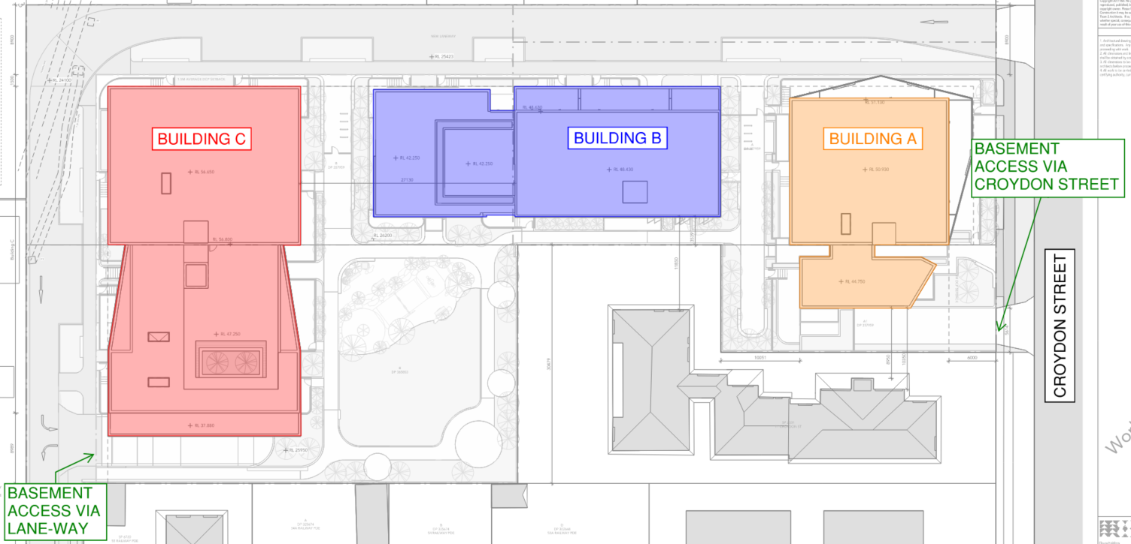
Figure 1 – Location of Subject Buildings
A digital render indicative of the intended finished building is shown in Figure 2, as seen from Croydon Street.
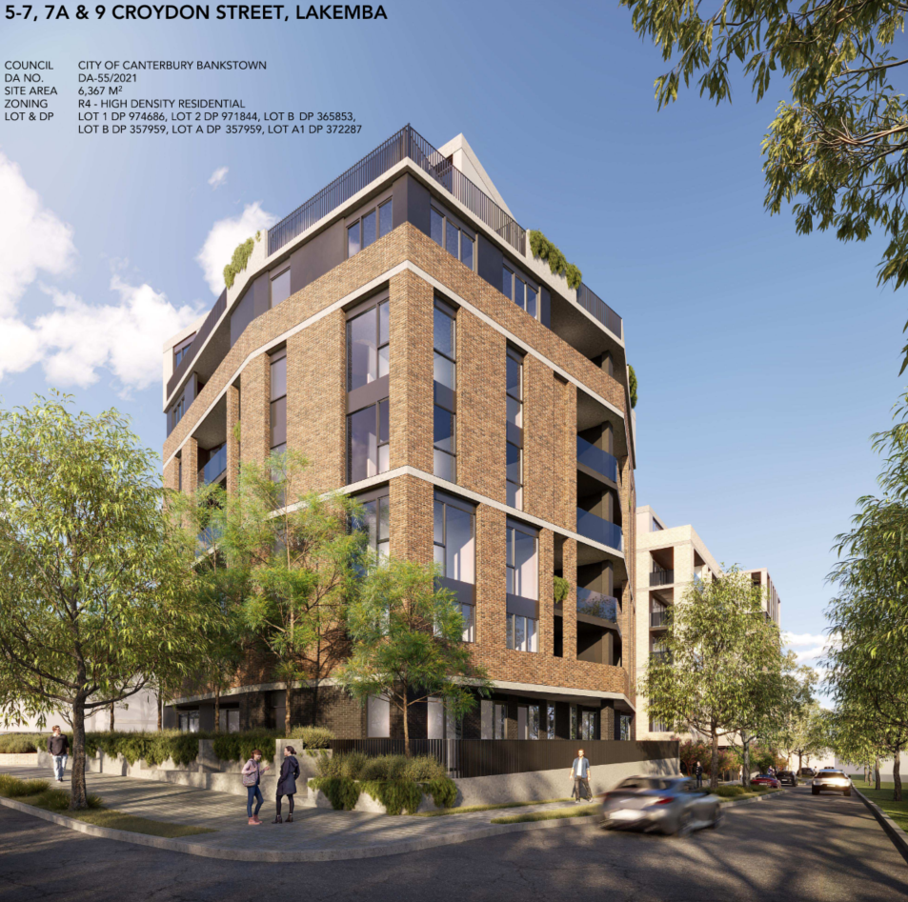
Figure 2 – Indicative Digital Render – Seen from Croydon Street
Stair Pressurisation
The building is provided with a stair pressurisation system in accordance with the BCA DtS Provisions. It is noted that BCA Clause D2D4 states that stair pressurisation is required for fire isolated stairways serving any storey above an effective height of 25 m. It is noted that the stairs serving a storey above an effective height are the fire-isolated stairways of Building A and the scissor stair serving the upper levels of Building C, as depicted in Figure 3 and Figure 4 below.
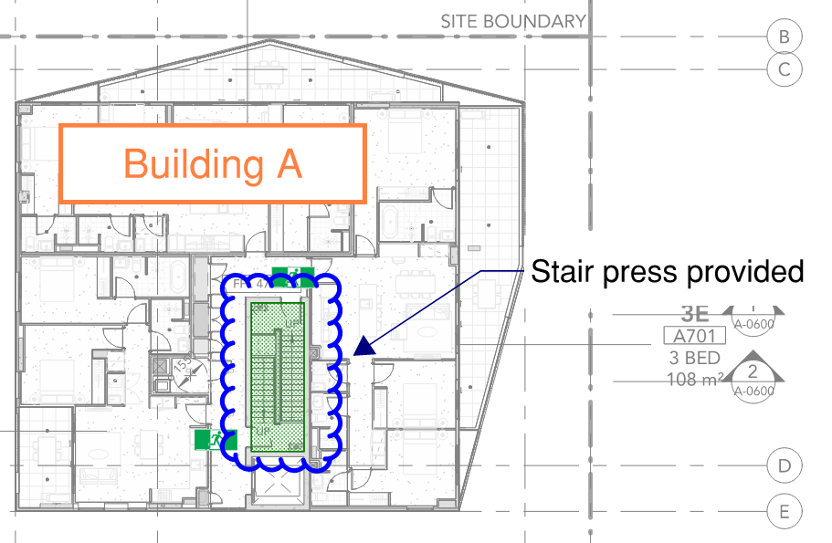
Figure 3 – Stair Pressurisation – Building A
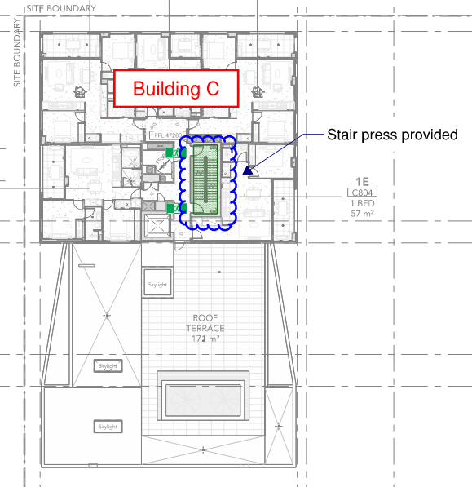
Figure 4 – Stair Pressurisation – Building C
Outline the services provided for fire brigade / fire services intervention:
The following firefighting facilities are of particular interest to Fire & Rescue NSW:
- The fire control centre will be located within the main entrance lobby of Building A, accessed via Croydon Street, refer to Figure 5.
- The fire brigade hydrant and sprinkler booster will be located along Croydon Street, refer to Figure 5. Further discussion regarding these provisions can be found in Issue number: 21.
- The fire pump room will be located on Lower Ground, accessed via the air-lock that is connected to the fire-isolated stairway from Croydon Street, refer to Figure 6.
- The hydrant and sprinkler water tank will be located on Lower Ground adjacent and accessed from the fire pump room, refer to Figure 6.
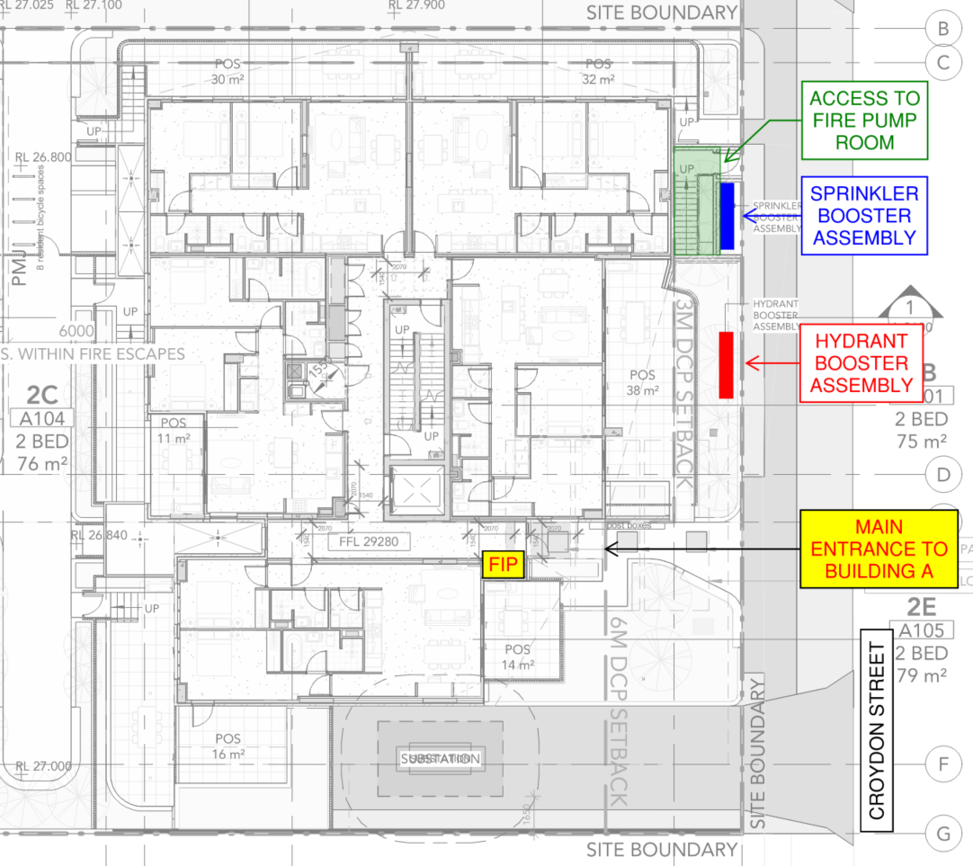
Figure 5 – Location of Fire Brigade Facilities – Level 1
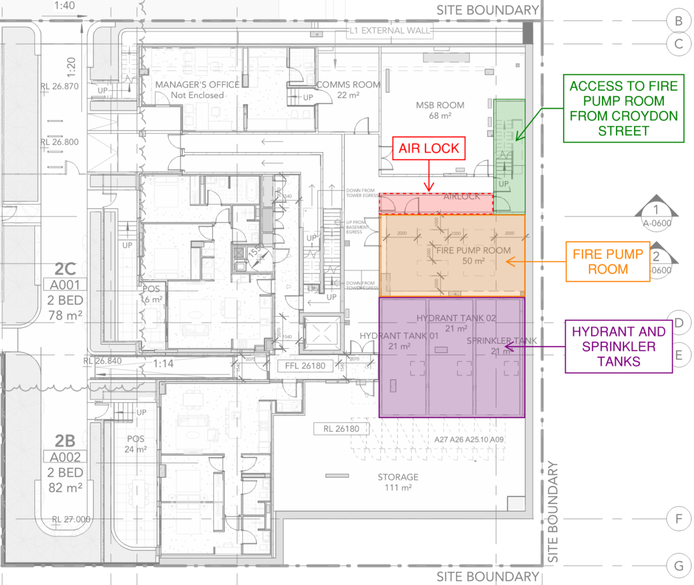
Figure 6 – Location of Fire Brigade Facilities – Lower Ground
List key occupant characteristics for the building:
The occupants expected to use the building include:
- Residents,
- Visitors and transient occupants, and
- Maintenance contractors.
Table 4.1 - Occupant Characteristics
Building Area | Occupant Attributes
General | Occupants are expected to be a representative of the general public, including the distribution of age and gender.  Occupants are generally expected to be mobile and are expected to be capable of determining fire escape routes based on the provision of illuminated exit signage.  Mobility, or other, impaired occupants are expected to be able to evacuate the building independently or with assistance via their own Personal Emergency Evacuation Plan (PEEP).  In the building, it is assumed that there will be a mix of men and women and therefore, the range of 45 – 55 cm is considered reasonable. Fruin’s ‘Pedestrian Planning and Design’ (pg.19) gives a shoulder width of 20.7 inches (52.5cm) for 99% of adult men.
Residential | Occupants within residential areas may be awake or asleep, and may be under the influence of intoxicants at times.  Medium/long terms residents are expected to be location of exits and egress routes.  Residents are expected to have an understanding of the necessary actions to take on initiation of the occupant warning system.
Carparking | Occupants within the carpark are expected to be a mixture of occupants from other areas of the building.  Occupants are expected to be alert and awake given the carpark is a transient space.
Occupant evacuation will consider a travel speed of 0.8 m/s, as presented in Chapter 64 of the SFPE handbook, and considers occupants with a locomotion disability. This also considers date provided by the Australian Network on Disability.

Hazards
Outline any hazards unique to the building:
The use of the building, as understood, is not expected to result in an increased risk in a building containing Class 2, Class 7a, Class 7b, and Class 9 areas.
 Combustible external cladding  Insulated sandwich panels
 Combustible waste (i.e. waste facility)  Podium type building
 Electricity supply system (e.g. substations)  A basement level
 Battery system (e.g. BSS, BESS, ESS)  An atrium (Part G3 of BCA)
 Alternative electrical generation (e.g. solar, tri-gen)  Car stacker
 Electric vehicle charging  Green wall
 Automatic storage and retrieval system (ASRS)
 Hazardous chemicals / dangerous goods (provide details)
 Other: (provide details)
Note: Clauses E1.10 / E1D17 and E2.3 / E2D21 of the NCC should be addressed when special hazards exist (e.g. car stacker, hazardous chemicals/dangerous goods).
Electric Vehicles
The position and associated documentation published by AFAC (National Council for Fire and Emergency Services) titled “Electric Vehicles (EV) and EV Charging Equipment in the Built Environment” dated 22nd December 2022. In particular, Page 4 of this document provides a number of considerations for EV’s and EV charging equipment that are to be considered as part of the proposed design. Where these recommendations/considerations are to be implemented as part of the proposed design, the assessment will adequately demonstrate that they are commensurate to the hazard and risk(s) associated with the proposed EV charging bays.
It is acknowledged that the provision of Electric Vehicle (EV) charging stations in the basement carpark may introduce additional fire risks which are considered under BCA Clauses E1D17 and E2D21. It is proposed that two EV charging stations per building are provided in the basement (~6 total), intended to operate as part of a shared vehicle scheme. With acknowledgement of the potential additional fire risks, consideration of the risk and treatments to be implemented into the design, based on recommended considerations outlined in the AFAC publication.
A summary of the risks is shown in Table 2, with further requirements incorporated into the nominated preventative and protective measures outlined in Section 6.
Table 2: EV Charging Station Fire Risk Consideration
Design Consideration |  | Implementation or Treatment in this Project
Location | Proximity to other vehicles, exits, other fire safety systems, building utilities and critical infrastructure | Two separate EV charging stations are proposed per building (~6 total). Not more than 2 charges are permitted adjacent to each other.  Minimum separation distances are nominated from exits.
Fire Resistance Levels | Consideration of appropriate fire resistance levels | Basement is provided with FRLs in accordance with BCA Deemed-to-Satisfy provisions.
Fire safety systems | Suitability of active fire detection, suppression and ventilation systems | Fire sprinkler protection to be provided to basement in accordance with AS 2118.1:2017 with fast response sprinklers.  Fire hydrant protection in accordance with AS 2419.1:2021 with pumped supply to provide attack characteristics based on 700 kPa residual pressure.  Hydrants to be located a minimum of 10 metres from EV charging bays.  Smoke detection provided to circulation spaces to provide earlier notification in the event of a fire.  Occupant warning provided throughout.  Carpark ventilation provided which will run automatically in the event of a basement fire alarm (detector or sprinkler).
Adequacy of vehicle separation. | Particular consideration for car stacker arrangements. | Car stacker scenario is not applicable.  Not more than 2 charges are permitted adjacent to each other.
Fire Brigade Intervention | Capabilities of the local fire authority | The site is served by career fire stations who are expected to have current training on the most appropriate fire fighting practices.
Fire water run-off | Potential for contaminated water run-off | Drainage is provided to the basement.  Proposed to provide on-site portable bunds to allow rapid deployment around basement drainage inlets.
Remote emergency or automatic shutdown |  | EV charging systems to be specified with automatic shut-down under fault conditions which may lead to a fire  Electrical supply circuits to EV charging stations to be provided with automatic fire trip signals to shut-off power in the event of a basement fire alarm condition.
Vehicle impact protection |  | EV charging equipment to be located away from the roadway.  High speed vehicle movements are not considered based on the location in a carpark, perpendicular to the roadway, not at the end of an aisle.
Equipment specification | Best practice standards for EV charging equipment | EV charging equipment to be specified to comply with current best practice guidance, and shall satisfy current International electrotechnical guidance as outlined in IEC 62196-2, IEC 61851-1, IEC 61851-22 and IEC 62196-1.
Ongoing performance | Maintenance of EV Charging equipment | Regular maintenance of EV charging equipment in accordance with best practices to be included as a requirement for the building’s Fire Safety Schedule

Preventative and protective measures
Identify fire safety measures that are, or will be, provided throughout the building, including anything undecided, which should be mentioned as part of the FEBQ review. Additional information may be added to the comments section below to better describe any systems or indicate systems that may be subject to a performance solution.
Suppression system | Detection system | Facilities for emergency services
 CA16 (existing building) |  AS 3786:2014 |  Emergency lifts
 AS 2118.1-2017 |  AS 3786-1993 (existing building) |  Fire control centre
 AS 2118.1-2006 |  AS 1670.1:2018 |  Fire control room
 AS 2118.1-1999 (existing building) |  AS 1670.1:2015 (existing building) |  Perimeter vehicular access
 AS 2118.2-2021 (wall-wetting) |  AS 1668.1:2015 |  Standby power supply system
 AS 2118.2-2010 (wall-wetting) |  AS 1670.3-2018 (monitored) | Occupant warning system
 AS 2118.3-2010 (deluge) |  AS 1670.3-2004 (existing building) |  Building occupant warning
 AS 2118.4-2012 (residential) |  Smoke alarms |  EWIS
 AS 2118.5-2006 (domestic) |  Heat alarms |  SSISEP
 AS 2118.6-2012 (combined) |  Smoke detectors |  Break glass unit
 FPAA101D |  Heat detectors |  Visual / tactile alarm devices
 FPAA101H |  Flame detectors | Signage
 Fast response heads |  CO detectors |  Emergency lighting
 ESFR |  Multi-criteria fire detectors |  Exit and direction signs
 Storage mode sprinklers |  Aspirated smoke detection |  Warning and operational signs
 Gaseous suppression system |  Beam detection | Protection of openings
 Water mist system | Water supply |  Fire doors
Hydrant system |  Reticulated town main |  Smoke doors
 AS 2419.1-2021 |  Private water main |  Solid core doors
 AS 2419.1-2017 |  Onsite storage tank |  Fire windows
 AS 2419.1-2005 |  Gravity tank/reservoir |  Fire shutters
 AS 2419.1-1994 (existing building) |  Dual supply (sprinklers) |  Wall-wetting sprinklers
 Ordinance 70 (existing building) |  Dual supply (hydrants) |  Fire curtain
 Dry fire hydrant system | Smoke hazard management |  Smoke curtain
 External hydrants |  Zone smoke control |  Safety curtain for openings
 Internal hydrants |  Purge system (existing building) |  Fire dampers
 Street hydrant coverage only |  Smoke and heat vents |  Smoke dampers
 Hydrant booster assembly |  Smoke exhaust |  Fire seals (intumescent)
 Pumpset |  Smoke baffles |  Medium temp. smoke seals
Firefighting equipment |  Ridge vents |  Fire collars
 Portable fire extinguishers |  Stair pressurisation |  Attenuation screens
 Fire hose reels |  Impulse / jet fans (in carpark)
Additional information:
Architectural:
- The storage room is provided with separation achieving a Fire Resistance Level (FRL) of 120/120/120.
  - Doors serving the storage room are to achieve an FRL of -/120/30 and be self-closing.
  - Doors to be provided with medium temperature smoke seals are to be capable of resisting smoke at 200°C for up to 30 minutes in accordance with as 1530.7.
- 120/120/120 FRL requirement for garbage room bounding construction.
- Garbage chute shafts are to achieve an FRL of 120/120/120.
- Self-closing fire rated door sets to be provided to garbage rooms.
- Doors to be provided with medium temperature smoke seals are to be capable of resisting smoke at 200°C for up to 30 minutes in accordance with AS1530.7.
- Physical barriers (e.g. wire mesh) are required above all storage cages to prevent any storage within 500mm of sprinkler heads and storage above sprinkler heads.
- Penetrations through the carpark roof slab are to be no closer than 3 metres from each other and egress paths on roof level (as per BCA DTS Clause D3D13)
- Penetrations through the roof slab are expected to be treated with cast-in fire collars (Trafalgar Fire Collar Cast-In Stack Pipe, or similar product that achieves an FRL of at least -/120/120) or retrofit fire collars (Trafalgar Fire Retrofit Fire Collar or similar).
- Penetrations shall be in accordance with the tested prototypes detailed in Exova Warrington Fire EWFA Report No. 35506000.4 dated 15/10/2015 or EWFA Report 39465800.3 dated 22/05/2017.
- A fire rated sealant is to be applied where the water filled pipes penetrate fire rated walls or slabs, capable of providing an FRL in line with BCA Specification 5.
- Provide all doors serving public corridor with medium temperature smoke seals, capable of withstanding temperatures of 200°C for 30 minutes and tested in accordance with AS 1530.7. The doors are to be self-closing -/60/30 fire rated door sets.
- Lining materials serving the public corridors are to meet the requirements of Group 1 materials.
- Fire rated board capable of achieving -/90/90 is to be installed between Hebel wall and façade, such as Promat Vermiculux or similar – affixed as per manufacturers specifications (configuration 2 – see below).
- Fire sealant is to be used where fire rated board fixes to the Hebel, and at the façade (configuration 2 – see below).
- The Communications, MSB Room and electrical cupboards are to be constructed with an FRL rating of 120/120/120.
  - Doors serving these compartments are to achieve an FRL of -/120/30, be automatically closing and be provided with medium temperature smoke seals capable of withstanding temperatures of 200°C for 30 minutes and tested in accordance with AS 1530.7.
- The fire stair access hatches at roof level are required to be constructed from non-combustible materials.
- Building C, which has an effective height of greater than 25m, is to provided with 2 exits from all levels in accordance with BCA Clause D2D3. It is also noted the Building A is provided with 2 exits per level in accordance with BCA Clause D2D3.
Building Services:
- A detection system is to be provided, compliant to AS 1670.1 – 2018 Amendment 1.
  - Additional smoke detectors will be located in public corridors throughout.
- Thermal detectors will be provided within SOUs, connected to the AS 1670.1 detection system.
- Thermal detectors are to be installed at the top of lift shafts, directly above the elevator roof hatch, such that thermal detectors are serviceable from within the lift car. Thermal detectors are to activate the building occupant warning system upon detection of a fire.
- Thermal detectors are to be located with 1.5 m of the SOU and service room entry doors in accordance with AS 1670.1-2018.
- The building is to be sprinkler protected throughout in accordance with AS2118.1-2017 with fast response heads throughout.
- A hydrant system is to be provided throughout in accordance with AS 2419.1-2001.
- An enhanced EWIS will be provided, increasing the reliability of audible alarms to sleeping occupants.
- Illuminated wayfinding and exit signage is to be provided to residential corridors throughout the development.
- Portable 4.5kg (ABE) fire extinguishers are to be installed in accordance with BCA Clause E1.6 and AS2444-2001 in the same locations as fire hose reels would be required.
- A 4.5kg ABE portable fire extinguisher is to be provided serving the residential lobbies in Building A Lower Ground, and Building C Level 1.
- Dry chemical powder ABE portable fire extinguishers are to be installed within the subject compartments, compliant to AS 2444 – 2001.
- Where fire hose reels have been removed from garbage rooms in Issue number: 7, portable 4.5kg (ABE) fire extinguishers are to be installed in accordance with BCA Clause E1D14 and AS2444-2001 in the same locations as fire hose reels would be required.
- A strobe light is required to identify the location of the hydrant booster assembly along Croydon Street. The strobe light is to activate upon activation of the building alarm.
- A strobe light is required within the Plant / Store Room in Basement 2 to activate upon activation of the building alarm.
EV Charging Stations
The building will be provided with EV charging stations in two locations per building (~6 in total),
The following design considerations have been implemented as part of the risk mitigation strategy:
- The EV chargers is to be located appropriately such that the occupant evacuation is not hindered in the event of an emergency (i.e. not directly in front of the exits). EV charging points are to be located a minimum of 6 m from fire isolated exits.
- One designated fast response sprinkler head is to be located above each EV parking bay.
- An interlinked smoke detection and alarm system throughout the basement carparking levels, in addition on designated detector located above each EV parking bay.
- Charging bays are to be located such that they are directly adjacent to a maximum of one other EV, with the charging infrastructure located away from the roadway.
- It is to be ensured that the car parking portions of the basement are appropriately fire separated with an FRL not less than the 120/120/120.
- Signage is to be installed at the Fire Brigade Panel (FBP per AS 1670.1 terminology) to notify the fire brigade of the presence of the EV charging points and the location of main switches.
- Fire hydrant coverage shall be provided based on a maximum hose length of 30 metres from a hydrant located at least 10 metres from the EV charging bays.
- The EV charging connections are to be in accordance with the International Electrotechnical guidance IEC 62196-2, IEC 61851-1, IEC 61851-22 and IEC 62196-1
- The circuits serving the EV charging stations shall be provided with automatic shutdown upon detection of a fire in the basement
- Periodic maintenance schedule for the EV charging points will be implemented based on best practice requirements. This will be included as an essential feature in the Fire Safety Schedule
Signage:
- Site block plans are required to note the location of the hydrant booster and sprinkler booster at the building’s main Fire Indicator Panel in Building A, as well as the mimic panels in Buildings B and C.
Maintenance and Management-in-use Procedures:
- Management in use provision to maintain the residential corridors as sterile spaces not for the storage of materials will be developed.
  - The residential corridors and lobbies are to be kept free of material storage. This requirement shall be listed as an essential Fire Safety measure in the building’s management in use plan. Signage is to be installed stating “No Combustible Materials” or similar. The lettering is to be at least 25mm high and of a colour contrasting the background.
- Management in use requirement is to be developed to maintain the public corridors as sterile spaces and not permitted to be used for the storage of combustible items.
  - Signage is to be provided within the public corridors stating: “NO STORAGE THROUGHOUT THIS AREA”. The signage is to be at a height of 1.75 – 2 m FFL, with the wording not less than 20 mm high on a colour contrasting background. This is to be noted in the fire safety schedule.
    - Signage is to be provided serving the external covered area of Building C with the same requirements.
  - The mail boxes in the covered discharge path of Building C are required to be construction from non-combustible materials.
- Management in use provision to maintain the residential corridors as sterile spaces not for the storage of materials will be developed.
- Management procedures and maintenance provisions will include the requirements for regular inspection of lift shafts to ensure that accumulation of debris does not occur.

Departures from the Deemed-to-Satisfy Provisions
- Title: Reduced FRL to Storage Room
Details of departures from DtS provisions:
It is proposed to construct the storage area on Lower Ground Floor of Building A with buildings elements achieving an FRL of 120/120/120 in lieu of 240/240/240 as required by BCA Specification 5.
Applicable DtS provisions (including clause excerpt): | C2D2, Specification 5, C3D9, and C3D10  See Clause excerpt below | Applicable Performance Requirements: | C1P1, C1P2
List key fire safety measures:
- The storage room is provided with separation achieving an FRL of 120/120/120.
  - Doors serving the storage room are to achieve an FRL of -/120/30 and be self-closing.
  - Doors to be provided with medium temperature smoke seals are to be capable of resisting smoke at 200°C for up to 30 minutes in accordance with as 1530.7.
- The building is to be sprinkler protected throughout in accordance with AS2118.1-2017 with fast response heads throughout.
- Physical barriers (e.g. wire mesh) are required above all storage cages to prevent any storage within 500mm of sprinkler heads and storage above sprinkler heads.
- Portable 4.5kg (ABE) fire extinguishers are to be installed in accordance with BCA Clause E1.6 and AS2444-2001 in the same locations as fire hose reels would be required.
Proposed performance solution:
BCA Comparison
BCA Clause C2D2 states that the minimum type of fire-resisting construction of a building must be in accordance with those detailed in BCA Specification 5. BCA Specification 5 prescribes the fire resistance levels of building elements in a building required to be of Type A Construction. Table S5C11d states that common walls and fire walls separating Class 7b storage areas are to achieve an FRL of 240/240/240.
BCA Clause C3D9 sets the requirements for separation of classifications in the same storey, and states that if a building has parts of different classifications located alongside one another in the same storey, each building element in that storey must have the higher FRL prescribed in Specification 5 for that element for the classifications concerned.
BCA Clause C3D10 sets the requirements for separation of classifications in different storeys, and states that if parts of different classifications are situation one above the other in adjoining storeys in Type A construction, the floor between the adjoining parts must have an FRL of not less than that prescribed in Specification 5 for the classification of the lower storey.
Performance Requirement C1P1 states that a building must have elements which will, to the degree necessary, maintain structural stability during a fire appropriate to the building they serve.
Performance Requirement C1P2 states that a building must have elements which will, to the degree necessary, avoid the spread of fire to exits, SOUs and public corridors, between buildings and in a building. Avoidance of the spread of fire must be appropriate to the building they serve.
The Lower Ground storage room constitutes a floor area of greater than 10%, requiring these spaces to be classified as Class 7b and therefore require an FRL rating of 240/240/240.
The proposed assessment along with the inclusion of additional fire safety measures will demonstrate that the reduction in FRLs from 240/240/240 down to 120/120/120 on Lower Ground level for the subject Class 7b storage area will not represent an undue risk of fire spread nor compromise fire brigade-operations. It will be demonstrated that the fuel load within the Class 7b areas will be contained within a 120-minute fire rated construction. Therefore, the assessment will demonstrate compliance with Performance Requirements C1P1 and C1P2.
Qualitative Analysis
The subject storage area is located on Lower Ground Floor and depicted in Figure 7 below. See attached fire compartmentation plans for details regarding the proposed compartmentation layout.

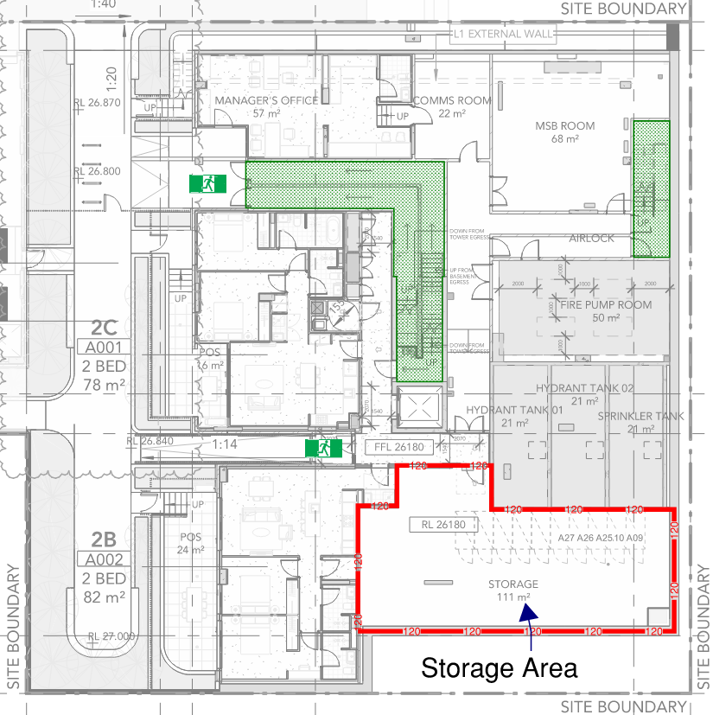
Figure 7: Proposed location of reduced FRLs
Fire Scenario
In the event of fire in the storage room, it is expected that the sprinkler system will activate and prevent fire growth and fire spread. Further information on the benefits of sprinkler protection will be documented in the FER.
In the unlikely event that a fire started in the storage room and the sprinkler system failed to operate, then it is credible that the fire could grow and pose a risk of fire spread into the car park space. To mitigate this risk, it is proposed to enclose the storage areas by 2-hour fire rated construction.
The assessment in the upcoming FER will demonstrate that the reduction in FRLs from 240/240/240 down to 120/120/120 in the storage area will not represent an undue risk of fire spread, nor compromise fire brigade-operations. Modelling will be conducted to demonstrate that even with a conservative level of fuel with the subject areas, that a fire would be contained within the 120-minute fire rated compartment.

Quantitative Assessment
Zone Modelling
A compartment fire zone representing the storage area will be modelled with the intent to demonstrate that the temperature conditions to which the bounding construction is actually exposed to are less severe than the temperatures in the standard fire test as per AS1530.1.
A parametric study will be conducted using a zone fire model called Ozone for a fire scenario in the proposed basement. Ozone is a tool, which has been developed to help engineers in designing structural elements when subjected to compartment fires.
Zone models have been extensively validated (McGrattan et al, 2010a) against experimental data. Zone modelling software such as Ozone model compartment fires using a two-zone model, where a hot smoke layer forms at the ceiling level, with a cool lower layer. This is considered appropriate for the storage area assessment herein.
It should be noted that the standard time-equivalence method calculation is not applicable in this instance, as there would be no glazed openings available to ventilate heated combustion products from these rooms given the storage area is located on the Lower Ground Level and served by a single door.
The suitability of Ozone models on modelling small compartment fires has been extensively researched (J. F. Cadorin, J. M. Franssen, 2003) by comparison with experimental tests. 36 fire tests were performed in 1970 at CTICM (Arnault et al, 1973) in a compartment measuring 3.13m high, with a rectangular floor of 3.38 x 3.68 m. The opening area between the tests varied between 1.062 and 6.366 m². Cadorin and Franssen (J. F. Cadorin, J. M. Franssen, 2003) conclude that the agreement between experimental test results and results computed by the numerical code based on this procedure appears as quite satisfactory.
The modelling presented and to be detailed in the FER accounts for limited ventilation in the model by modelling the air gap around the door serving the storage area. The assessment will also consider a scenario where the door serving the room is held open, which is unlikely given the requirement for the door to be automatically closing. The zone modelling considers a 3 cm gap around all edges of the doors.
A parametric compartment fire zone model has been carried out in the storage area. To demonstrate that the temperature conditions to which the bounding construction is actually exposed are much less severe than the temperatures in the standard fire test curve as per AS1530.1, a parametric study was conducted using a two-zone fire model called Ozone [Cadorin] for a fire scenario. Table 3 presents the inputs for the assessment.
Table 3: Ozone Input Parameters
Location | Floor Area (m²) | Lining material | Lining Thickness (mm) | Growth Rate | Heat Release Rate (kW/m²) | FLED (MJ/m²)
Basement Storage | 111 | Normal Weight Concrete | 200 | Fast | 500 | 1980
References:
All building: C/VM2 Verification Method Amendment 4 states that all buildings and storage stacks height of less than 3m is a fast 0.0469t² growth rate and 500 kW/m².
As defined by IFEG Table 3.4.1a, the FLED for “storage - workshop storage etc.” has been used, which has an average FLED of 1200 MJ/m². The methodology given on page 3.4-2 of the IFEG has been used to determine the 90% fractile value.
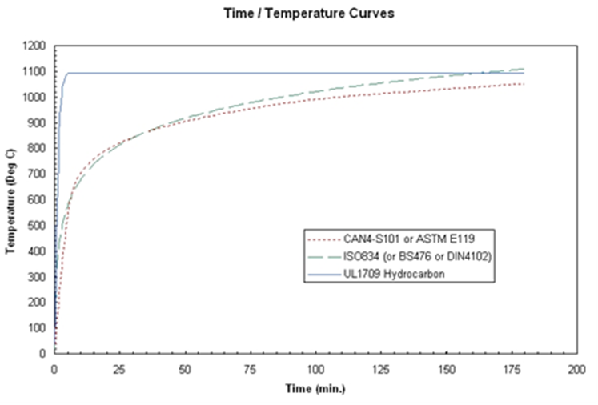
Figure 8: Temperature curve in standard fire tests [AS1530.1/ISO834]
The assessment will demonstrate that the storage area can be enclosed and protected by construction with an FRL of 120/120/120.
As defined by IFEG Table 3.4.1a, the FLED for “storage - workshop storage etc.” has been used, which has an average FLED of 1200 MJ/m². Two fire scenarios have been performed, one where the doors are held open, and another with the doors closed incorporating a 3cm gap around the perimeter of the door. The resultant hot gas temperature within the room for this scenario can be found in the figures below.
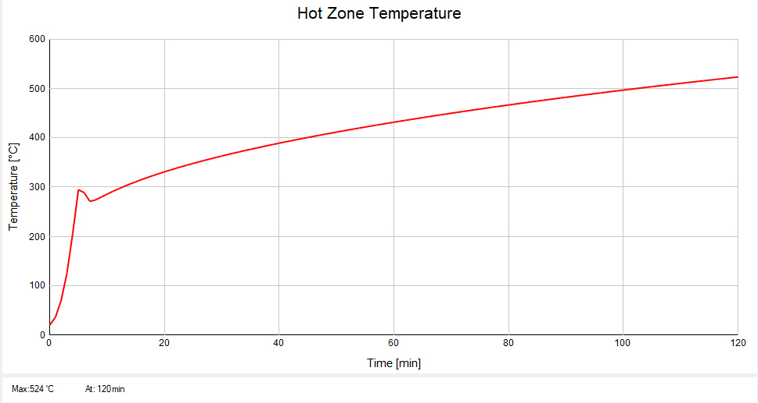
Figure 9: The temperature time curve within the storage area – Doors held open
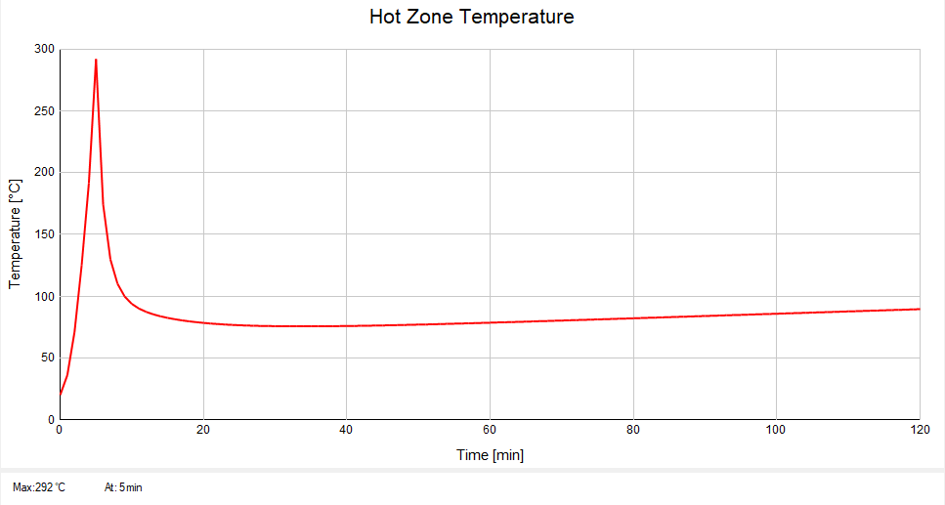
Figure 10: The temperature time curve within the storage area – Doors closed

As shown in the figures above, the door held open fire scenario reaches a peak of ~524°C at 120 minutes. It is noted that the temperature that the construction is exposed to is significantly less than the temperature conditions depicted in the standard fire curve depicted in Figure 8, where a temperature of roughly 1000°C is reached after 120 minutes. This suggests that even in the unlikely event that a fire occurs in the storage area while the door is choked open, that the fire is ventilation controlled.
FRNSW Comment: For the door open scenario, Figure 9 above indicates that the temperature inside the room continues to increase for 120 minutes indicating that the fire still grows and has not reached burnout. Therefore, FRNSW considers that it is unable to demonstrate that provision of an FRL of 120 is adequate to contain the fire. FRNSW recommends additional assessment be undertaken to demonstrate the adequacy of the proposed FRL. Alternatively, FRNSW recommends fire severity calculations be undertaken for this scenario to demonstrate that the proposed FRL is adequate for a burnout.
The door closed fire scenario reaches a peak of ~282°C at approximately 5 minutes, after which point there is insufficient oxygen in the compartment for it to continue the combustion process, meaning the fire simply smoulders for the remainder of the simulation.
The temperature conditions within the subject compartments in this fire scenario have been found to be much less severe than the temperatures in the standard fire test shown in Figure 8. A 120/120/120 FRL within the storage area is therefore considered adequate to mitigate the chance of structural failure in this space, while also preventing the spread of fire to adjacent areas.
Fire Brigade Intervention
As detailed in the assessment above, the reduced FRLs will be demonstrated to be adequate as the compartments are calculated to survive complete burnout even after the reduction in FRLs. As such, fire spread beyond the origin of the fire event is prevented, which will ensure fire brigade intervention is not impeded by fire spread.
The brigade will be able to effectively fight the fire in the lower ground floor by approaching from the ramp serving the central access between Building A and Building B, or via the fire stairs serving the lower ground floor.
Conclusion
Based on the quantitative assessments undertaken above, it is considered that a fire within the storage area on lower ground floor will not represent any additional risk of fire spread, nor to the safety of occupant and fire brigade operations. Therefore, Performance Requirement C1P1 and C1P2 are considered to have been met.
Performance solution:
 A2G2(1)(a) or A2.2(1)(a) - Comply with all relevant performance requirements
 A2G2(1)(b) or A2.2(1)(b) - Be at least equivalent to the DtS provisions
Assessment methods:
 A2G2(2)(a) or A2.2(2)(a) - Evidence of suitability
 A2G2(2)(b)(i) or A2.2(2)(b)(i) - Verification methods provided in the NCC
 A2G2(2)(b)(ii) or A2.2(2)(b)(ii) - Other verification methods accepted by the appropriate authority
 A2G2(2)(c) or A2.2(2)(c) - Expert judgement
 A2G2(2)(d) or A2.2(2)(d) - Comparison with the DtS provisions
Assessment approach:
 Comparative  Qualitative  Deterministic
 Absolute  Quantitative  Probabilistic
AFEG sub-systems used in the analysis:
 A – Fire initiation and development and control  D – Fire detection, warning and suppression
 B – Smoke development and spread and control  E – Occupant evacuation and control
 C – Fire spread and impact and control  F – Fire services intervention
Acceptance criteria and factor of safety:
The proposed solution will be considered to meet the Performance Requirements if it is demonstrated that fire severity does not exceed that of the proposed FRLs.
Fire scenarios and design fire parameters:
The assessment considers a fire in the Storage Area on Lower Ground Floor of Building A.
Describe how fire brigade intervention will be addressed or considered:
The zone modelling has demonstrated that the reduction in FRL will maintain the integrity of the wall bounding the storage area. It is expected that the bounding walls will be able to contain that fire for an appropriate time whereby the fire brigade are able to arrive on site and begin intervention and fight the fire if is not extinguished by the sprinklers.
Verification/validation analyses:
 Sensitivity studies  Redundancy studies  Uncertainty studies  None
The assessment considers a sprinkler failure scenario and a door held open scenario.
Provide details on proposed modelling/assessment tools:
Ozone Calculations, inputs listed in Table 3.
FRNSW Comment: FRNSW recommends the above comments be appropriately addressed.

- Title: Garbage Room Enclosures
Details of departures from DtS provisions:
To permit each respective garbage room on Basement 1 to form the base of the fire rated garbage chute shaft in lieu of enclosing the bottom of the garbage chute.
Applicable DtS provisions (including clause excerpt): | C2D2, Specification 5 | Applicable Performance Requirements: | C1P2
List key fire safety measures:
- 120/120/120 FRL requirement for garbage room bounding construction.
- Garbage chute shafts are to achieve an FRL of 120/120/120.
- Self-closing fire rated door sets to be provided to garbage rooms.
  - Doors to be provided with medium temperature smoke seals are to be capable of resisting smoke at 200°C for up to 30 minutes in accordance with AS1530.7.
- Where fire hose reels have been removed from garbage rooms in Issue number: 7, portable 4.5kg (ABE) fire extinguishers are to be installed in accordance with BCA Clause E1D14 and AS2444-2001 in the same locations as fire hose reels would be required.
Proposed performance solution:
BCA Comparison
BCA Clause C2D2 dictates the requirements for fire resisting construction, given the building class and construction type used in the subject building.
BCA Specification 5 requires that the bottom of the garbage chutes be enclosed, with an enclosure that achieve an FRL at least to the same degree as the walls of the garbage chute. The intent of this clause is to limit the potential for fire spread, containing a fire within the chute and preventing a fire from spreading to the surrounding areas of the building.
Performance requirement C1P2 requires a building must have elements which will, to the degree necessary, avoid the spread of fire.
The intent of the above requirements is to prevent the spread of fire throughout the building, specifically containing any combustible materials within the garbage chute to the degree necessary to conform with the relevant performance requirements. A DtS design would require the garbage chute installed with a fire rated enclosure surrounding the collection point at the bottom of the chute.
The proposed design will instead have the entire garbage collection room act as the fire rated enclosure, and this will be addressed in the following assessment by qualitatively analysing the fire rated construction of the garbage room, and the fire safety provisions within the room. This will show that the spread of fire is not facilitated by the proposed design of the garbage chute, and consequently compliance with Performance Requirement C1P2 will be achieved.
Qualitative Analysis
The garbage rooms at the base of the garbage chutes on Basement 1 are depicted in Figure 11. Note, compartmentation has been depicted around the garbage rooms in accordance with the fire safety provisions of this Performance Solution. Refer to compartmentation plans for further details regarding the required FRL of construction.
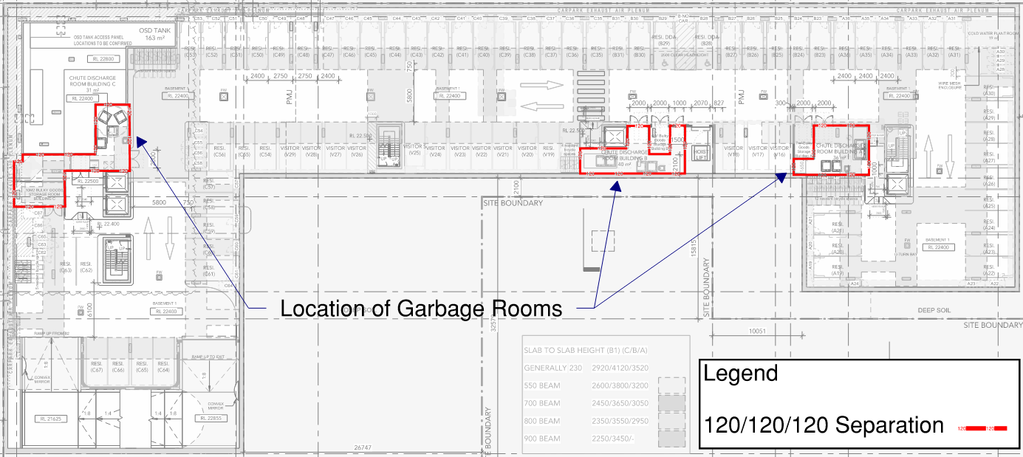
Figure 11: Location of Garbage Rooms – Basement 1 Plan
The proposed design is to use the garbage room itself as the garbage chute enclosure, with the fire rated shaft coming down from the levels above and terminating inside the room. In order to ensure that the spread of fire is sufficiently contained within the garbage rooms to the degree necessary to conform with the related performance requirements, the garbage rooms will be bounded with 120/120/120 FRL walls. Additionally, to mitigate the smoke spread risk from the enclosures, medium temperature smoke seals are to be installed to the self-closing fire doors of the garbage chute enclosure. The medium temperature smoke seals are to be capable of resisting smoke at 200°C for up to 30 minutes in accordance with AS1530.7.
If a fire were to break out within the garbage chute and spread to the garbage receptacle at the bottom of the chute, the presence of an enclosure would limit the ability of the sprinkler suppression system within the room to control the fire in the early stages of fire growth. While the fire would be sufficiently contained within the fire rated enclosure, there would be no suppression of the fire and it may be allowed to grow, given the potentially large amounts of fuel load within the garbage receptacles.
A fire within the garbage room, constructed as per the proposed design, will be contained within the compartment, given the fire rated construction and fire safety provisions described above. Consequently, the proposed assessment will have demonstrated that the spread of fire is not facilitated by the proposed design of the garbage room. Additionally, the spread of fire will be contained to the same degree that a DtS design would achieve, however the presence of sprinkler protection within the garbage room space means that there is an additional layer of suppression The proposed assessment will therefore have demonstrated a compliance with Performance Requirement C1P2.
Conclusion
The proposed solution above will demonstrate that the garbage room bounding walls will effectively replace the function of the garbage chute enclosure. The bounding walls of the garbage room are rated with a 120-minute FRL, and the compliant sprinkler system with fast response heads within the room will suppress a fire during the early stages of fire growth. Consequently, a fire within the garbage room would be contained to a degree that is deemed as being at least equivalent to the fire protection provided by a chute enclosure, and is in compliance with Performance Requirement C1P2.
Performance solution:
 A2G2(1)(a) or A2.2(1)(a) - Comply with all relevant performance requirements
 A2G2(1)(b) or A2.2(1)(b) - Be at least equivalent to the DtS provisions
Assessment methods:
 A2G2(2)(a) or A2.2(2)(a) - Evidence of suitability
 A2G2(2)(b)(i) or A2.2(2)(b)(i) - Verification methods provided in the NCC
 A2G2(2)(b)(ii) or A2.2(2)(b)(ii) - Other verification methods accepted by the appropriate authority
 A2G2(2)(c) or A2.2(2)(c) - Expert judgement
 A2G2(2)(d) or A2.2(2)(d) - Comparison with the DtS provisions
Assessment approach:
 Comparative  Qualitative  Deterministic
 Absolute  Quantitative  Probabilistic
AFEG sub-systems used in the analysis:
 A – Fire initiation and development and control  D – Fire detection, warning and suppression
 B – Smoke development and spread and control  E – Occupant evacuation and control
 C – Fire spread and impact and control  F – Fire services intervention
Acceptance criteria and factor of safety:
The proposed solution will be deemed as acceptable if it is able to be demonstrated that the omission of a chute enclosure will not result in a risk of fire spread, given the FRL rated bounding walls of the garbage room and the sprinkler system within the space.
Fire scenarios and design fire parameters:
The assessment considers a fire in the garbage chute, and in the fire-rated garbage room at the base of the chute.
Describe how fire brigade intervention will be addressed or considered:
Fire Brigade intervention is not considered as being impacted, as the proposed design limits the spread of fire to the degree necessary to conform with the necessary performance requirements. The fire brigade would potentially be faced with a lesser fire over a DtS design, given the provision of a sprinkler system within the compartment.
Verification/validation analyses:
 Sensitivity studies  Redundancy studies  Uncertainty studies  None
Assessment is qualitative in nature.
Provide details on proposed modelling/assessment tools:
Assessment is qualitative in nature.
FRNSW Comment: FRNSW does not support the proposal and provides the following comments:
- With the bottom of the garbage chute not being protected, there is a risk that a fire within the garbage room will spread upwards to the upper levels along the garbage chute. This is due to the fact that Clause C4D14 (d) of the NCC only requires a non-combustible door or hopper to the inlet openings to the garbage shaft. After the failure of the door or hopper, smoke will fill the residential corridors which constitute the egress paths for the residents. In this case, compliance with Performance Requirement E2P2 is considered not to be achieved.
- Given the building is a high-rise building with an effective height of greater than 25 m, the stack effect will play a significant part on the smoke spread to upper levels of the building. This has to be appropriately addressed.
Based on the above, FRNSW recommends the bottom of the garbage chutes be protected in accordance with the DtS provisions of the NCC.

- Title: Omit Sprinklers from Lift Shafts
Details of departures from DtS provisions:
Permit the omission of sprinklers from the lift shafts within the subject development.
Applicable DtS provisions (including clause excerpt): | E1D4 | Applicable Performance Requirements: | E1P4
List key fire safety measures:
- Thermal detectors are to be installed at the top of lift shafts, directly above the elevator roof hatch, such that thermal detectors are serviceable from within the lift car. Thermal detectors are to activate the building occupant warning system upon detection of a fire.
- The building is to be sprinkler protected throughout in accordance with AS2118.1-2017 with fast response heads throughout, except where modified in this document.
Proposed performance solution:
BCA Comparison
BCA Clause E1D4 states that a sprinkler system must be installed where required by BCA Clause E1D5 to E1D12 as applicable, and must comply with BCA Specification 17 and Specification 18 as applicable. BCA Clause E1D6 states that a sprinkler system must be provided throughout the whole Class 2 building if any part of the building has an effective height of more than 25 metres.
Performance Requirement E1P4 states that an automatic fire suppression system must be installed to the degree necessary to control the development and spread of fire appropriate to the nature and use of the building.
The following proposed solution aims to demonstrate that the provision of thermal detection within the lift shafts will be sufficient to activate the building alarm system and notify the building occupants to the degree necessary to facilitate occupant evacuation. Furthermore, the likelihood of fire spread given the low fire load and the lift shaft’s fire-resistant construction will also be considered as part of the rationalisation.
Qualitative Assessment
Figure 12 depicts the locations of lift shafts serving the development.
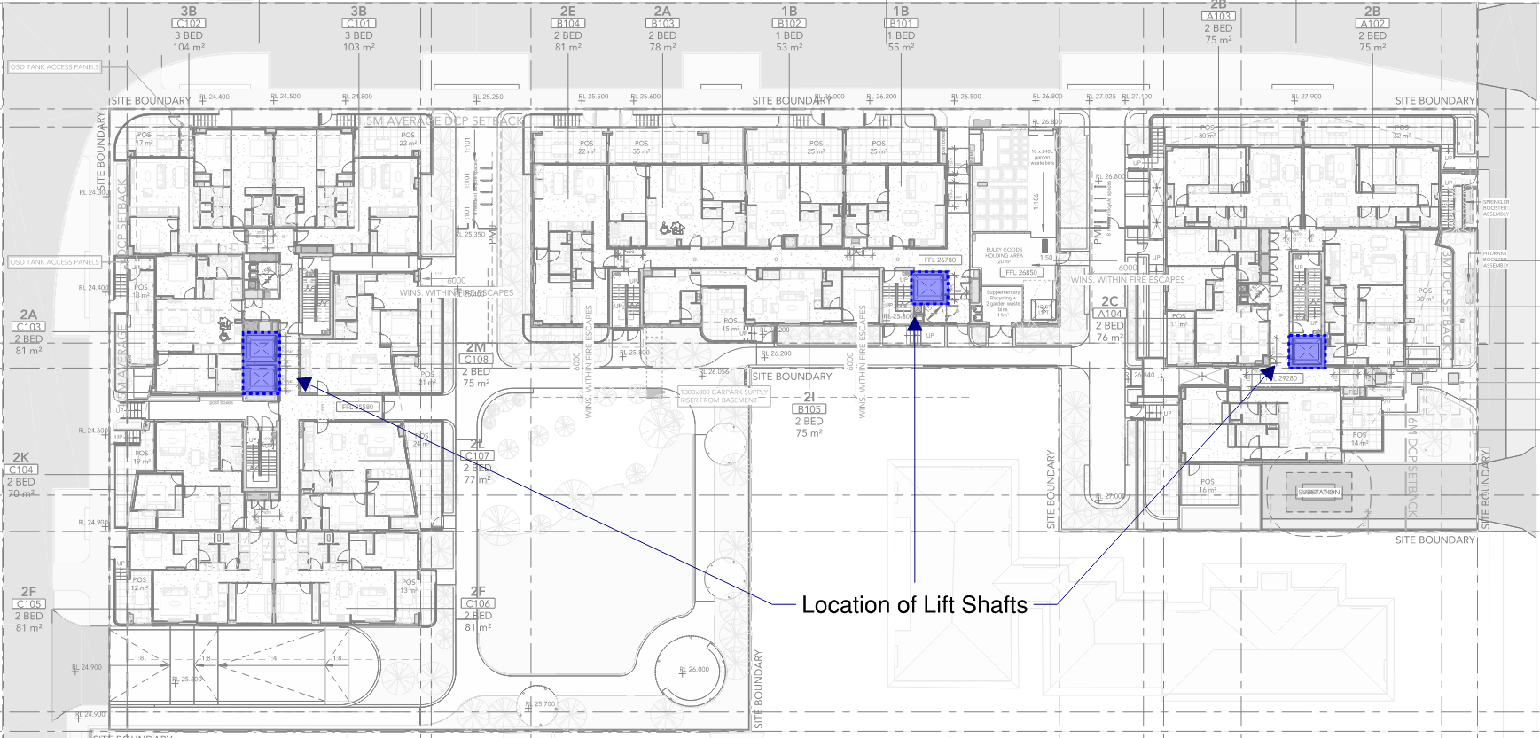
Figure 12: Location of elevator shafts throughout development – Ground floor plan

Fire Risk
The expected fire load within the lift shaft, with the exception of the lift equipment, is very low. The main combustible fuel load expected within the lift shaft is the electrical motor and components, which are also the potential ignition sources. Rubbish and other combustible materials may accumulate at the bottom of the lift pit which is another source of fire load within the lift shaft. In the event of a fire within the lift shaft, the likelihood of fire spread from the lift shaft to the surrounding residential/basement areas is low given the required level of fire separation provided, and referenced in the attached fire compartmentation drawings. However, there is a potential for smoke to spread via the lift doorways. The likelihood of smoke spread is considered equivalent to a Deemed-to-Satisfy solution. In this instance, and as part of the Performance Solution, fire detection within the lift shaft will be provided by a thermal detector in lieu of a sprinkler head.
FRNSW Comment: FRNSW does not agree with the statement stating that “The likelihood of smoke spread is considered equivalent to a Deemed-to-Satisfy solution.”. Without sprinkler protection to the lift shaft, a fire within the lift shaft will grow freely and produce large quantities of hot smoke. The hot smoke would have greater buoyancy than that in a DtS compliant design where smoke may be cooled down by the spray of sprinklers.
Thermal Detection
The removal of sprinkler protection to the high level of the lift shaft is considered an appropriate fire safety provision as activation of a sprinkler head at the top of lift shafts is expected to introduce water damage into the lift shaft. While specific firefighting-only lifts are not required it is important to note that British Standard EN 81-72:2003 aims to limit water ingress into lift shafts to prevent malfunction to machinery/electronic equipment caused by water when required to be used by fire services.
In lieu of sprinklers, it is proposed to implement thermal detection within the lift shaft which will ensure the Fire indicator panel is notified of a significant rise in temperature within the shaft and alert the attending fire service of the location of the fire. It is also noted that within the lift shaft, combustibles that emit low smoke such as overheated wires, dust and dirt are considered to be more appropriately catered for by thermal detectors when compared to smoke detectors.
FRNSW Comment: It is noted that in accordance with Clause 3.27.12 of AS 1670.1 – 2018, lift shafts shall be protected by a smoke detector at the top of the shaft. Therefore, provision of a heat detector at the top of the lift shaft will not provide an earlier fire alarm to occupants if compared to a DtS compliant design.
Lift Shaft Construction
In accordance with the requirements of BCA Specification 5, the lift shaft is to be constructed with fire-resisting construction. This fire separation of the lift shaft from the rest of the building will ensure there is a low likelihood of fire spread from the lift shaft to other parts of the building. The fire separation of lift shafts will therefore ensure occupants will have ample time to evacuate the building in the case of a fire within the lift shaft, regardless of whether the fire is sprinkler controlled.
Conclusion
The assessment above has demonstrated that the provision of the thermal detector within the compliantly separated lift shafts provides means of detection to the degree necessary for a fire in the lift shafts. Therefore, the proposed design is considered to comply with Performance Requirement E1P4.
Performance solution:
 A2G2(1)(a) or A2.2(1)(a) - Comply with all relevant performance requirements
 A2G2(1)(b) or A2.2(1)(b) - Be at least equivalent to the DtS provisions
Assessment methods:
 A2G2(2)(a) or A2.2(2)(a) - Evidence of suitability
 A2G2(2)(b)(i) or A2.2(2)(b)(i) - Verification methods provided in the NCC
 A2G2(2)(b)(ii) or A2.2(2)(b)(ii) - Other verification methods accepted by the appropriate authority
 A2G2(2)(c) or A2.2(2)(c) - Expert judgement
 A2G2(2)(d) or A2.2(2)(d) - Comparison with the DtS provisions
Assessment approach:
 Comparative  Qualitative  Deterministic
 Absolute  Quantitative  Probabilistic
AFEG sub-systems used in the analysis:
 A – Fire initiation and development and control  D – Fire detection, warning and suppression
 B – Smoke development and spread and control  E – Occupant evacuation and control
 C – Fire spread and impact and control  F – Fire services intervention
Acceptance criteria and factor of safety:
The acceptance criterion for this Performance Solution is to demonstrate the risk of fire developing and spreading from a fire-resistant lift shaft will not be exacerbated by providing thermal detection in lieu of fire sprinkler protection and sufficient warning is provided.
Fire scenarios and design fire parameters:
The assessment considers a fire in a lift shaft throughout the development.
Describe how fire brigade intervention will be addressed or considered:
The proposed design is considered as sufficient in providing a warning of a fire within the lift shaft, such that occupants are afforded ample time to safely evacuate from the building. Furthermore, the lift shafts are constructed with compliant fire-resistant bounding walls, sufficiently limiting the spread of fire. Consequently, the attending Fire Brigade is not considered to be impacted, as they will not be faced with the undue spread of fire, nor the search and rescue of trapped occupants within.
Verification/validation analyses:
 Sensitivity studies  Redundancy studies  Uncertainty studies  None
Assessment is qualitative in nature.
Provide details on proposed modelling/assessment tools:
Assessment is qualitative in nature.
FRNSW Comment: FRNSW considers that the performance solution is inadequate to demonstrate compliance with the relevant performance requirements. As such FRNSW does not support the proposal and recommends the lift shafts be sprinkler protected as per the DtS provisions.
- Title: Basement Roof Penetrations
Details of departures from DtS provisions:
Permit penetrations within the roof the basement carpark, which will only achieve an FRL rating of -/120/120 in lieu of the required 120/120/120.
FRNSW Comment: FRNSW does not consider this as a non-compliance with the NCC. FRNSW recommends this be confirmed with the certifier.
Applicable DtS provisions (including clause excerpt): | D3D13  (See Clause excerpt below) | Applicable Performance Requirements: | D1P4
List key fire safety measures:
- Penetrations through the carpark roof slab are to be no closer than 3 metres from each other and egress paths on roof level (as per BCA DTS Clause D3D13).
- Penetrations through the roof slab are expected to be treated with cast-in fire collars (Trafalgar Fire Collar Cast-In Stack Pipe, or similar product that achieves an FRL of at least -/120/120) or retrofit fire collars (Trafalgar Fire Retrofit Fire Collar or similar).
Proposed performance solution:
BCA Comparison
BCA Clause D3D13 states that if an exit discharges to a roof of a building, the roof must have an FRL of not less than 120/120/120; and not have any roof lights or other openings within 3 m of the path of travel of persons using the exit to reach a road or open space.
Performance Requirement D1P4 states that exits must be provided from a building to allow occupants to evacuate safely, with their number, location and dimensions being appropriate to-
- The travel distance; and
- The number, mobility and other characteristics of occupants; and
- The function or use of the building; and
- The height of the building; and
- Whether the exit is from above or below ground level.
The proposed design is to have penetrations through the carpark roof transfer slab to allow for services, drainage, etc. The penetrations are to be installed with cast-in fire collars or be retro-fitted with fire collars below the slab, (basement side) which do not achieve the 120/120/120 FRL rating in accordance with BCA Clause D3D13.
The following proposed solution aims to demonstrate that the penetrations through the roof slab will not endanger the life safety of evacuating occupants, given the limited size of the penetrations, the provision of fire collars at the penetration point, and the multiple egress routes afforded to occupants.
Qualitative Assessment
The location of the basement roof slab has been overlayed on the Level 1 Floor plan in Figure 13 below.
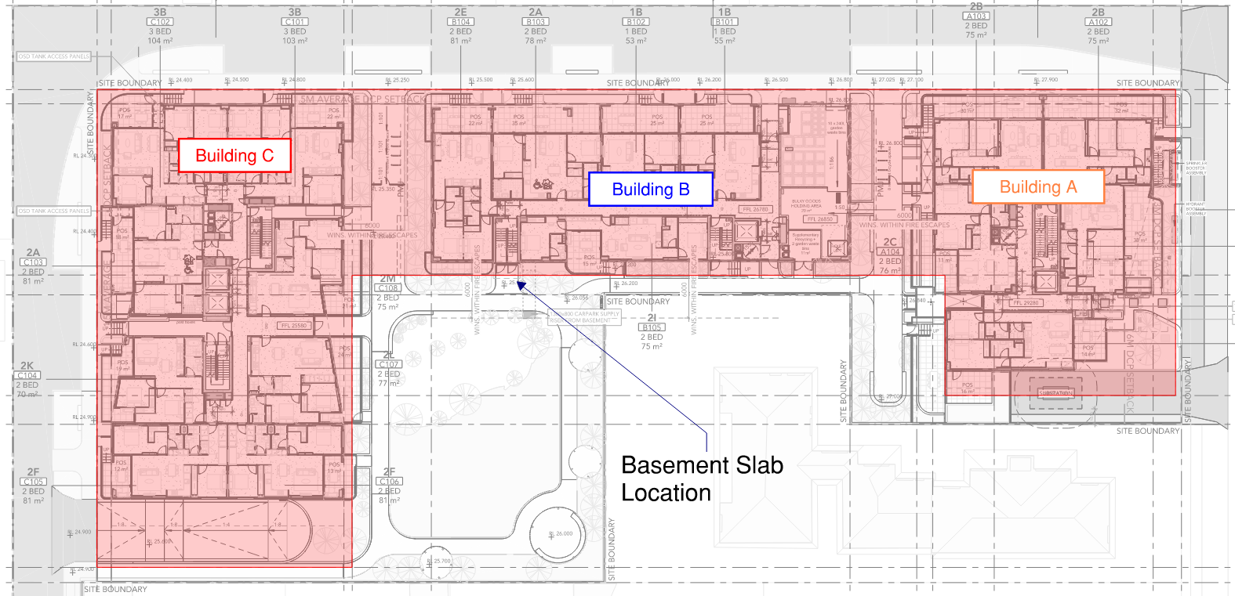
Figure 13: Location of basement roof slab – Overlayed on ground floor plan
BCA Clause D3D13 requires that any elements installed within a roof that also serves as a route of evacuation are to achieve an FRL rating of 120/120/120. However, the proposed design does not achieve the required FRL where there are penetrations through the slab for the purpose of drainage, as there will be no structural integrity rating at the points of penetration.
The proposed design consists of utilising cast-in fire collars or retrofitted collars in order to provide a level of protection where the drainage penetrations are located within the roof slab. The fire collars that are proposed to be used are proposed to be Trafalgar Fire Cast-In Collar or similar (that are to achieve an FRL rating of at least -/120/120). The BCA guide states that the intent of Clause D3D13 is to provide any potential occupants that are evacuating via the roof with a sufficient level of protection from a fire below, so that a safe evacuation is facilitated.
The proposed design is consistent with the intent of this specific BCA clause, as the subject fire collars are to be provided with an FRL of (at least) -/120/120, meaning that the spread of fire and smoke, as well as the conduction of heat to the roof side of the penetration, is sufficiently limited by the collar. The structural integrity aspect of the required FRL rating (as dictated by Clause D3D13) is not considered as a necessity for the penetrations, as they do not form part of the structure on which occupants will be evacuating on. Additionally, given the limited extent of the penetrations in relation to the size of the roof slab, the penetrations will not jeopardise the structural integrity of the roof as a whole, in the event of a basement carpark fire. It is also noted that occupants are provided with multiple alternative egress paths on the carpark roof.
As part of the performance solution, the penetrations are not to be installed closer than 3 metres apart (as per the allowable distance dictated in Clause D3D13). This further mitigates the likelihood of fire spread through the slab penetrations by spacing them at a sufficiently large distance to each other.
Therefore, the proposed design therefore is considered as in compliance with the relevant Performance Requirement D1P4.
Performance solution:
 A2G2(1)(a) or A2.2(1)(a) - Comply with all relevant performance requirements
 A2G2(1)(b) or A2.2(1)(b) - Be at least equivalent to the DtS provisions
Assessment methods:
 A2G2(2)(a) or A2.2(2)(a) - Evidence of suitability
 A2G2(2)(b)(i) or A2.2(2)(b)(i) - Verification methods provided in the NCC
 A2G2(2)(b)(ii) or A2.2(2)(b)(ii) - Other verification methods accepted by the appropriate authority
 A2G2(2)(c) or A2.2(2)(c) - Expert judgement
 A2G2(2)(d) or A2.2(2)(d) - Comparison with the DtS provisions
Assessment approach:
 Comparative  Qualitative  Deterministic
 Absolute  Quantitative  Probabilistic
AFEG sub-systems used in the analysis:
 A – Fire initiation and development and control  D – Fire detection, warning and suppression
 B – Smoke development and spread and control  E – Occupant evacuation and control
 C – Fire spread and impact and control  F – Fire services intervention
Acceptance criteria and factor of safety:
The solution will be deemed as acceptable upon demonstration that the drainage penetrations through the carpark roof will not endanger the life safety of occupants evacuating on the top surface of the basement roof slab nor promote fire spread from the basement level to the roof level.
Fire scenarios and design fire parameters:
The assessment is purely qualitative and it is not considered necessary to qualify a specific design fire.
Describe how fire brigade intervention will be addressed or considered:
As occupant evacuation is facilitated to the degree necessary, the impact to the attending fire brigade is considered as negligible.
Verification/validation analyses:
 Sensitivity studies  Redundancy studies  Uncertainty studies  None
N/A
Provide details on proposed modelling/assessment tools:
N/A
FRNSW Comment: See comments above.

- Title: Cast in Conduits
Details of departures from DtS provisions:
It is proposed to permit conduits to be cast in the floor slab separation over multiple fire compartments (such as penetrations for NBN and similar services). The conduits are to penetrate into the ceiling/floor slab from within the building hallways, into each individual SOU.
Applicable DtS provisions (including clause excerpt): | C4D15 | Applicable Performance Requirements: | C1P2, C1P8
List key fire safety measures:
- Penetrations shall be in accordance with the tested prototypes detailed in Exova Warrington Fire EWFA Report No. 35506000.4 dated 15/10/2015 or EWFA Report 39465800.3 dated 22/05/2017.
FRNSW Comment: FRNSW notes that the above referenced assessment report (EWFA No 39465800.3) has expired at 30/11/2020. The associated fire test report (Report No. 35506000.4) is considered invalid automatically. Therefore, it is considered that the above two reports are not qualified as an appropriate Evidence of Suitability for the proposed application.
- The building is to be sprinkler protected throughout in accordance with AS2118.1-2017 with fast response heads throughout, except where modified in this document.
Proposed performance solution:
BCA Comparison
BCA Clause C4D15 states where an electrical, electronic, plumbing, mechanical ventilation, air-conditioning or other service penetrates a building element (other than an external wall or roof) that is required to have an FRL with respect to integrity or insulation or a resistance to the incipient spread of fire, that installation must comply with any one of the following:
- Tested system: The service, building element and any protection method at the penetration are identical with a prototype assembly of the service, building element and protection method which has been tested in accordance with AS 4072.1 and AS 1530.4 and has achieved the required FRL or resistance to the incipient spread of fire.
Performance Requirement C1P2 requires a building must have elements which will, to the degree necessary, avoid the spread of fire.
Performance Requirement C1P8 requires any building element provided to resist the spread of fire must be protected, to the degree necessary, so that an adequate level of performance is maintained —
- where openings, construction joints and the like occur; and
- where penetrations occur for building services.
The intent of BCA Clause C4D15 is to maintain the fire performance of building elements by limiting fire spread by way of service penetrations.
The Performance Requirements recognise that different building elements require differing levels of protection, depending on the circumstances within they are used and installed. In this instance, the intent of BCA Clause C4D15 and the performance requirements described above is to limit the spread of fire within the building by way of the penetrations used for various electrical services.
Qualitative Assessment
This performance solution addresses a technical non-compliance where AS1530.4-2014 does not specifically address the testing of penetrations that pass across multiple fire compartments within the slab. This FEBQ references the following test certificates that assess the performance of conduit penetrations running horizontally through the ceiling/floor slab in general accordance with AS1530.4-2005 methodology (test reports to be attached in the subsequent FER):
- Exova Warrington Fire EWFA Report No. 35506000.4 dated 15/10/2015
- EWFA Report 39465800.3 dated 22/05/2017
Both reports assess the fire resistance performance of various plastic pipes and conduits embedded in concrete floors when tested in accordance with AS 1530.4-2005 for penetrations within slabs across multiple fire compartments. Both reports outline the tested prototypes, testing method and results. All conduit configurations tested did not exceed the failure criterion at 120 minutes.

Fire Stopping Systems
The service conduits that run horizontally through the slab will be installed in accordance with a tested system as per the attached test reports.
As per the results outlined in the assessment report, the unexposed side of the conduit did not show any signs of fire or smoke damage after the test.
The test report details a number of different configurations for the cast-in conduits, including the installation of a fire collar and two different intumescent sealants (as well as the use of no local fire stopping methods as well). No discernible difference in terms of fire performance was observed across the different conduit installation methods, which demonstrates that this method of casting conduits through the slab were effective at preventing the spread of fire via the penetrations. According to the subject test report:
“It is confirmed that the performance of the specimens tested is applicable to the performance of a wall and floor junction if tested in accordance with AS 1530.4 – 2005 as appropriate for penetration within a slab under a fire wall.”
Therefore, in the event of a fire inside the development where a service conduit runs horizontally through the slab, it is considered that the spread of fire will not be facilitated by the proposed design.
It should be noted it is proposed to seal the cast-in conduits (using an intumescent fire sealant) within the subject building, on the public hallway side only. Given the information detailed in the test reports discussed above, this method of protection will be sufficient to prevent the spread of fire and smoke via the conduit penetrations.
It is also noted that the test reports discussed above assess the fire performance of a conduit penetration that runs down into the slab, runs horizontally through the slab and then up and out of the slab on the far side of the fire wall.
The conduits within the subject development are proposed to penetrate upward into the slab, run horizontally and exit downward into an adjacent fire compartment. There is a potential for this configuration to more readily facilitate the spread of heat and smoke, as the smoke layer will rise and accumulate in close proximity to where conduits penetrate the slab. However, the conduit penetrations were directly exposed to the furnace in the fire test discussed above, which is considered as a much more severe scenario when considering the fire resistance of the cast-in conduits. As such, it is considered that the proposed configuration will not adversely effect the fire resistance of the conduit penetrations, when compared to the configuration of the tested system.
FRNSW Comment: Given the proposed arrangements of the routing of the cast-in slab service is significantly different to the ones referenced in the test report, FRNSW considers that the test reports are not applicable to the proposed application even a current report is provided. FRNSW recommends the relevant fire test report for the proposed arrangement be provided as the appropriate Evidence of Suitability.
It is therefore considered that the proposed cast-in conduit design does not facilitate the spread of fire within the building by way of the penetrations used for various services in accordance with Performance Requirements C1P2 and C1P8.
Performance solution:
 A2G2(1)(a) or A2.2(1)(a) - Comply with all relevant performance requirements
 A2G2(1)(b) or A2.2(1)(b) - Be at least equivalent to the DtS provisions
Assessment methods:
 A2G2(2)(a) or A2.2(2)(a) - Evidence of suitability
 A2G2(2)(b)(i) or A2.2(2)(b)(i) - Verification methods provided in the NCC
 A2G2(2)(b)(ii) or A2.2(2)(b)(ii) - Other verification methods accepted by the appropriate authority
 A2G2(2)(c) or A2.2(2)(c) - Expert judgement
 A2G2(2)(d) or A2.2(2)(d) - Comparison with the DtS provisions
Assessment approach:
 Comparative  Qualitative  Deterministic
 Absolute  Quantitative  Probabilistic
AFEG sub-systems used in the analysis:
 A – Fire initiation and development and control  D – Fire detection, warning and suppression
 B – Smoke development and spread and control  E – Occupant evacuation and control
 C – Fire spread and impact and control  F – Fire services intervention
Acceptance criteria and factor of safety:
The Performance Solution shall be deemed as acceptable if it can be demonstrated that the spread of fire is not facilitated by the service penetrations detailed in the above assessment.
Fire scenarios and design fire parameters:
The assessment considers a fire in the development that could spread between compartments via cast in conduits.
Describe how fire brigade intervention will be addressed or considered:
Fire Brigade intervention is not considered to be impacted in the solution meets the acceptance criteria.
Verification/validation analyses:
 Sensitivity studies  Redundancy studies  Uncertainty studies  None
The fire conditions during testing are indicative of sprinkler failure scenarios.
Provide details on proposed modelling/assessment tools:
NA
FRNSW Comment: FRNSW recommends the above comments be appropriately addressed.

- Title: Performance Based Fire Stopping of Fire Services Pipework Penetrations
Details of departures from DtS provisions:
The water filled fire services pipes are required to penetrate fire walls. They will be fire stopped through the fire wall in accordance with BCA Clause C4D15 with exception to the insulation criteria of the required FRL.
FRNSW Comment: FRNSW recommends the location of the service penetrations be identified on the floor plans such that FRNSW can undertake an informed review. For example, if it occurs in a required exit, it may affect safe occupant evacuation. If the pipes are associated with fire hydrant system, it may affect effective fire brigade intervention activities. These should be appropriately addressed.
Applicable DtS provisions (including clause excerpt): | C4D15 | Applicable Performance Requirements: | C1P2, C1P8
List key fire safety measures:
- A fire rated sealant is to be applied where the water filled pipes penetrate fire rated walls or slabs, capable of providing an FRL in line with BCA Specification 5.
- The building is to be sprinkler protected throughout in accordance with AS2118.1-2017 with fast response heads throughout, except where modified in this document.
Proposed performance solution:
BCA Comparison
BCA Clause C4D15 states in part where a plumbing or other service penetrates a building element that is required to have an FRL with respect to integrity or insulation or a resistance to the incipient spread of fire, that installation must comply with any of the following:
- A tested system in accordance with AS 4072.1 and AS 1530.4 to maintain the required FRL of the building element; or
- Specification 13, and the pipe system does not contain a flammable or combustible liquid or gas.
For a tested system, the insulation criteria need not be applied if –
- The service is a pipe system comprised entirely of metal; and
- Any combustible building element is not located within 100 mm of the service for 2 m from the penetration; and
- Combustible material is not able to be located 100 mm of the service for 2m from the service penetration.
The proposed performance solution is to permit water filled pipes to be fire stopped in accordance with Clause C4D15(2)(a)(i) with the exception of the insulation criteria of the required FRL where there is likely to be combustible materials i.e. PVC pipes, pex pipes, cables etc located within 100 mm radius for a distance of 2 m from the penetration. Therefore, the issue to be addressed is to ensure the water filled pipes which penetrate through fire rated building elements will not increase the likelihood of fire spread between fire separated compartments.
Performance requirement C1P2 outlines the requirements to prevent the spread of fire between buildings. Exits, sole-occupancy units, corridors and in a building.
Performance requirement C1P8 states any building element provided to resist the spread of fire must be protected, to the degree necessary, so that an adequate level of performance is maintained where openings, construction joints and the like occur; and where penetrations occur for building services. The intent of C1P2 and C1P8 is to minimise the likelihood of fire spread from a point of origin to another location.
AS 1530.4 - 2014 states that the failure criteria for insulation rating is when;
- The average temperature of the unexposed face of the test specimen exceeds the initial temperature by more than 140˚K; or
- The temperature at any location on the unexposed face of the test specimen exceeds the initial temperature by more than 180˚K.
Quantitative Assessment
The water filled metal pipes will be fire stopped though the fire wall in accordance with Clause C4D15(2)(a)(i) with exception to the insulation criteria of the required FRL. All relevant fire scenarios are to be considered to demonstrate that the proposed design meets the applicable performance requirements. Therefore, the risk is due to the absence of an insulation rating as heat could plausibly radiate between the fire compartments due to the pipe penetrations.
The two scenarios that will be considered are a fire originating in the fire compartment which the water filled metal pipes penetrate with static water and the second scenario will consider flowing water through the pipes which is most likely an activated sprinkler system.
It should be noted that a scenario in which there is a dry pipe (no water within the pipe, possibly due to pump failure etc.) is considered to present an equivalent risk to a DtS compliant design with a dry pump as the heat will be able to travel directly into the steel pipe and into the other fire compartment, unimpacted by the fire seal.
Scenario 1
The first scenario will assess static water in the water filled metal pipes and a fire in the compartment in which the pipe penetrates. The assessment will consider heat transfer to the other side of the compartment by way of the pipe and static water. It should be noted that if water is heated beyond 100°C it will turn into steam which would rapidly disperse through the pipe system causing the sprinkler heads to activate in the adjoining compartment. This scenario would then cause the water to potentially flow through the penetration from the fire affected compartment towards the non-fire affected compartment that is sprinkler protected. Therefore, it is considered that with the water flowing through the pipe that the temperature of the water would remain significantly below 100°C given the high flow rate from a cold-water source, thereby maintaining the temperature below limiting criteria of 140°C.
Scenario 2
The flowing water filled metal pipe scenario is most likely to be an activated sprinkler system. The system is expected to activate for the majority of the time based on a number of studies (to be referenced in the subsequent FER). A fire originating in an SOU is considered to be the worst-case scenario due to the high fuel load within the area. This circumstance poses the likelihood of fire spread due to radiated heat through the sprinkler penetration.
A fire large enough to cause heat transfer through the penetration that will lead to fire spread between the connected compartments is highly unlikely to be reached due to the fact that a large fire in an SOU is likely to activate the sprinkler system. The sprinkler system is likely to suppress the fire resulting in the reduction in radiated heat transferred from the pipe to the other side of the fire wall. A quantitative assessment has been undertaken to assess the steel temperature after the activation of the sprinkler pipe. It has been shown through heat transfer calculations that the flowing water in the sprinkler pipes removed the heat from the pipe and prevents temperatures on the other side of the fire wall from reaching failure criteria. The calculation details and results are shown in Figure 14 and Table 4.
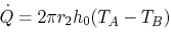
Figure 14: Heat transfer through a pipe

The following inputs are required for the quantitative assessment. The radius of the steel pipe (r₂), the heat transfer coefficient (h₀), the room temperature (T_{A}) and the temperature of the steel (T_{B}).
Table 4: Input parameters
Parameter | X | Units
Outer Diameter | 42 | mm
Inner Diameter | 35.6 | mm
Thickness | 3.20 | mm
Material Density | 7800.00 | kg/m³
Water Density | 1000.00 | kg/m³
Material Specific Heat Capacity | 0.46 | kJ/kg.K
Internal Liquid Specific Heat Capacity | 4.18 | kJ/kg.K
Steel Starting Temperature | 20.00 | °C
Internal Liquid Starting Temperature | 20.00 | °C
External Surface Heat Transfer Coefficient | 0.02 | kW/m²K
Internal Surface Heat Transfer Coefficient | 0.50 | kW/m²K
Time Step Size | 10.00 | Sec
Pipe Volume per unit length | 0.0004 | m³
Pipe Mass per unit length | 3.04 | Kg
Water Volume per unit length | 0.00100 | m³
Water Mass per unit length | 1.00 | kg

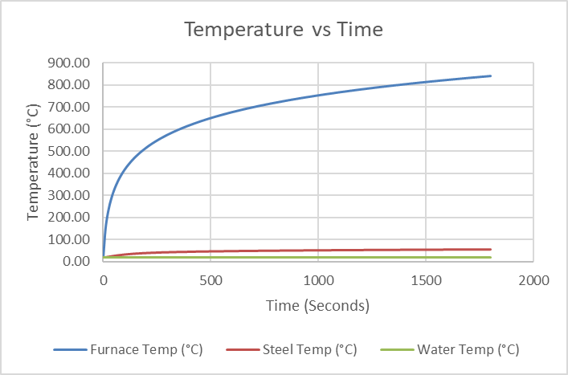
Figure 15: Activated system steel temperature

As shown in Figure 15 the fire parameters are in line with a standard parametric fire curve and when the sprinkler system is activated the temperature of the steel is kept below 80˚C for as long as 60 minutes. The fire properties of the FRL are maintained there is no increased risk of fire spread from a fire in a SOU to the corridor.
Therefore, the assessment has demonstrated that the proposed water filled pipes comply with Performance Requirements C1P2 and C1P8.
Performance solution:
 A2G2(1)(a) or A2.2(1)(a) - Comply with all relevant performance requirements
 A2G2(1)(b) or A2.2(1)(b) - Be at least equivalent to the DtS provisions
Assessment methods:
 A2G2(2)(a) or A2.2(2)(a) - Evidence of suitability
 A2G2(2)(b)(i) or A2.2(2)(b)(i) - Verification methods provided in the NCC
 A2G2(2)(b)(ii) or A2.2(2)(b)(ii) - Other verification methods accepted by the appropriate authority
 A2G2(2)(c) or A2.2(2)(c) - Expert judgement
 A2G2(2)(d) or A2.2(2)(d) - Comparison with the DtS provisions
Assessment approach:
 Comparative  Qualitative  Deterministic
 Absolute  Quantitative  Probabilistic
AFEG sub-systems used in the analysis:
 A – Fire initiation and development and control  D – Fire detection, warning and suppression
 B – Smoke development and spread and control  E – Occupant evacuation and control
 C – Fire spread and impact and control  F – Fire services intervention
Acceptance criteria and factor of safety:
The proposed solution will be deemed as acceptable if it can be demonstrated that the water filled pipes will not result in the spread of fire, given the fact they do not achieve the required insulation rating as per Specification 13.
Fire scenarios and design fire parameters:
The worst-case scenario is considered a sprinkler failure scenario, where there is no running water through the water filled pipes and the unsuppressed fire is able to transfer large amounts of energy via the metal pipe. The heat transfer from SOU to SOU is considered, caused by an unsprinklered 5 MW fire within the residential section of the building.
Describe how fire brigade intervention will be addressed or considered:
Fire brigade impact is considered as negligible, as the water filled pipes are to be shown to not facilitate the spread of fire to the degree necessary.
Verification/validation analyses:
 Sensitivity studies  Redundancy studies  Uncertainty studies  None
The assessment considers sprinkler failure scenarios.
Provide details on proposed modelling/assessment tools:
Excel has been used for the calculation within the solution.
FRNSW Comment: In principle support is provided subject to the following:
- All FRNSW comments be adequately addressed.
- All analysis inputs and assumptions being detailed in the FER and agreed upon by all relevant stakeholders, and the analysis demonstrating compliance with the Performance Requirements of the NCC.

- Title: Omit Fire Hose Reels from Garbage Rooms
Details of departures from DtS provisions:
To omit Fire Hose Reel coverage from the Basement 1 level garbage rooms, based on protection being provided via portable 4.5kg (ABE) Fire Extinguishers.
Applicable DtS provisions (including clause excerpt): | E1D3 | Applicable Performance Requirements: | E1P1
List key fire safety measures:
- 120/120/120 FRL requirement for garbage room bounding construction.
- Garbage chute shafts are to achieve an FRL of 120/120/120.
- Self-closing fire rated door sets to be provided to garbage rooms.
  - Doors to be provided with medium temperature smoke seals are to be capable of resisting smoke at 200°C for up to 30 minutes in accordance with AS1530.7.
- Portable 4.5kg (ABE) fire extinguishers are to be installed in accordance with BCA Clause E1D14 and AS2444-2001 in the same locations as fire hose reels would be required.
- The building is to be sprinkler protected throughout in accordance with AS2118.1-2017 with fast response heads throughout, except where modified in this document.
Proposed performance solution:
BCA Comparison
BCA Clause E1D3 dictates the requirements for the provision of fire hose reels within a building.
Performance Requirement E1P1(a) states a fire hose reel system must be installed to the degree necessary to allow occupants to safely undertake initial attack on a fire appropriate to the size of the fire compartment. (c) states that the fire hose reel system must be appropriate to any other fire safety systems installed in the building.
The intent of Clause E1D3 and performance requirement E1P1 is to provide occupants with the appropriate equipment to allow them to undertake an initial attack on a fire in the early stages of fire growth.
Fire hose reels would be provided in garbage rooms in a DtS design, however it is proposed that portable fire extinguishers replace the need for fire hose reels within the areas highlighted in Figure 16 below. It should be noted that performance requirement E1P1 refers to the provision of fire hose reels, however there is an identical requirement pertaining to the use of portable fire extinguishers (E1P2).
The following proposed solution will demonstrate that the tendency for occupants is to evacuate in the event of a fire scenario, regardless of the presence of either fire hose reels or portable fire extinguishers. The proposed solution will also demonstrate that the provision of portable fire extinguishers, and compliant sprinkler systems within the subject areas is at least equivalent to a DtS design.
Qualitative Assessment
The garbage rooms subject to this Performance Solution are depicted in Figure 16 below.

Figure 16: Location of Garbage Rooms – Basement 1 Plan
Statistics on Occupants Fire-fighting
In order to qualify the risk to occupants, it is important to acknowledge how occupants respond to a fire. Occupants having responded to a fire cue or alarm signal may either decide to evacuate or attempt to fight a fire.
Based on research as discussed by Bryan, a correlation is drawn upon for various occupancy types and the percentage of occupancies in which fire-fighting was utilized. It is evident from the figure below that the use of fire-fighting equipment in buildings other than dwellings and smaller apartments is limited, accounting for less than 5% of incidents.
It should be noted that the figure below represents a total of 64 incidents across all occupancy types listed.
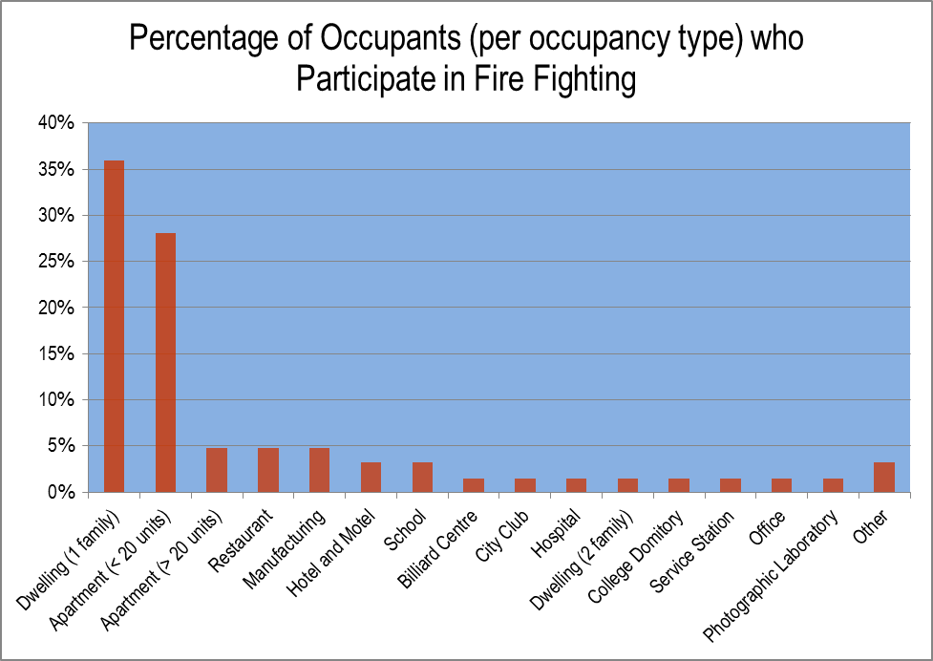
Figure 17 - Occupants who participate in firefighting
Occupants are expected to use fire hose reels when they consider it is safe to do so, in the early stage of a fire development. Therefore, heat and smoke from the fire are expected to be limited when occupants are trying to fight the fire.
Fire hose reels are connected to the water main and therefore supplies an indefinite amount of water. As such, fire hoses provide enough water for extinguishing relatively large fires. On the other side, the amount of extinguishing agent in a portable fire extinguisher is limited and there may be fires that are too large to extinguish with it. If the fire is noticed at an early stage both fire hoses and fire extinguishers provide sufficient means for undertaking an initial attack. If the fire is noticed at a later stage it could have developed to a size where it is beyond the capabilities of a fire extinguisher. A fire hose might be sufficient, but due to the larger fire size the risk to occupants will have increased as well.
It is not considered appropriate under such conditions for occupants to attempt to extinguish such a fire. If the fire is too large to extinguish with a portable extinguisher it is growing at an increasing rate. Due to the fact that occupants are not experienced setting up a fire hose reel there will likely be a time delay before the use can be undertaken; allowing the fire to grow even larger. Even if the amount of water during use is indefinite, occupants will have to fight the fire without any personal protective equipment or breathing apparatus. In addition to heat from the fire and toxic gas, occupants could also be harmed by the steam produced when applying water to the fire.
Therefore, if the fire is too large to extinguish with a portable fire extinguisher, occupants should evacuate the building instead of undertaking an initial attack.
Fire extinguishers complying with Australian Standards are marked with a classification and rating, determined in accordance with the relevant hazard that is likely to be present within the space. These are classified according to Class A through Class F as shown in the table below.
Table 5 - Categories of fire extinguishers
Fire Extinguisher Type | Type of Fire, Class and Suitability
Class A | Wood, paper, plastics, etc.
Class B | Flammable liquids
Class C | Flammable gases
Class D | Metal fires
Class E | Energized electrical equipment
Class F | Cooking oils and fats

Given the nature and use of the garbage room areas, it is reasonable to assume that any occupants residing in the compartment during the early stages of a fire scenario will prioritise evacuation to adjacent safe compartments or out of the building rather than undertaking initial fire-fighting. It is proposed to provide appropriate fire extinguishers and extinguishants in accordance with the Australian Standard AS2444-2001.
Extinguishers also have the benefit of being considerably lighter than fire hose reels, meaning that they can be used by a wider range of building occupants.
Compartment Analysis
The compartments that are the subject of this proposed performance solution are to be used as collection and storage rooms for the garbage chutes serving the residential floors above. In the event of a fire breaking out within the garbage room while there are occupants within the compartment, the presence of fire extinguishers means that occupants will be able to undertake fire fighting procedures in the early stages of fire growth. This is highly unlikely, given the room will be unoccupied for the large majority of the time. Portable fire extinguishers will be sufficient to extinguish a fire in the early stages, and the proposed design is therefore considered at least equivalent to a DtS design in this scenario.
The rooms are expected to be empty for the majority of the time, however. In a worst-case scenario, in which the sprinklers fail to activate, the fire may grow to a large size given the potentially high fuel loads present within the garbage room. It would be hazardous for occupants to attempt to extinguish the fire in this scenario, and are expected to instead emphasise evacuation of the area. Furthermore, should occupants attempt to use the fire hose reel and fail to extinguish the growing flame, the garbage room fire door may be propped open by the hose, potentially allowing for the spread of fire from the garbage room to the surrounding areas. As the absence of fire hose reels removes the potential for this hazard, the proposed design is considered at least equivalent to a DtS design in this scenario also.
Additionally, as per Issue number: 2, the garbage rooms will also be constructed with bounding walls that are rated to 120/120/120. This means that a fire within the garbage room will be contained within the compartment, allowing occupants to safely evacuate from the surrounding areas without being exposed to hazardous egress conditions, further mitigating the risk that an absence of fire hose reels poses.
Conclusion
The proposed solution above will demonstrate that the presence of portable fire extinguishers in lieu of fire hose reels within the garbage rooms, will prove as at least equivalent to DtS provisions. The research discussed above shows that the tendency is for occupants to evacuate instead of undertaking firefighting activities, and that the portable extinguishers will be sufficient to suppress a fire in the early stages of fire growth. Furthermore, the FRL rated bounding walls will contain a fire within the compartment, allowing occupants to safely evacuate. Consequently, the proposed design will be considered as at least equivalent to a DtS design.
Performance solution:
 A2G2(1)(a) or A2.2(1)(a) - Comply with all relevant performance requirements
 A2G2(1)(b) or A2.2(1)(b) - Be at least equivalent to the DtS provisions
Assessment methods:
 A2G2(2)(a) or A2.2(2)(a) - Evidence of suitability
 A2G2(2)(b)(i) or A2.2(2)(b)(i) - Verification methods provided in the NCC
 A2G2(2)(b)(ii) or A2.2(2)(b)(ii) - Other verification methods accepted by the appropriate authority
 A2G2(2)(c) or A2.2(2)(c) - Expert judgement
 A2G2(2)(d) or A2.2(2)(d) - Comparison with the DtS provisions
Assessment approach:
 Comparative  Qualitative  Deterministic
 Absolute  Quantitative  Probabilistic
AFEG sub-systems used in the analysis:
 A – Fire initiation and development and control  D – Fire detection, warning and suppression
 B – Smoke development and spread and control  E – Occupant evacuation and control
 C – Fire spread and impact and control  F – Fire services intervention
Acceptance criteria and factor of safety:
It will be demonstrated that the ability of occupants to extinguish or control a fire in its infancy will not be diminished by the inclusion of fire extinguishers in lieu of Fire Hose Reels.
Fire scenarios and design fire parameters:
A fire within the garbage room is considered.
Describe how fire brigade intervention will be addressed or considered:
Fire brigade intervention is not required to be assessed by performance requirement E1P1, furthermore this performance solution is focused on occupant fire-fighting rather than brigade involvement.
Verification/validation analyses:
 Sensitivity studies  Redundancy studies  Uncertainty studies  None
N/A
Provide details on proposed modelling/assessment tools:
N/A
FRNSW Comment: In principle support is provided subject to the analysis in the FER demonstrating compliance with the performance requirements of the NCC.

- Title: Bathroom Sprinklers – Shower Screen Obstruction
Details of departures from DtS provisions:
Permit reduced sprinkler coverage due to the obstruction of the sprinkler heads by the full height shower door and the screen.
Applicable DtS provisions (including clause excerpt): | E1D4 | Applicable Performance Requirements: | E1P4
List key fire safety measures:
- The building is to be sprinkler protected throughout in accordance with AS2118.1-2017 with fast response heads throughout, except where modified in this document.
Proposed performance solution:
BCA Comparison
BCA Clause E1D4 states that a sprinkler system must be installed in a building or part of a building when required by E1D5 to D1D12 as applicable; and comply with Specification 12 and Specification 18 as applicable.
Performance Requirement E1P4 requires a fire suppression system to be installed to the degree necessary to control the development and spread of fire appropriate to-
(a) the size of the fire compartment; and
(b) the function or use of the building; and
(c) the fire hazard; and
(d) the height of the building.
The intent of these requirements is to provide sprinkler coverage where required in buildings to provide automatic means of suppressing fires in their infancy. It is proposed to omit sprinkler coverage from the shower cubicles within the bathrooms, where the glass shower screen extends from the floor level to the ceiling, preventing sprinkler coverage inside the shower cubicles.
Qualitative Assessment
The scope of the proposed solution applies only to the shower cubicles within bathrooms throughout the development. The sprinkler system provided within the bathrooms is expected to prevent a severe fire from occurring and spreading to other areas of the building. The benefit of a sprinkler system is that it reduces or potentially eliminates the risk of exposing occupants and the Fire Brigade to high temperatures and high levels of toxicity within the building. The FER will provide further information regarding the efficacy of sprinkler systems.
It is proposed to modify the extent of sprinkler protection to bathroom amenities to have sprinkler coverage omitted from the shower cubicles. The reason for requiring sprinklers to be provided throughout the bathroom, and to the shower cubicle is to prevent a fire from spreading.
It is considered that any shortfalls of sprinkler coverage arising from obstruction caused by the shower screens is offset by the low fuel loads within these areas coupled with their use as ‘wet’ areas. Fire hazards within bathrooms are expected to be limited, with showers expected to be constructed with non-combustible materials such as tiles and metal brackets and shower heads etc. Similarly, ignition sources are not expected to be widely present.
The height of the glass doors leading into the showers are provided with the intent of containing shower water within the shower cubicle. As such the showers are wet areas. The SOU’s bathrooms are to be protected with automatic fire sprinklers that provide coverage throughout in accordance AS 2118.1-2017, except where modified in this document. The BCA requires that when a sprinkler system is provided, compliance must be to the Australian Standards.
AS2118.1-2017 Amendment 2 allows a concession for sprinkler coverage to showers, as seen below. It is considered that this is in recognition of the low fire hazard properties of shower cubicles.
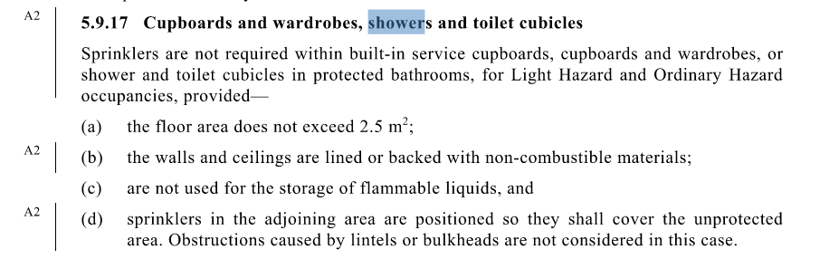
The size of the shower cubicles is currently being designed and ranges from 1.5 m² to 2.5m².
AS 2118.1-2017 requires sprinklers be provided to toilet and bathroom areas. However, comparatively, AS 2118.4-2012 allows for the omission of bathroom sprinklers based on the reasoning that the omission of sprinklers does not increase the risk of flashover (total involvement) in a room/area of fire origin nor decrease the chance for occupants to escape or be evacuated. This is further recognized by NFPA 13, which allows the omission of sprinklers to bathroom areas < 5 m² within dwelling units.
The effects of the shower screen height will have negligible differences in fire development and spread due to the fact that showers are wet areas with the absence of combustible material and fuel loads. In the unlikely event that a fire did start within the shower cubicle, the shower screen glass would shatter allowing the sprinklers to discharge into the shower area and suppress the fire, and in turn activating the alarm.
Conclusion
In summary the intent in providing compliant sprinkler coverage throughout the amenities are to mitigate the risk of fire spread. A fire initiating within the shower areas is expected to be very unlikely due to the limited fuel load within the wet area. The sprinkler coverage provided to the remainder of the bathroom units will prevent the spread of fire. Therefore, it is considered that Performance Requirement E1P4 has been met.
Performance solution:
 A2G2(1)(a) or A2.2(1)(a) - Comply with all relevant performance requirements
 A2G2(1)(b) or A2.2(1)(b) - Be at least equivalent to the DtS provisions
Assessment methods:
 A2G2(2)(a) or A2.2(2)(a) - Evidence of suitability
 A2G2(2)(b)(i) or A2.2(2)(b)(i) - Verification methods provided in the NCC
 A2G2(2)(b)(ii) or A2.2(2)(b)(ii) - Other verification methods accepted by the appropriate authority
 A2G2(2)(c) or A2.2(2)(c) - Expert judgement
 A2G2(2)(d) or A2.2(2)(d) - Comparison with the DtS provisions
Assessment approach:
 Comparative  Qualitative  Deterministic
 Absolute  Quantitative  Probabilistic
AFEG sub-systems used in the analysis:
 A – Fire initiation and development and control  D – Fire detection, warning and suppression
 B – Smoke development and spread and control  E – Occupant evacuation and control
 C – Fire spread and impact and control  F – Fire services intervention
Acceptance criteria and factor of safety:
The acceptance criteria for this Performance Solution is that the omission of compliant sprinkler coverage to the SOU bathroom shower cubicles (defined wet areas only) would not compromise occupant life safety in the building or facilitate the spread of fire.
Fire scenarios and design fire parameters:
The assessment considered as a fire within the bathroom portions of the development.
Describe how fire brigade intervention will be addressed or considered:
As fire spread and impact on occupants is not considered to be impacted by the proposed solution, fire brigade intervention is not considered to be impacted.
Verification/validation analyses:
 Sensitivity studies  Redundancy studies  Uncertainty studies  None
Assessment is qualitative in nature.
Provide details on proposed modelling/assessment tools:
Assessment is qualitative in nature.
FRNSW Comment: In principle support is provided subject to the analysis in the FER demonstrating compliance with the performance requirements of the NCC.

- Title: Extended Travel Distances – Basement
Details of departures from DtS provisions:
It is proposed to permit the following extended travel distances to a point of choice in the basement levels:
- South-eastern corner of the plant/storeroom on Basement Level 2 approximately up to 30 m to a point of choice, and FRNSW Comment: As indicated in Figure 18, it appears to be “south-western corner”. Clarification required.
- South-eastern corner parking bays on Basement Level 1 and Basement Level 2 is approximately up to 21 m to a point of choice.
Furthermore, Permit extended travel distance between alternative exits in the basement in lieu of the DtS limit of 60m:
- Up to 67m in basement 1
- Up to 78m in basement 2
Applicable DtS provisions (including clause excerpt): | D2D5(3)(a), D2D6(c)(iii) | Applicable Performance Requirements: | D1P4, E2P2
List key fire safety measures:
- The building is to be sprinkler protected throughout in accordance with AS2118.1-2017 with fast response heads throughout, except where modified in this document.
- A detection system is to be provided, compliant to AS 1670.1 – 2018 Amendment 1.
- A strobe light is required within the Plant / Store Room in Basement 2 to activate upon activation of the building alarm.
Proposed performance solution:
BCA Comparison
BCA Clause D2D5(3)(a) states that in Class 5, 6, 7, 8 or 9 buildings, no point on a floor must be more than 20 m from an exit, or a point from which travel in different directions to 2 exits is available, in which case the maximum distance to one of those exits must not exceed 40 m.
BCA Clause D2D6(c)(iii) states that exits that are required as alternative means of egress must be not more than 60m apart in Class 7a carpark areas.
The intent of Clause D2D5 is to maximise the safety of occupants by enabling them to be close enough to an exit to safely evacuate. The DtS travel distances are based on an assumption of what is considered “reasonable” distances to be travelled by occupants in reaching an exit.
The intent of Clause D2D6 is to ensure alternative exits are located close enough together such that occupants can evacuate via an alternative exit if one is blocked prior to the onset of untenable conditions.
The risk associated with an increase in travel distance either to an exit or to an alternative exit is that the additional time required for occupants to egress via the extended travel distance may be exposed to untenable conditions during egress.
The assessment demonstrates the proposed design facilitates occupant egress under tenable conditions to a degree at least equivalent to that of a BCA DtS compliant design.
Qualitative Analysis
The assessment herein addresses the non-compliances of extended travel distances to point of choice within the basement levels, which are depicted in the figures below.
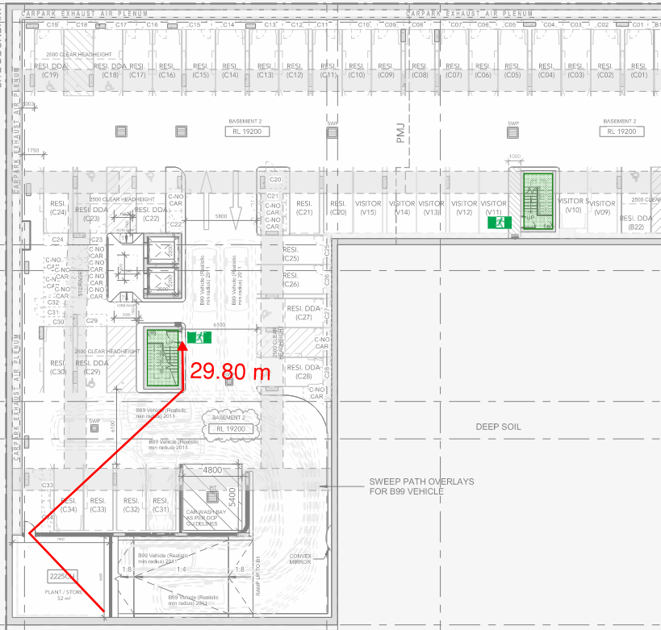
Figure 18: Extended Travel Distance to a Point of Choice – Plant / Store Room – Basement 2

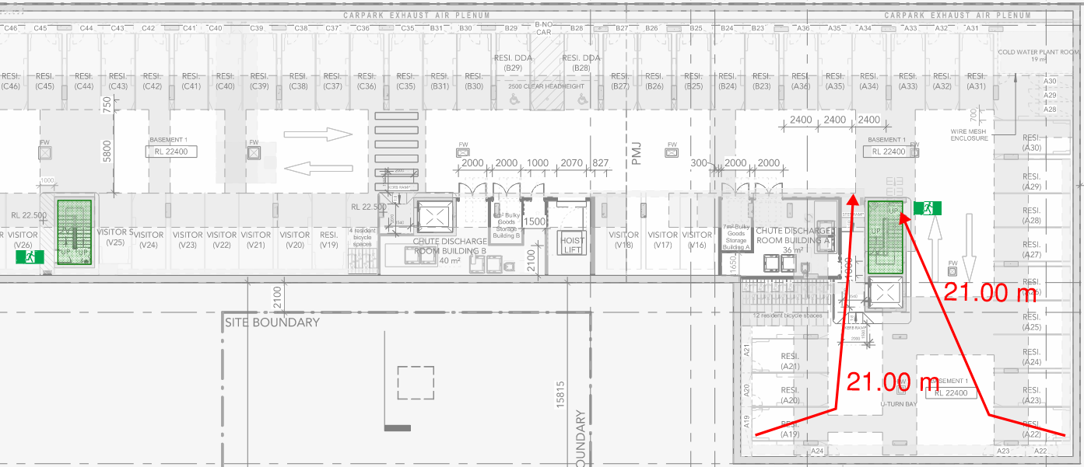
Figure 19: Extended Travel Distance to a Point of Choice – South-eastern end – Basement 1
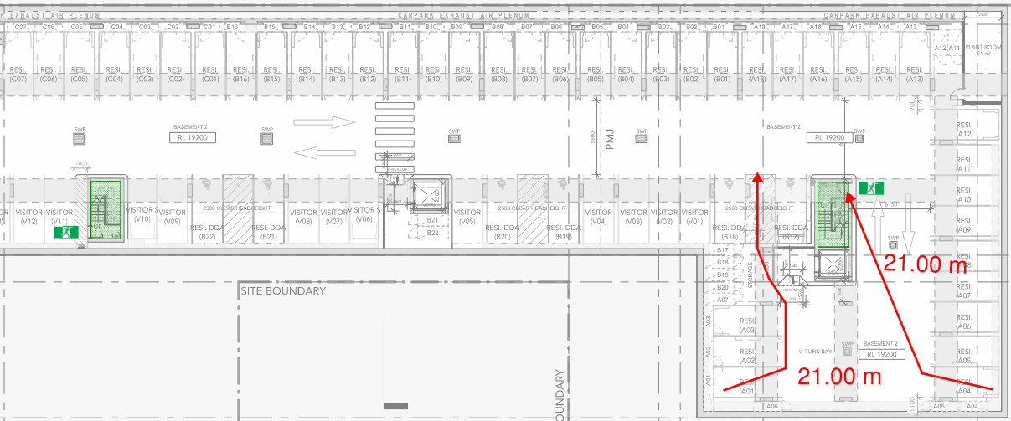
Figure 20: Extended Travel Distance to a Point of Choice – South-eastern end – Basement 2
The assessment herein addresses the non-compliances of extended travel distances to point of choice within the basement levels, which are depicted in the figures below.
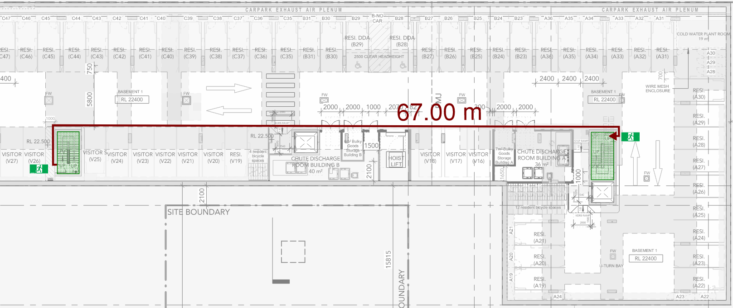
Figure 21: Extended Travel Distance between alternative exits – Basement 1
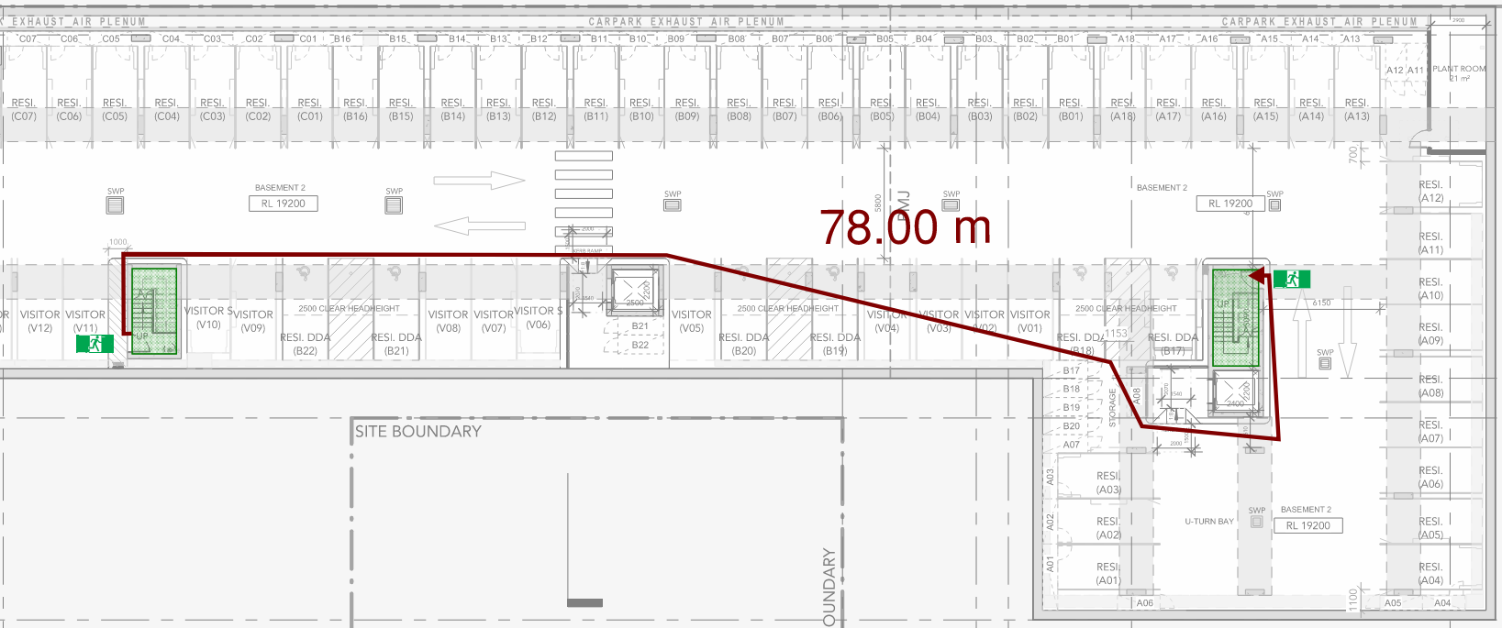
Figure 22: Extended Travel Distance between alternative exits – Basement 2
The analysis herein contains a qualitative analysis section which discusses the benefits of fast response sprinkler heads, the statistics of fires in carparks, and the open design of the subject carpark. The quantitative analysis section describes the RSET analysis with the intent to show that the proposed fast response sprinkler system provides earlier detection time such that the egress time is less than or equivalent to a DtS design where standard response sprinkler heads provide the activation time.
Benefits of Sprinklers
The space is to be provided with sprinkler protection throughout in accordance with AS 2118.1-2017 with fast response heads throughout. In the event of a fire, the sprinkler system is expected to control, if not suppress the fire. The sprinkler system acts to cool the upper smoke layer and wet adjacent combustibles and partitions helping to prevent the fire from spreading beyond the area of origin. The reliability and efficacy of sprinkler systems has been well researched.
Statistics from the National Fire Protection Association (NFPA), as published by Hall , provides recorded statistics on buildings fitted with automatic fire sprinkler systems between the years 2003-2007 in the United States. Based on the NFPA data, when sprinklers operate, they are effective 97 % of the time, resulting in a combined performance of operating effectively in 89 % of all reported fires where sprinklers were present in the fire area and the fire was large enough to activate them. The reliability of sprinkler system in Australia and New Zealand is generally significantly higher than in the US as researched by Marryatt . The FER will contain further details of sprinkler system performance.
Furthermore, by controlling the fire size, smoke produced is also reduced. Hence the provision of sprinklers in a building enhances life safety, property protection and fire brigade intervention. Where the sprinkler system operates successfully, the risk to occupants, fire brigade, and building property is significantly reduced. The high reliability and efficiency of fire sprinklers is also supported by fire tests and statistics on structural building fires.
Benefits of Sprinklers – Travel Distance
The benefits of sprinklers are recognized by many international building codes by providing a range of concessions when sprinklers are provided. Many of these include an allowance to increase the travel distance when sprinklers are provided. A comparative study has been undertaken on the travel distance limitations contained within various building codes and standards. The findings are presented below.
Table 6: Comparison of single exit travel distance provisions in a sample of international building codes demonstrating extended travel distance allowances when sprinklers are provided
Building Code | Maximum allowable travel distance to a single exit or POC |  |  | Allowable increase for sprinklers (%)
 | No sprinkler protection | Sprinkler protection
Australia – BCA | 20 |  | 20 | 0
US – NFPA 101 (2009) | 23 |  | 30 | 30
UK – Building Regulations 2000 | 18 |  | 18 | 0
BS 9999 (Risk profile B2) | 20 |  | 24 | 20
New Zealand – C/AS7 (2014) | 45 |  | 70 | 55
New Zealand – C/AS4 (2014) | 20 |  | 40 | 100
Table 7: Comparison of maximum travel distance to the nearest exit provisions in a sample of international building codes demonstrating extended travel distance allowances when sprinklers are provided
Building Code | Maximum allowable travel distance to the nearest exit of alternative exits |  |  | Allowable increase for sprinklers (%)
 | No sprinkler protection | Sprinkler protection
Australia – BCA | 40 |  | 40 | 0
US – NFPA 101 (2009) | 60 |  | 91 | 50
UK – Building Regulations 2000 | 45 |  | 45 | 0
BS 9999 (Risk profile B2) | 50 |  | 60 | 20
New Zealand – C/AS7 (2014) | 110 |  | 180 | 63
New Zealand – C/AS4 (2014) | 50 |  | 100 | 100
The tables above demonstrate that up to 100% travel distance increases are allowed by some building codes in recognition of the efficacy of sprinklers. It should however be noted that a direct comparison between the absolute travel distances are not appropriate as the overall fire safety measure provisions and the ways that travel distances are measured could vary between the codes. However, the principle of allowing an increase when sprinklers are provided is clearly demonstrated.
Alternative Exits
Despite the extended distance within the car park basement levels, occupants within this area have a point of choice almost everywhere within the floorplate. Therefore, in the event of a fire blocking their path to an exit, occupants are quickly able to choose an alternative path of travel. The assessment herein addresses the areas of the carpark where a choice in egress direction is not provided.
Ease of way-finding
Despite the extended travel distance to an exit, occupants of the car park are in sight of the exit for the majority of their travel. This ease of way-finding will greatly speed up evacuation time as unlike many exit paths, the exit can be seen by occupants early on. Occupants will therefore be expected to be able to safely evacuate despite the extended travel distance.
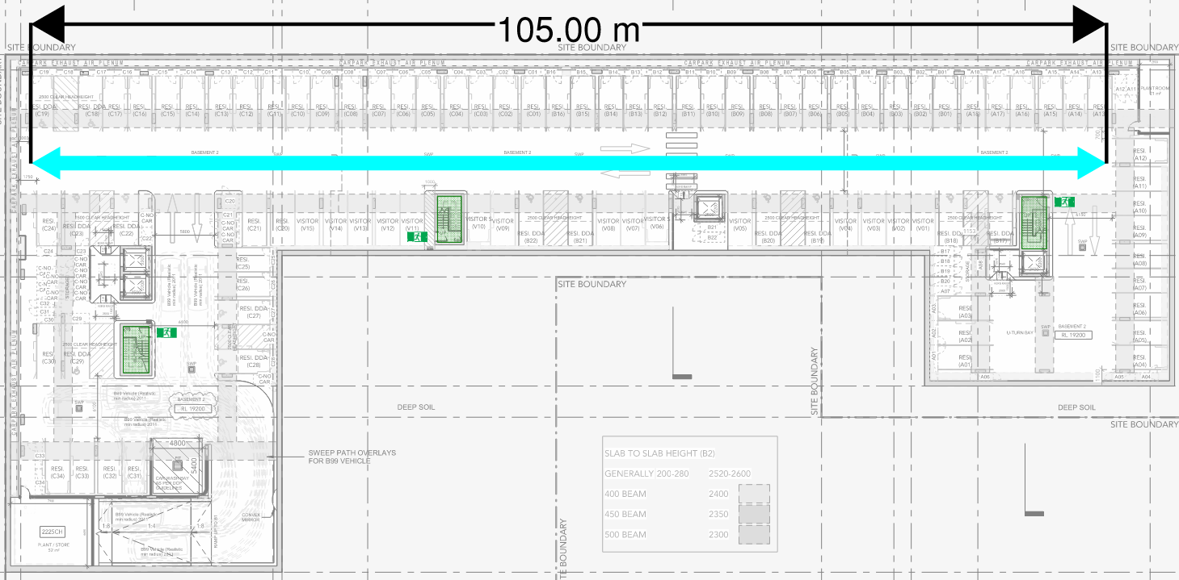
Figure 23: Carpark Lines of Sight – Basement 2 Indicative
Plant / Store Room – Basement 2
The extended travel distance from the plant / store room on Basement 2 is proposed to be qualitatively justified by the following:
- Maintenance personnel
- Strobe light for reduced pre-movement time
- Sprinkler activation inside store room is faster given the size of the room
- Three staircases in lieu of 2 serving floor plate.
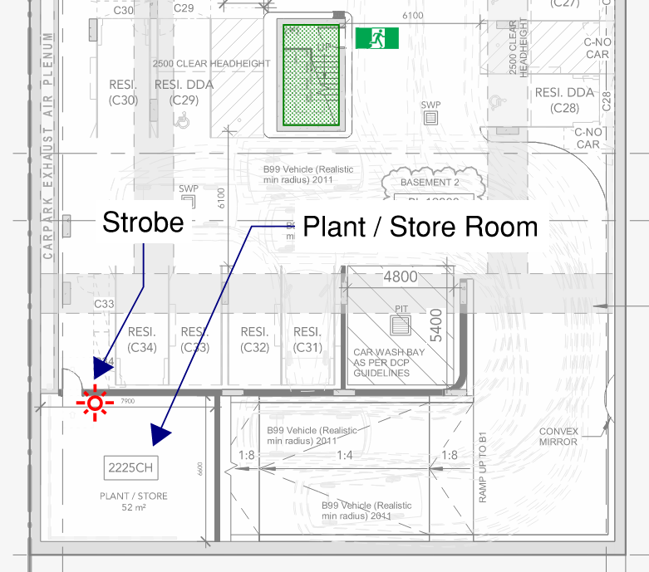
Figure 24: Carpark Lines of Sight – Basement 2 Indicative
Quantitative Analysis
The quantitative analysis will address the worst-case extended travel distance via a point of choice against a DtS compliant distance in Basement 2. The proposed building will be compared with an almost identical BCA DtS design but with the following differences in the design:
- Compliant travel distance to reach an alternative exit after discovering the first exit was blocked (40 m + 60 m = 100 m) compared with the proposed design (40 + 78m = 118 m). Note that the alternative exits on the western side of the carpark are connected via a compliant travel distance, and the eastern side of the carpark is not served by an extended travel distance to an exit.
- 3m x 4m standard response sprinkler heads system in the BCA DtS compliant design.
- 3m x 4m fast response sprinkler heads system in the proposed design.
Travel time comparison to a DtS Compliant Building
The maximum travel distance for occupants in the proposed building is up to 118 m instead of the permissible 100 m.
Based on guidance given in Section 8.6 of the DFES BEB Guideline No: GL-15 a travel speed of 0.93 m/s for fully mobile persons (movement speed on level travel) and 0.8 m/s for people with mobility difficulties should be used. For robustness in the design, the unimpeded walking speed of a person has been taken as 0.8 m/s to assess travel time (to allow for all anticipated occupants of the development).
Hence the delay in evacuation in the proposed building without any additional fire safety measure is a further 15 s between exits compared to a DtS compliant design as demonstrated in the table below.
Table 8: Travel Time comparison to DtS arrangement
Travel Distance review | Distance Between Exits
 | DtS Design | Proposed Design
Travel Distance | 100 m | 118
Travel Time (0.8 m/s) | 125 s | 147.5 s

The building is to be provided with a performance-based sprinkler system with fast response heads, that will activate sooner in the event of a fire. The inclusion of the performance-based sprinkler system to the basement levels contributes to providing early warning of a fire to offset the extended travel distance.
RSET Analysis
The proposed design will be analysed by comparing the difference in the Required Safe Egress Time (RSET) to a DtS compliant design. The RSET is the time it takes for all occupants to evacuate a building to a place of safety, therefore minimising the RSET is key in providing life safety. The components of RSET are shown in the figure below.
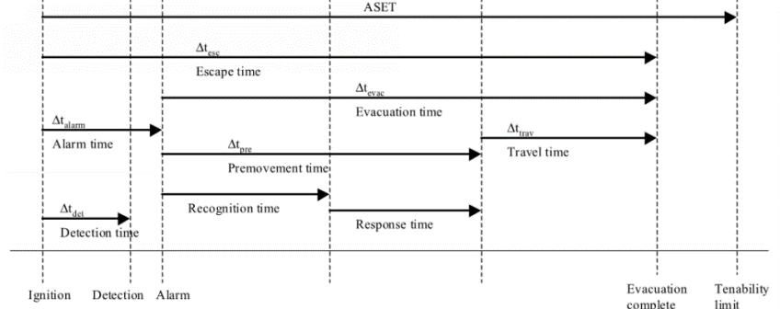
Figure 25: RSET components
The RSET, which is referred to as the escape time in the figure above is the sum of the following.
RSET = Detection time + Alarm time + Pre-movement time + Travel time
The time to activate the alarm (alarm time), is insignificant
Alarm time = Detection time
The proposed design with the provision of a sprinkler system with fast response heads is compared against a BCA DtS design with standard response heads will provide the means for detection and alarm activation. Both scenarios use a fast growth rate fire, fuel height of 0.5 m and a ceiling height of 2.7 m.
The table below details the fire size at sprinkler activation. Sprinkler activation has been determined by Alperts Ceiling Jet Correlation, based on sprinkler data provided for standard response heads and fast response heads contained in Verification Method C/VM2.
Table 9: Fire size assessment
Comparison | RTI  $$\sqrt{ms}$$ | Conductance | Detection time | Fire size at sprinkler activation
Proposed Sprinkler system (fast response heads) | 50 | 0.65 | 126.5 sec | 750 kW
BCA Sprinkler system (standard response heads) | 135 | 0.85 | 163 sec | 1246 kW
As seen in the table above, the fire size at the time of sprinkler activation is substantially smaller in the proposed design compared to the DtS design. Reduced fire size corresponds to reduced smoke and heat development in the space. As such, risks incurred by the extended travel distance is largely offset by the fast response sprinkler system.
The table below summarises the RSET comparison. The pre-movement time is considered the same in both cases and is discarded from the calculation. The detection time is taken as the sprinkler activation time given that the detection system activates the sprinkler system in the proposed design.
Table 10: RSET comparison
Comparison | Travel time (sec) | Sprinkler Activation Time (sec) | RSET (sec)
Proposed design | 147.5 | 126.5 | 288
DtS Design | 125 | 163 | 274

Conclusion
It can be seen that the RSET of the proposed design is less than the RSET of a DtS compliant design, meaning that occupants require less time to evacuate than in a DtS design. The analysis herein met the acceptance criteria for the worst-case scenario and as such will meet the acceptance criteria for all the extended travel distances listed above. Furthermore, the qualitative assessment above has demonstrated the provision of alternative exits, ease of wayfinding, and fire safety measures within the plant room result in occupants being provided the opportunity to egress under tenable conditions. Therefore, Performance Requirements D1P4 and E2P2 are seen to be met throughout the basement levels.
Performance solution:
 A2G2(1)(a) or A2.2(1)(a) - Comply with all relevant performance requirements
 A2G2(1)(b) or A2.2(1)(b) - Be at least equivalent to the DtS provisions
Assessment methods:
 A2G2(2)(a) or A2.2(2)(a) - Evidence of suitability
 A2G2(2)(b)(i) or A2.2(2)(b)(i) - Verification methods provided in the NCC
 A2G2(2)(b)(ii) or A2.2(2)(b)(ii) - Other verification methods accepted by the appropriate authority
 A2G2(2)(c) or A2.2(2)(c) - Expert judgement
 A2G2(2)(d) or A2.2(2)(d) - Comparison with the DtS provisions
Assessment approach:
 Comparative  Qualitative  Deterministic
 Absolute  Quantitative  Probabilistic
AFEG sub-systems used in the analysis:
 A – Fire initiation and development and control  D – Fire detection, warning and suppression
 B – Smoke development and spread and control  E – Occupant evacuation and control
 C – Fire spread and impact and control  F – Fire services intervention
Acceptance criteria and factor of safety:
The Fire Engineering Assessment undertaken will demonstrate that the extended travel distances within car parking areas do not increase the risk of safe evacuation of occupants, nor compromise the evacuation route.
The quantitative acceptance criteria are as follows: RSET (Proposed) ≤ RSET (BCA DtS)
The analysis compared the proposed design against a BCA DtS design where the detection time is reliant on sprinkler activation with standard response heads.
Fire scenarios and design fire parameters:
The assessment considers a fire within the basement car park.
For the quantitative assessment, a fast growth rate t² fire will be used to determine the time taken for sprinkler activation to occur.
Describe how fire brigade intervention will be addressed or considered:
As it has been demonstrated that occupants are provided with the opportunity to egress under tenable conditions, it is considered that the proposed design does not impact fire brigade intervention. The attending brigade will access the basement carpark via the fire stairs serving the basement.
Verification/validation analyses:
 Sensitivity studies  Redundancy studies  Uncertainty studies  None
Fast growth rate fire considered which is more conservative and reduces the margin between activation times compared.
Provide details on proposed modelling/assessment tools:
Sprinkler activation calculations will be undertaken using Alpert’s ceiling jet correlation.
FRNSW Comment: In principle support is provided subject to all analysis inputs and assumptions being detailed in the FER and agreed upon by all relevant stakeholders, and the analysis demonstrating compliance with the Performance Requirements of the NCC.

- Title: Extended Travel Distance to a Point of Choice - Residential
Details of departures from DtS provisions:
Proposed to permit the following extended travel distances from residential SOU entry doors to a point of choice, in lieu of the DtS limit of 6 m:
- Building B – Eastern SOU entry door is approximately 7 m to an exit.
- Building C – South-western SOU entry door, approximately 9 m to an exit.
Applicable DtS provisions (including clause excerpt): | D2D5(1)(a)(i)  (see clause excerpt below) | Applicable Performance Requirements: | D1P4, E2P2
List key fire safety measures:
- The building is to be sprinkler protected throughout in accordance with AS2118.1-2017 with fast response heads throughout, except where modified in this document.
- A detection system is to be provided, compliant to AS 1670.1 – 2018 Amendment 1.
  - Additional smoke detectors will be located in public corridors throughout.
- Thermal detectors will be provided within SOUs, connected to the AS 1670.1 detection system.
- Provide all doors serving public corridor with medium temperature smoke seals, capable of withstanding temperatures of 200°C for 30 minutes and tested in accordance with AS 1530.7. The doors are to be self-closing -/60/30 fire rated door sets.
- Management in use provision to maintain the residential corridors as sterile spaces not for the storage of materials will be developed.
  - The residential corridors and lobbies are to be kept free of material storage. This requirement shall be listed as an essential Fire Safety measure in the building’s management in use plan. Signage is to be installed stating “No Combustible Materials” or similar. The lettering is to be at least 25mm high and of a colour contrasting the background.
  - Linings within public corridors are to achieve Group 1 ratings.
- An enhanced EWIS will be provided, increasing the reliability of audible alarms to sleeping occupants.
FRNSW Comment: Additional information should be provided to clarify what enhancement is provided to the EWIS system.
- Illuminated wayfinding and exit signage is to be provided to residential corridors throughout the development.
Proposed performance solution:
BCA Comparison
BCA Clause D2D5(1)(a)(i) states that in Class 2 and 3 buildings the entrance doorway of any sole-occupancy unit must be not more than 6 m from an exit or from a point from which travel in different directions to 2 exits is available.
The intent of Clause D2D5 is to maximise the safety of occupants by enabling them to be close enough to an exit to safely evacuate. The DtS travel distances are based on an assumption of what is considered “reasonable” distances to be travelled by occupants in reaching an exit.
The risk associated with an increase in travel distance either to an exit or to an alternative exit is that occupants who may be asleep/unconscious at the time of alarm may be unable to evacuate before conditions become untenable.
The assessment demonstrates the proposed design facilitates occupant egress under tenable conditions to a degree at least equivalent to that of a BCA DtS compliant design.
Qualitative Analysis
The assessment herein addresses the non-compliances of extended travel distances to an exit, which are depicted in Figure 26 and Figure 27 below.
It is considered that Building B represents the worst-case assessment, given that the tower has both a single exit on Levels 6 and 7 as addressed in Issue number: 18, and extended travel distances addressed herein. It is therefore considered that by demonstrating that the proposed design of Building B facilitates occupant evacuation and fire brigade intervention to the degree necessary, the remaining towers are also demonstrated to meet the acceptance criteria.
FRNSW Comment: FRNSW considers that the extended travel distances in both Building B and Building C should be assessed. It is considered that the egress provisions of Building B are not representative of Building C.
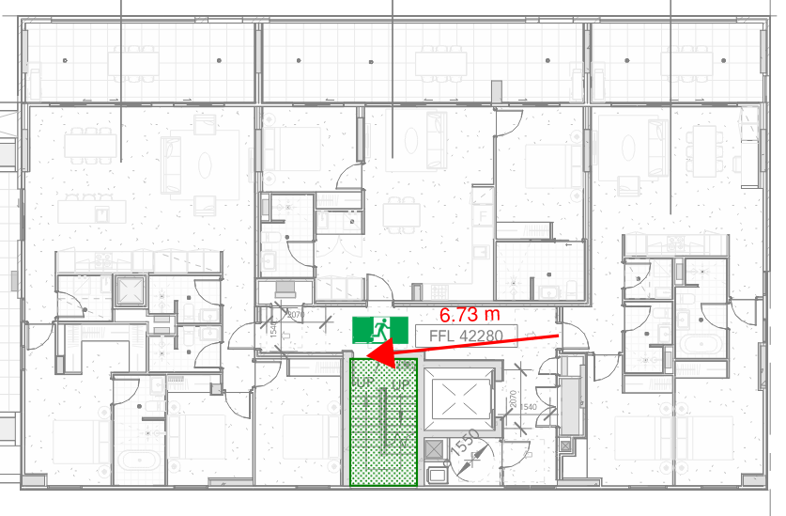
Figure 26: Extended Travel Distance from an SOU - Building B – Level 6 indicative

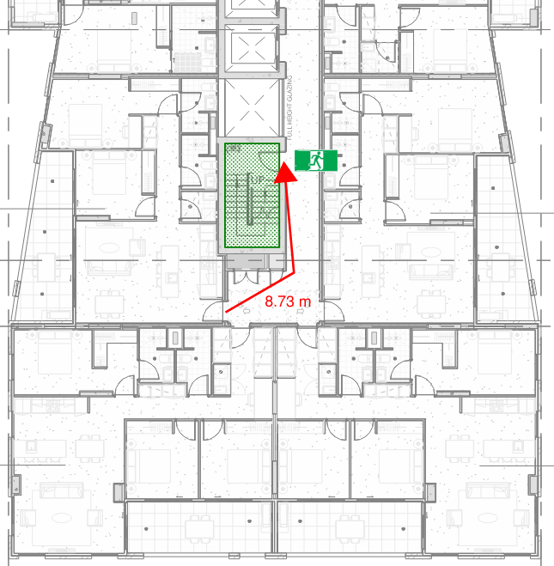
Figure 27: Extended Travel Distance from an SOU - Building C – Level 3 indicative
Corridor Tenability
The intent of the BCA Clause D2D5 is to limit maximum travel distances within a building to an exit in order to maximise occupant safety, allowing them enough time to egress a building safely in the event of a fire.
In the unlikely event of a fire it is considered that heat and smoke will be adequately limited within the corridor due to the provision of fire and smoke seals and increased corridor volume. In comparison with a DtS design, the proposed design offers either an equivalent or higher level of tenability within the corridor. This has been demonstrated by quantitative analysis within Issue number: 18. FRNSW Comment: FRNSW notes that there is no quantitative analysis being undertaken in Issue #18. Clarification required.
The primary use of the corridors is for the circulation of occupants, and is therefore expected to have low fuel loads. The low hazard nature of the egress path implies a low danger to occupants in the event of a fire. In the event of a fire it is extremely unlikely that a significant hazard will be present in the corridor area, as this area consists of minimal combustible fuels. It is more likely that a fire will occur inside an SOU adjoining the corridor. This will be enforced by a management in use provision to require the residential corridors to be sterile spaces not for the storage of combustible materials throughout the development.
It is considered a more likely fire scenario is a fire inside one of the residential SOUs served by the residential corridors. A fire is expected to be contained within the apartment of fire origin due to protection by bounding walls, achieving an FRL as per the DtS provisions. Therefore, the corridor bounding construction is expected to withstand the typical fire scenarios in an SOU and provide adequate time for occupants to egress from the building and for FRNSW to safely access the level of fire origin.
In addition to the bounding construction provided, all SOU and fire stair entry doors are provided with medium temperature smoke seals capable of resisting smoke at 200°C for up to 30 minutes in accordance with AS1530.7. The provision of the fire and smoke separation is expected to significantly reduce fire spread and smoke leakage into the common corridors, ensuring they remain tenable for longer periods of time in comparison with a DtS compliant design. This has been demonstrated by quantitative analysis within Issue number: 18.
Furthermore, the corridors are to be provided with additional smoke detectors will be located in public corridors throughout. Thermal detectors will be provided within SOUs, connected to the AS 1670.1 detection system. An enhanced EWIS will be provided, increasing the reliability of audible alarms to sleeping occupants. These measures will ensure that in the unlikely event of a fire, the fire is detected in its early stages and occupants are adequately alerted to the fire scenario.
Occupant Familiarity
As the building is a residential development, occupants are expected to be owner-occupier or long-term tenants, therefore it is expected that occupants will be familiar with the building layout and the alternative egress routes available.
According to the literature reviews by the Society of Fire Protection Engineers (SFPE) into human behaviour in a fire, the familiarity of occupants within the proposed development and its fire safety systems is an important factor in analysing the occupant response and use of route in evacuating the building in a fire event. Based on these research studies, the frequent users of a building may have a complete knowledge of the nearest and alternative egress routes and warning systems. Therefore, it is expected that no major delay would occur for occupants to make their way to the exit, minimising the detriment of the extended travel distance.
The public corridor serving the residential levels being part of the egress route, it is not expected that combustible items shall be present with the possible exception of building materials such as linings. This sterile path of travel is not likely to exacerbate the tenability levels for evacuating occupants. The low probability of a fire occurring within these areas can further be supported by a report conducted by the National Fire Protection Association (Ahrens, 2013), which states that between 2000 and 2004; 42% of 380,000 fires occurring in apartment structures in the aforementioned period were recorded to have occurred within the kitchen.
A study of fires in the U.S.A. (Ahrens, 2013) indicates that apartment fires most commonly originate in kitchens, bedrooms and living spaces (refer to Figure 28). From this information, it is significantly more likely that a fire will begin in an apartment rather than the corridor and therefore the fire and smoke conditions in the corridor shall be limited by the entrance doors to all apartments.
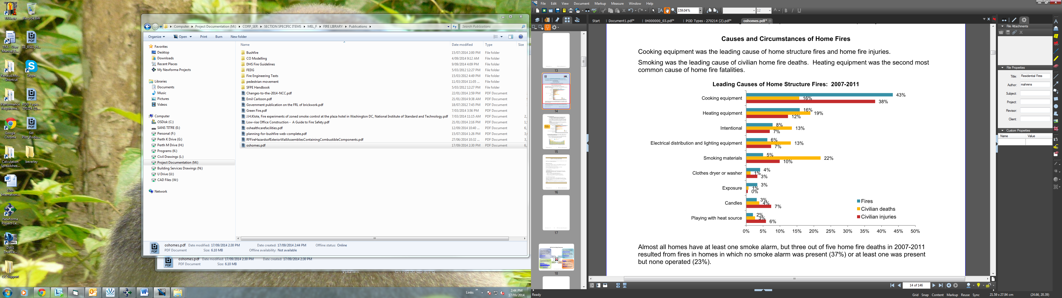
Figure 28: Leading causes of home structure fires, U.S fire statistics (Ahrens, 2013)

Conclusion
The assessment in the FER will demonstrate that the proposed design with non-compliances of extended travel distances will not impede occupant evacuation and fire brigade intervention. This has been demonstrated with quantitative analysis within Issue number: 18, which has compared the smoke leakage rates between the proposed design and a DtS design. The assessment has shown that the additional fire safety provisions facilitate corridor tenability and occupant egress under tenability conditions that are better than a DtS design. Furthermore, the assessment has demonstrated that fire spread is adequately limited by the proposed design. Therefore, the assessment is considered to meet the acceptance criteria.
Performance solution:
 A2G2(1)(a) or A2.2(1)(a) - Comply with all relevant performance requirements
 A2G2(1)(b) or A2.2(1)(b) - Be at least equivalent to the DtS provisions
Assessment methods:
 A2G2(2)(a) or A2.2(2)(a) - Evidence of suitability
 A2G2(2)(b)(i) or A2.2(2)(b)(i) - Verification methods provided in the NCC
 A2G2(2)(b)(ii) or A2.2(2)(b)(ii) - Other verification methods accepted by the appropriate authority
 A2G2(2)(c) or A2.2(2)(c) - Expert judgement
 A2G2(2)(d) or A2.2(2)(d) - Comparison with the DtS provisions
Assessment approach:
 Comparative  Qualitative  Deterministic
 Absolute  Quantitative  Probabilistic
AFEG sub-systems used in the analysis:
 A – Fire initiation and development and control  D – Fire detection, warning and suppression
 B – Smoke development and spread and control  E – Occupant evacuation and control
 C – Fire spread and impact and control  F – Fire services intervention
Acceptance criteria and factor of safety:
The Performance Solution will be deemed to have satisfied the Performance Requirements if it is demonstrated through a quantitative assessment that occupant egress and fire brigade intervention is facilitated to a degree better than or at least equivalent to that of a BCA DtS compliant design.
Fire scenarios and design fire parameters:
The assessment considers fire scenarios in the residential corridors and the SOUs served by the corridors.
Describe how fire brigade intervention will be addressed or considered:
By demonstrating quantitatively that smoke spread to the corridors is limited to a degree better than or at least equivalent to that of a BCA DtS compliant design, it is considered that fire brigade access would be safely facilitated to a similar degree.
Verification/validation analyses:
 Sensitivity studies  Redundancy studies  Uncertainty studies  None
See quantitative analysis within Issue number: 18.
Provide details on proposed modelling/assessment tools:
See quantitative analysis within Issue number: 8.
FRNSW Comment: In principle support is provided subject to the following:
- All FRNSW comments be adequately addressed.
- All analysis inputs and assumptions being detailed in the FER and agreed upon by all relevant stakeholders, and the analysis demonstrating compliance with the Performance Requirements of the NCC.

- Title: Travel Distance between Alternative Exits - Residential
Details of departures from DtS provisions:
Permit the distance between the following alternative exits (scissor stairs) to be less than 9 m in accordance with BCA Clause D2D6(b):
- Building A Levels 2 – 7 will be a minimum of 8 m apart.
- Building C Levels 2 – 10 will be a minimum of 5 m apart.
Applicable DtS provisions (including clause excerpt): | D2D6(b) | Applicable Performance Requirements: | D1P4, E2P2
List key fire safety measures:
- The building is to be sprinkler protected throughout in accordance with AS2118.1-2017 with fast response heads throughout, except where modified in this document.
- Thermal detectors are to be located with 1.5 m of the SOU and service room entry doors in accordance with AS 1670.1-2018.
- Lining materials serving the public corridors are to meet the requirements of Group 1 materials.
- Management in use requirement is to be developed to maintain the public corridors as sterile spaces and not permitted to be used for the storage of combustible items.
  - Signage is to be provided within the public corridor stating: “NO STORAGE THROUGHOUT THIS AREA”. The signage is to be at a height of 1.75 – 2 m FFL, with the wording not less than 20 mm high on a colour contrasting background. This is to be noted in the fire safety schedule.
- Provide all doors serving public corridor with medium temperature smoke seals, capable of withstanding temperatures of 200°C for 30 minutes and tested in accordance with AS 1530.7.
Proposed performance solution:
BCA Comparison
BCA Clause D2D6 states;
“Exits that are required as an alternative means of egress must be not less than 9m apart”.
The BCA guide states that the intent of D2D6 is to minimise the risk of a single fire blocking both fire exits.
Performance requirement D1P4 states that exits must be provided from a building to allow occupants to evacuate safely with regards to their number, location and dimensions.
Performance requirement E2P2 states that the conditions in any evacuation route must be maintained as to facilitate the safe evacuation from the building in the event of a fire.
The intent of these performance requirements is to afford occupants a safe evacuation route from the building at all times, without being exposed to untenable egress conditions. The proposed solution will demonstrate that the fire doors are located within an area of low fire hazard, which offsets the risk associated with the reduced distance between alternative exits.
Qualitative Assessment
The following performance solution will show that the building will, to the degree necessary, avoid the risk of fire spreading to block the alternative exit. This will be achieved by assessing fire scenarios that have the potential to block alternative exits. The non-compliance arises at the scissor stairs serving Building A and Building C, as seen in Figure 29 and Figure 30 below.
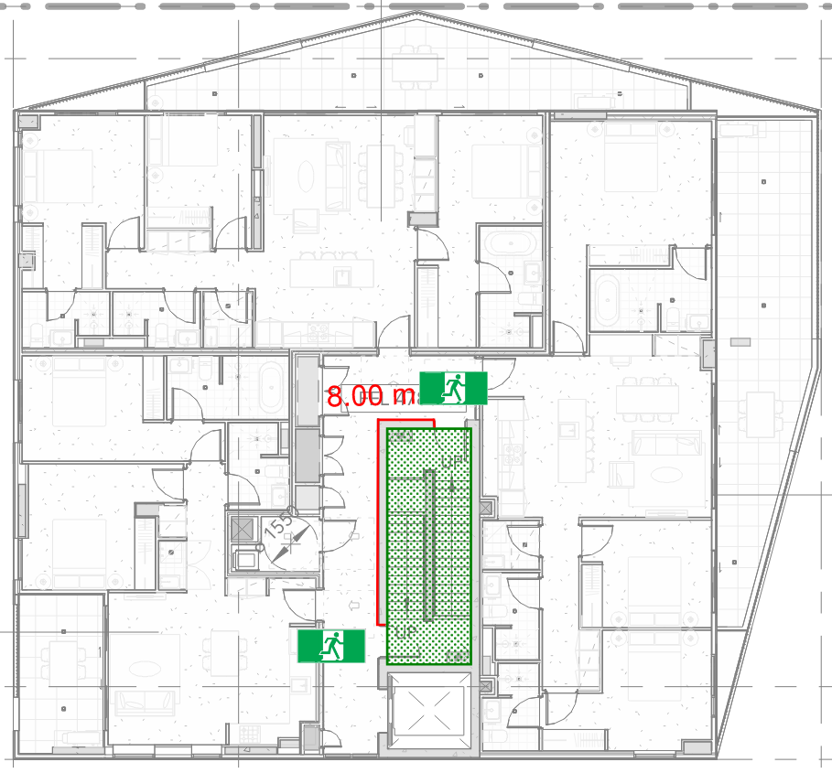
Figure 29: Non-compliant distance between alternate exits – Scissor stairs – Building A Level 7 Indicative

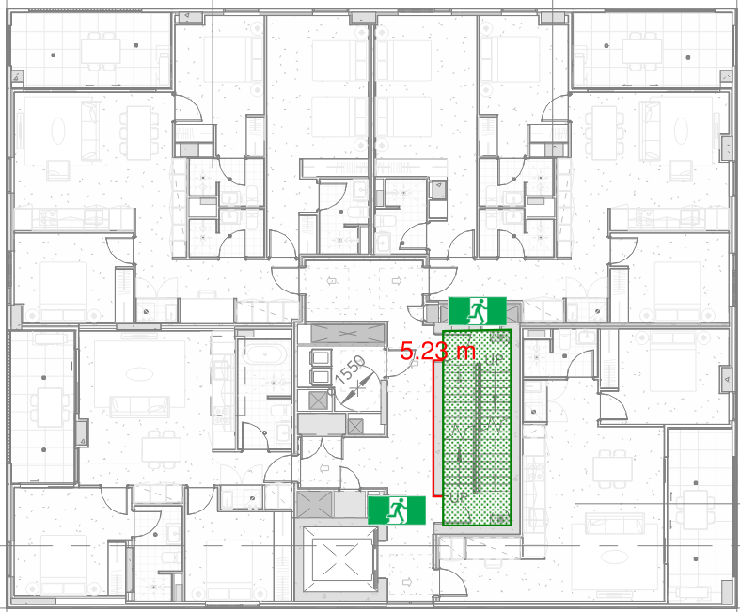
Figure 30: Non-compliant distance between alternate exits – Scissor stairs – Building C Level 9 Indicative

Issue number: 17 contains additional discussion regarding the fire safety measures proposed to serve the residential corridors throughout, and quantitative assessment on the efficacy of smoke seals.
The corridor in which the non-compliant fire stair doors are located is a space used primarily for occupant thoroughfare, and therefore will be a space of low fuel load. In order to ensure that the fuel load within the corridor is kept at a minimum at all times, a management in use requirement is to be developed to maintain the residential/hotel corridors as sterile spaces and not permitted to be used for the storage of combustible items. The corridors are also to be compliantly sprinkler protected with fast response heads, meaning that in the event of a fire starting within the corridor space, it will not quickly grow to a size that blocks the fire stair doors, allowing occupants to evacuate from the area before untenable egress conditions arise. In the highly unlikely event of sprinkler failure, the fuel load restrictions will limit the growth of the fire, minimising the risk of a single fire within the corridor from blocking both exits.
This will be supported by a Management in use requirement to be developed to maintain the public corridors as sterile spaces and not permitted to be used for the storage of combustible items. Signage is to be provided within the public corridor stating: “NO STORAGE THROUGHOUT THIS AREA”. The signage is to be at a height of 1.75 – 2 m FFL, with the wording not less than 20 mm high on a colour contrasting background. This is to be noted in the fire safety schedule.
A fire within one of the surrounding SOUs is the more likely fire scenario however, given the larger fuel load within the units. The unit entry doors are fire rated as per BCA requirements, and as a further provision are to be installed with medium temperature smoke seals, which will mitigate the risk of fire and smoke spreading from one of the SOUs into the public corridor. Issue number: 17 contains supporting quantitative analysis which demonstrates that the smoke seals provide an additional level of safety over a DtS design. The risk of this fire and smoke blocking both doors into the fire stairs is considered sufficiently mitigated by the provisions described above, to a level where compliance with the relevant performance requirements has been met.

Conclusion
The proposed performance solution will demonstrate that the risk of a single fire blocking both entrances into the fire stairs is sufficiently mitigated by the sprinkler system within the corridor, the restriction of fuel load (achieved by maintaining the corridor as a sterile space and signage), and the SOU fire rated and smoke sealed doors. Consequently, compliance with performance requirements D1P4 and E2P2 is deemed as having been met.
Performance solution:
 A2G2(1)(a) or A2.2(1)(a) - Comply with all relevant performance requirements
 A2G2(1)(b) or A2.2(1)(b) - Be at least equivalent to the DtS provisions
Assessment methods:
 A2G2(2)(a) or A2.2(2)(a) - Evidence of suitability
 A2G2(2)(b)(i) or A2.2(2)(b)(i) - Verification methods provided in the NCC
 A2G2(2)(b)(ii) or A2.2(2)(b)(ii) - Other verification methods accepted by the appropriate authority
 A2G2(2)(c) or A2.2(2)(c) - Expert judgement
 A2G2(2)(d) or A2.2(2)(d) - Comparison with the DtS provisions
Assessment approach:
 Comparative  Qualitative  Deterministic
 Absolute  Quantitative  Probabilistic
AFEG sub-systems used in the analysis:
 A – Fire initiation and development and control  D – Fire detection, warning and suppression
 B – Smoke development and spread and control  E – Occupant evacuation and control
 C – Fire spread and impact and control  F – Fire services intervention
Acceptance criteria and factor of safety:
The performance solution will meet the acceptance criteria if it can be demonstrated that the risk of a single fire blocking both doors into the fire stairs is sufficiently mitigated.
Fire scenarios and design fire parameters:
- A fire in the public corridor
- A fire within an apartment spreading to the public corridor
Describe how fire brigade intervention will be addressed or considered:
Fire brigade intervention is not considered to be impacted, as the proposed solution will demonstrate that the proposed design will not impede the ability of the occupants to evacuate from the building. As such, the fire brigade will not be faced with the rescue of trapped occupants, and will be able to concentrate on firefighting operations upon arriving on site. The brigade will access the fire affected level by the fire-isolated stairs.
Verification/validation analyses:
 Sensitivity studies  Redundancy studies  Uncertainty studies  None
N/A
Provide details on proposed modelling/assessment tools:
N/A
FRNSW Comment: FRNSW considers that the performance solution in the current form is not adequate to demonstrate compliance with the relevant performance requirements. As such FRNSW cannot provide in principle support at this stage. FRNSW provides the following comments:
- FRNSW notes that the intake doors to the garbage chute at each level are located between the alternative exits. FRNSW considers that the performance solution in Issue #2 may affect this performance solution herein. FRNSW recommends the FRNSW comments in Issue #2 be appropriately addressed.
- FRNSW also notes that there are some service cupboards located between the alternative exits. FRNSW recommends the risk associated with a fire within the service cupboards be appropriately addressed.

- Title: Hebal Short of the Façade
Details of departures from DtS provisions:
Construction joints, spaces and the like in and between building elements required to be fire-resisting with respect to integrity and insulation must be protected in a manner identical with a prototype tested in accordance with AS 1530.4 to achieve the required FRL. The subject building is proposed to use Hebel at the façade of the building in the two configurations:
- Configuration 1: The internal Hebel fire rated wall between SOUs does not abut to the external façade wall, instead being constructed with a 5 mm gap.
- Configuration 2: The internal Hebel fire rated wall between SOUs terminates up to 100 mm from the external façade wall.
Applicable DtS provisions (including clause excerpt): | C4D16(1)(a) and Specification 5 | Applicable Performance Requirements: | C1P2
List key fire safety measures:
- Automatic Fire Suppression System is to be installed within the building, designed and installed in accordance with AS 2118.1 – 2017, except where modified by this document.
- Fire rated board capable of achieving -/90/90 is to be installed between Hebel wall and façade, such as Promat Vermiculux or similar – affixed as per manufacturers specifications (configuration 2 – see below).
- Fire sealant is to be used where fire rated board fixes to the Hebel, and at the façade (configuration 2 – see below).
Proposed performance solution:
Qualitative Assessment
Configuration 1
The layout of the Hebel wall system to be addressed in this section is illustrated in Figure 31. The risk associated with the proposed design is that the 5mm gap may allow for the spread of fire and smoke in between SOUs, hence the proposed design is considered to be non-compliant against BCA Specification 5.
However, the proposed design is not considered as facilitating the spread of fire, given the layout of the surrounding construction. In order for the 5mm gap to facilitate the spread of fire, a fire within an SOU must cause glazing failure and vent out of the corresponding opening, only then does the risk arise of fire spread through the gap. The 5mm gap sits at an angle of approximately 180° or more in relation to the glazed openings, which is considered as allowable under the DtS provisions of the BCA; Clause C4D4 states that there is no minimum distance requirement between external walls and associated openings in different fire compartments at an angle of 180°. A large, unprotected opening is considered as posing a greater potential risk to the spread of fire compared to a 5mm gap that is situated at 180° to an adjacent opening.
Furthermore, a fire within one of the SOUs in the proposed development is expected to cause glazing failure (if allowed to grow unsuppressed), venting products of combustion out to the atmosphere, further reducing the risk of fire spread via the 5 mm gap.

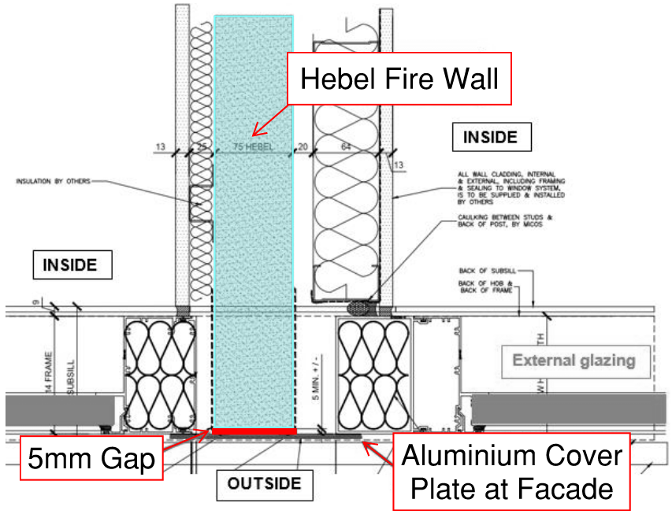
Figure 31: Configuration 1 – 5mm gap between Hebel wall and façade

Configuration 2
The layout of the Hebel wall system to be addressed in this section is illustrated in Figure 32 below.

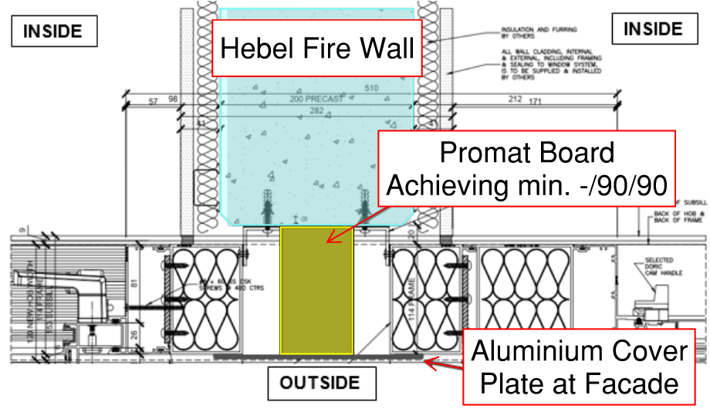
Figure 32: Configuration 2 – Up to 100mm gap between Hebel wall and façade
Configuration 2 is to have the Hebel wall terminate at a greater distance from the aluminium plate at the façade, leaving a maximum gap of 100mm. BCA Clause C4D16 states that spaces such as these must be protected in a manner identical with a prototype tested in accordance with AS 1530.4-2014. The proposed design is not in line with a tested wall system and therefore, the gap between the end of the Hebel wall and the aluminium plate at the façade is to be bridged by a fire rated board system, in order to achieve the FRL required of the Hebel wall.
The fire rated board is to achieve an FRL rating of at least -/90/90 (in line with the requirements of Specification 5), such as Promat Vermiculux board or similar, fixed in accordance with the manufacturer’s specifications. Where the fire rated board is affixed to the Hebel wall aluminium façade plate, a fire sealant is to be used in order to provide further protection against the spread of fire and smoke.
The proposed configuration 2 is considered to be sufficient in mitigating the risk of fire and smoke spread. While the proposed configuration will not be constructed in line with a tested system, the design is considered as meeting the intent of this clause as the risk of fire and smoke spread is sufficiently mitigated by the provision of a fire rated board and fire sealant within the gap detailed above.
Furthermore (as detailed in the previous section) a fire within one of the SOUs in the proposed development is expected to cause glazing failure, venting products of combustion out to the atmosphere, further reducing the risk of fire spread via gap between the Hebel wall and façade.
Conclusion
The proposed performance solution will demonstrate that the risk of fire spread is sufficiently mitigated by the proposed design for construction interfaces. Consequently, compliance with performance requirements C1P2 is deemed as having been met.
Performance solution:
 A2G2(1)(a) or A2.2(1)(a) - Comply with all relevant performance requirements
 A2G2(1)(b) or A2.2(1)(b) - Be at least equivalent to the DtS provisions
Assessment methods:
 A2G2(2)(a) or A2.2(2)(a) - Evidence of suitability
 A2G2(2)(b)(i) or A2.2(2)(b)(i) - Verification methods provided in the NCC
 A2G2(2)(b)(ii) or A2.2(2)(b)(ii) - Other verification methods accepted by the appropriate authority
 A2G2(2)(c) or A2.2(2)(c) - Expert judgement
 A2G2(2)(d) or A2.2(2)(d) - Comparison with the DtS provisions
Assessment approach:
 Comparative  Qualitative  Deterministic
 Absolute  Quantitative  Probabilistic
AFEG sub-systems used in the analysis:
 A – Fire initiation and development and control  D – Fire detection, warning and suppression
 B – Smoke development and spread and control  E – Occupant evacuation and control
 C – Fire spread and impact and control  F – Fire services intervention
Acceptance criteria and factor of safety:
The proposed solution will be deemed as acceptable if the proposed layout of the Hebel wall systems limit the spread of fire to the degree necessary to achieve compliance with the relevant performance requirements.
Fire scenarios and design fire parameters:
One fire, one location at one time will be assumed to occur.
Multiple fires are not considered.
Fires are assumed to occur within the residential apartments.
In the event of a occupants do not intervene during the early stages of fire growth, the sprinkler system is expected to either extinguish or control the fire in its origin.
Describe how fire brigade intervention will be addressed or considered:
Not applicable to this assessment. Fire brigade intervention has not been relied upon.
Verification/validation analyses:
 Sensitivity studies  Redundancy studies  Uncertainty studies  None
N/A
Provide details on proposed modelling/assessment tools:
N/A
FRNSW Comment: In principle support is provided subject to the analysis in the FER demonstrating compliance with the performance requirements of the NCC.

- Title: Reduction of Slab FRL Rating (60 minute to wet area only)
Details of departures from DtS provisions:
To reduce the Fire Resistance Level (FRL) of floor slabs within wet areas through residential levels from 90 minutes to 60 minutes.
Applicable DtS provisions (including clause excerpt): | C2D2, Specification 5, C3D8, C3D9, C3D10 | Applicable Performance Requirements: | C1P1, C1P2
List key fire safety measures:
- The building is to be sprinkler protected throughout in accordance with AS2118.1-2017 with fast response heads throughout, except where modified in this document.
- Management in use requirement is to be developed to maintain the public corridors as sterile spaces and not permitted to be used for the storage of combustible items.
- Lining materials serving the public corridors are to meet the requirements of Group 1 materials.
- Residential compartments are contained within their own fire compartments, containing the fuel load to a single SOU only.
Proposed performance solution:
Discussion and Comparison with the BCA
BCA Clause C2D2 states that the minimum type of fire-resisting construction of a building must be in accordance with those detailed in BCA Specification 5. Specification 5 requires the floor slab to have an FRL of 90/90/90 provided between residential levels.
BCA Clause C3D8 sets the requirements for separation by fire walls, and states that a fire wall must be constructed in accordance with the relevant FRL prescribed by Specification 5.
BCA Clause C3D9 sets the requirements for separation of classifications in the same storey, and states that if a building has parts of different classifications located alongside one another in the same storey, each building element in that storey must have the higher FRL prescribed in Specification 5 for that element for the classifications concerned.
BCA Clause C3D10 sets the requirements for separation of classifications in different storeys, and states that if parts of different classifications are situation one above the other in adjoining storeys in Type A construction, the floor between the adjoining parts must have an FRL of not less than that prescribed in Specification 5 for the classification of the lower storey.
Performance Requirement C1P1 states that a building must have elements which will, to the degree necessary, maintain structural stability during a fire appropriate to the building they serve.
Performance Requirement C1P2 states that a building must have elements which will, to the degree necessary, avoid the spread of fire to exits, SOUs and public corridors, between buildings and in a building. Avoidance of the spread of fire must be appropriate to the building they serve.
According to the Guide to the BCA, the main intention in establishing the required level of fire resisting construction is to maintain the structural stability of elements in a fire event within the building, and to prevent the spread of fire between different fire compartments.
The hazard in rationalising fire separation between fire compartments is that the rationalised construction may facilitate structural failure of the element and may lead to fire spread between fire compartments. The proposed Performance Solution herein will address this hazard with a combination of qualitative and quantitative assessments. A qualitative assessment is used in areas where the bathroom area in question falls above another bathroom (stacked arrangement) by qualitatively demonstrating the fire risk in bathroom areas is small. A quantitative assessment is proposed where the bathroom area does not fall above another bathroom area (not stacked arrangement), where a quantitative time equivalence assessment is proposed with the intent to demonstrate that a fully burned-out fire in the SOU below would not result in failure of the reduced slab on the level above.
FRNSW Comment: In a fully involved fire within a SOU, the entire area of the SOU would be involved in a fire including the bathroom area. As such, FRNSW recommends a quantitative assessment be undertaken for the bathroom areas regardless of whether they are stacked arrangement or non-stacked arrangement. It should also be clarified for a non-stacked arrangement whether a bathroom area is located above a classification other than Class 2 (e.g. Class 7a storage area).

Qualitative Assessment
The areas to be assessed are depicted in the figures below.
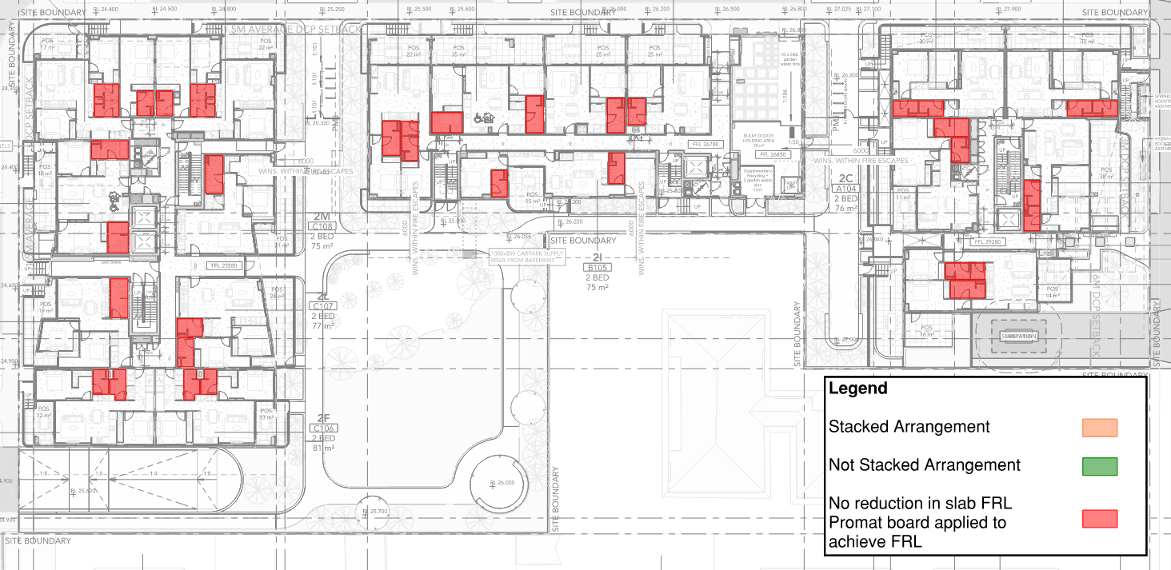
Figure 33: Slabs subject to Rationalised FRL – Level 1
FRNSW Comment: In accordance with the legend to the figure above, the wet areas slabs at Level 1 do not have reduction in FRLs. Confirmation required.
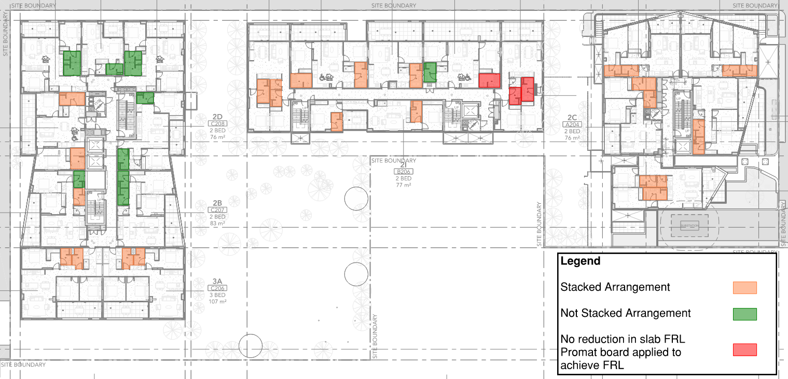
Figure 34: Slabs subject to Rationalised FRL – Level 2
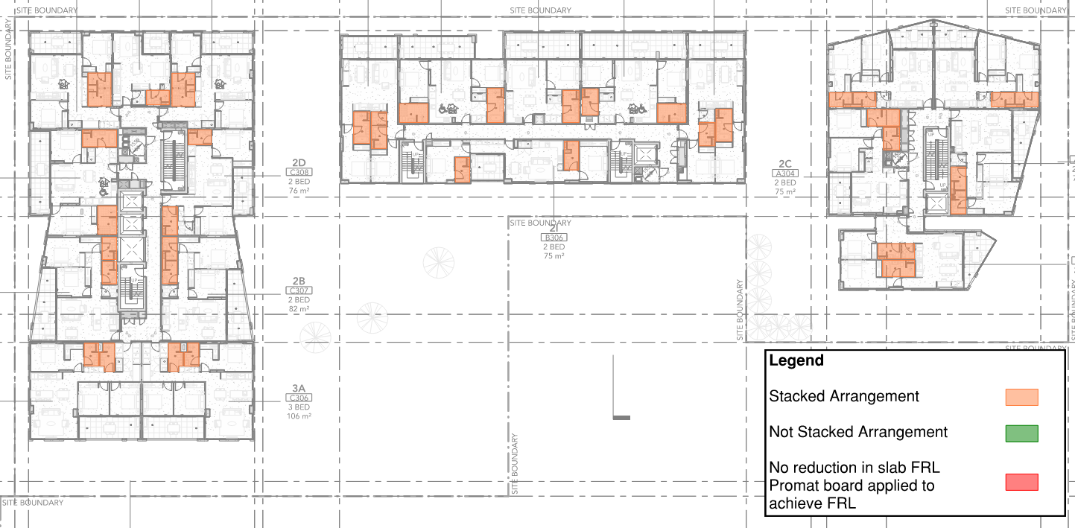
Figure 35: Slabs subject to Rationalised FRL – Level 3
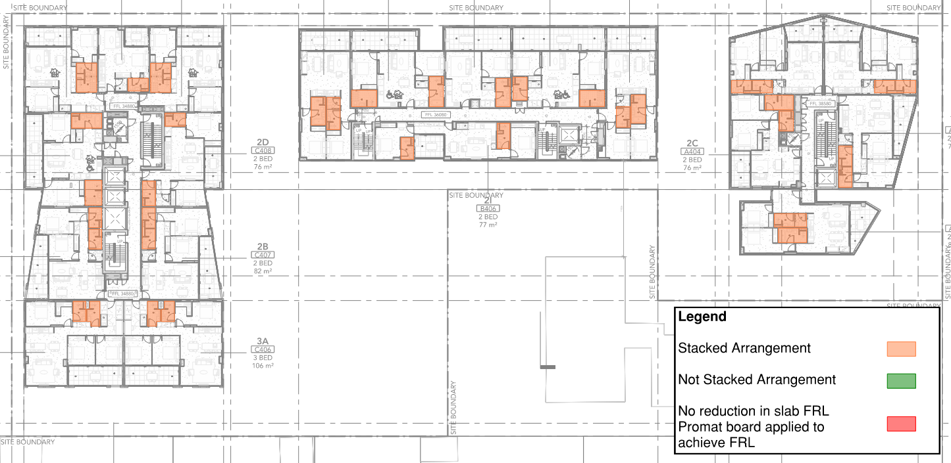
Figure 36: Slabs subject to Rationalised FRL – Level 4
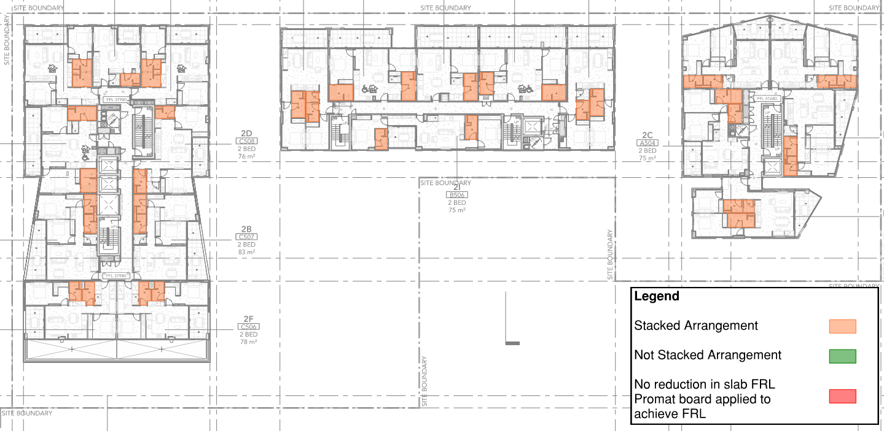
Figure 37: Slabs subject to Rationalised FRL – Level 5
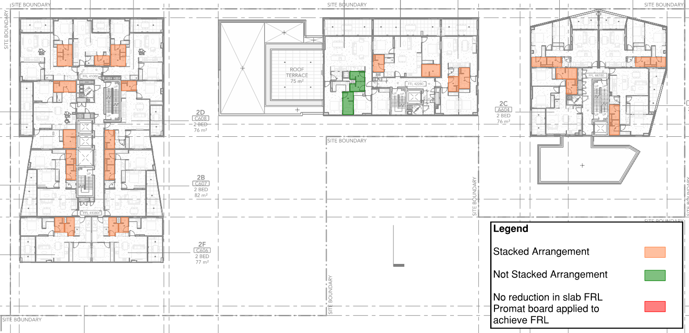
Figure 38: Slabs subject to Rationalised FRL – Level 6
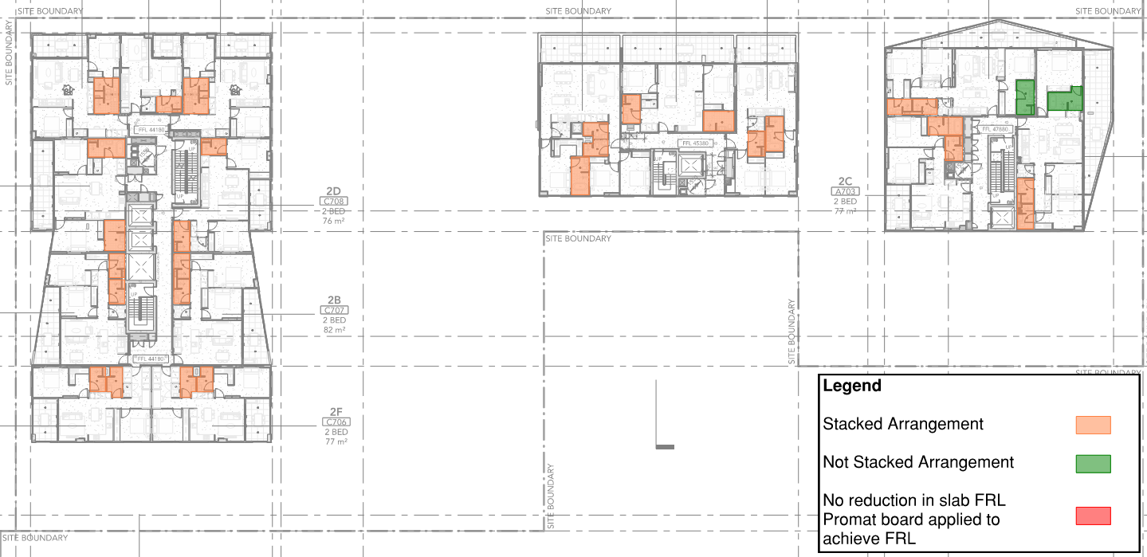
Figure 39: Slabs subject to Rationalised FRL – Level 7
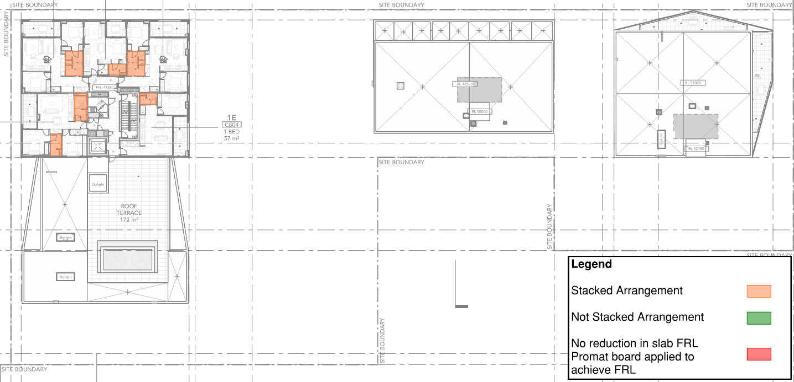
Figure 40: Slabs subject to Rationalised FRL – Level 8
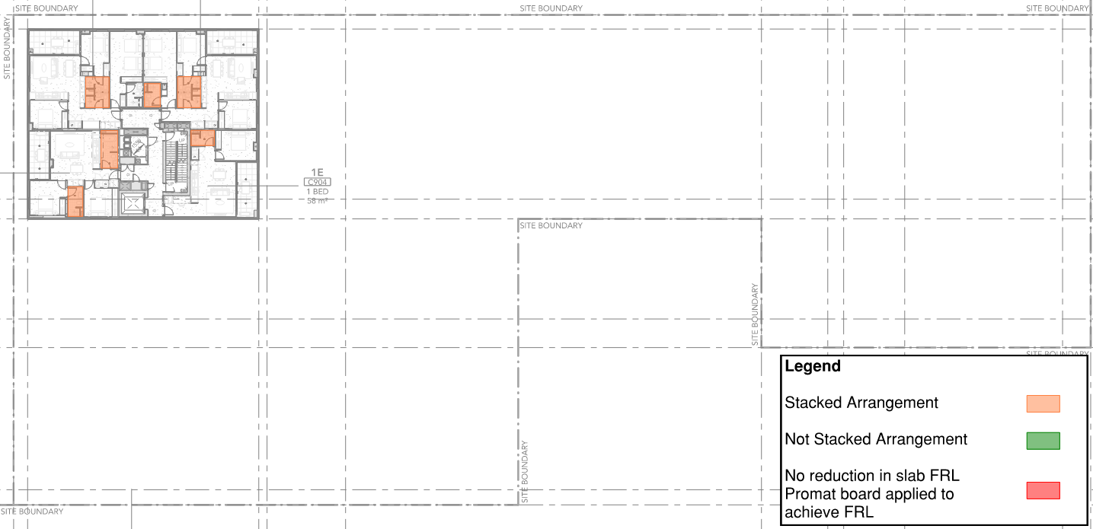
Figure 41: Slabs subject to Rationalised FRL – Level 9
It is proposed to qualitatively assess the reduction in slab FRL of bathroom areas that are stacked above other bathroom areas as indicated in the figures above. The assessment is based on the low fuel load within these areas coupled with their use as ‘wet’ areas. Combustible content within the bathroom shower recess areas may comprise of bottles of shampoo/body wash, sponges, towels and the like.
Furthermore, accumulation of a combustible fuel load necessary to sustain a significant fire is not considered to be found within these areas. Shower areas are predominantly expected to have non-combustible bounding walls of the shower required for water proofing of the areas such as tiling. Therefore, it can be expected the risk of fire development within the shower areas to be very low.
As denoted by the statistical studied carried out by Campbell, it was demonstrated that the likelihood of a fire initiating within a bathroom is considered to be low. Based on the number of recorded fire events over the period of 2007-2011 it was noted that 4% of all fires for an office building fell under that category of “Lavatory, bathroom, locker room or check room”. To further support this likelihood, fire statistics recorded over the period of 2009 – 2013 by Ahrens, indicated that under the same classification 3% of all fire events occurred within the lavatory, bathroom, locker room or check room.
Where the floor space below is not used as a residential unit and associated bathroom space these areas are not permitted to contain a reduced FRL. These areas are found on the Level 1 slab which sits above the basement carpark and lower ground level of building A, and are depicted in Figure 33 above.
Alternative Protection Methods
Where the reduction in slab thickness cannot be supported in line with the assessment above, it is proposed to provide a single layer of Promat Sheeting (Promatect-H) at least 9mm thick to the underside of the floor slabs fixed either directly to the concrete or spaced out with steel hat fixing.
FRNSW Comment: It appears from the above that the protection method using Promat Sheeting will be provided to all wet areas with non-stack arrangement. Confirmation required.
It is recorded within Promat’s Passive Fire Protection Systems: Application and Technical Manual: Concrete Upgrading, that when a 9mm sheeting is applied to the underside of the concrete slab it is suitable in upgrading the fire separation from 60 minutes to 120 minutes as tested in accordance with AS 1530.4 – 1990. Furthermore, this test is applicable to concrete with a minimum thickness of 100mm, where the subject building is proposed to contain thicker slabs which will result in higher levels of fire resistance. Whilst it is noted that the application of the additional protection fixed to the underside of the floor slab does not increase the FRL when subject to a fire above, the quantitative assessment below will demonstrate that the reduced FRL is sufficient for a fire within the residential units. An excerpt of the Promat Application and Technical Manual is provided below for reference. The installation is required to be in accordance with fixing details noted on Page 4 or Page 5 of the Application and Technical Manual.
FRNSW Comment: It appears that the referenced Application and Technical Manual for the Promatect-H product is outdated. The link below contains the latest technical manual for the product which specifies a minimum thickness of 12 mm of the Promatect-H board for application to concrete slab.
https://www.promat.com/en-au/construction/products-systems/products/boards/promatect-h-fire-board/
Appropriate evidence of suitability and/or data sheets are to be provided to justify the abovementioned Promat Sheeting to be incorporated into the installation on the underside of the slab to be provided in the FER.
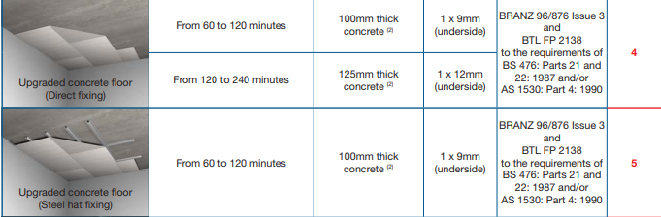
Figure 42: Excerpt of Promat Application and Technical Manual Page 3
SOUs Over Corridors / Fire-isolated exits
Where bathroom wet areas fall on top of residential corridors, fire-isolated exits and the like, it is required that a single layer of Promat Sheeting (Promatect-H) at least 9mm thick be provided to the underside of the floor slabs serving that bathroom wet area fixed either directly to the concrete or spaced out with steel hat fixing in accordance with the above. An example of this layout is depicted in Figure 43 and Figure 44 below.

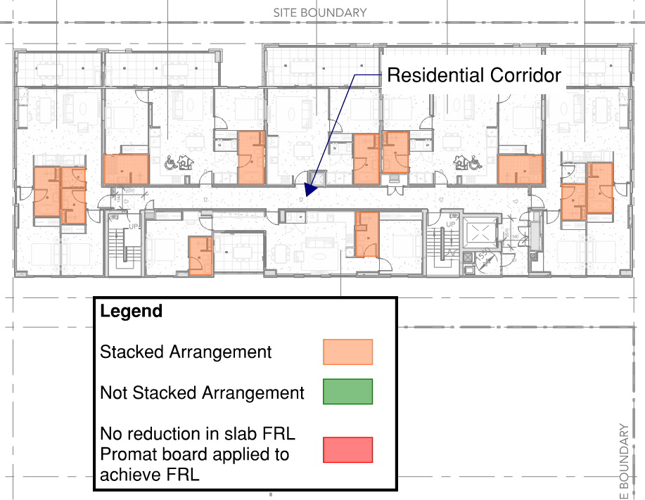 | 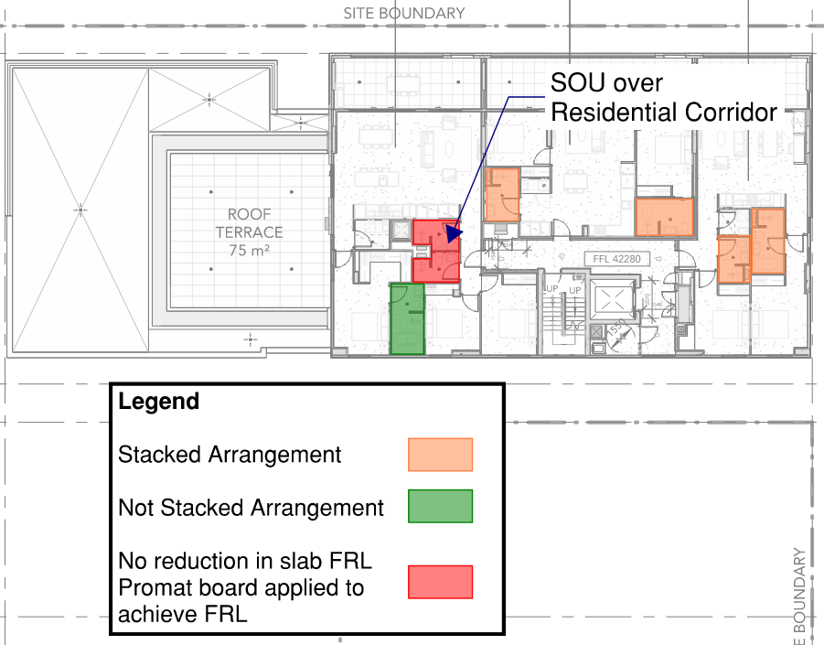
Figure 43: Wet Areas over Corridors – Building B Level 5 | Figure 44: Wet Areas over Corridors – Building B Level 6
Quantitative Analysis
A quantitative assessment is proposed where the bathroom area does not fall above another bathroom area (not stacked arrangement), where a quantitative time equivalence assessment is proposed with the intent to demonstrate that a fully burned-out fire in the SOU below would not result in failure of the reduced slab on the level above.
Time Equivalence Method
An assessment has been undertaken using calculations to evaluate the time-equivalence. The time equivalence formula is defined as the time of exposure to the standard fire resistance test that would result in the same thermal impact as a complete burnout of the compartment in a real fire. Assemblies provided with a fire resistance equal to, or greater than, the equivalent structural fire severity, are generally expected to be able to withstand a complete burnout of the compartment. The minimum Fire Resistance Levels (FRLs) that would be expected to withstand a full burnout of the considered compartment will therefore be determined based on the result of the calculations.
This technique has existed for quite a while and various means of calculating the equivalent period of fire exposure exist. These include Pettersson, Harmathy, Law, DIN 18230, CIB W14 and Eurocode 1. Although based upon experimental studies, Pattersson, Harmathy and Law techniques have been found to be limited either in their ease of use or scope of application. DIN 18230, CIB W14 and Eurocode a very similar in their approach differing only in the treatment of the individual parameters. The Eurocode is seen as the evolution of the DIN 1820 and CIB W14 approaches and the most applicable or current method of analysis.
Therefore, it is proposed to use the approach in the Eurocode 1 for the Time Equivalent Method.
Bathroom Setdowns – Time Equivalence
The assessment herein considers the case where the whole SOU including the bathroom area is fully burned-out to assess the risk of the slab on the level above failing. As discussed above, a bathroom fuel load is considered to be low in comparison to the whole SOU and it will take less time for a fire to burnout. Note that each SOU forms a single fire compartment in its own right and will assessed as such.
Floors of these SOUs / compartments are assumed to be concrete and walls plasterboard. The following table shows the worst-case SOUs, and the inputs which will be used in the assessment. Cell height of 2.85m is used.
FRNSW Comment: Additional information should be provided to justify that the selected SOUs listed in the table below represent the worst-case scenarios for the proposed fire severity calculations.
Table 11: SOU / Compartment Characteristics
Test | SOU / Compartment | Floor Area of SOU (m²) | Total Area of Openings (m²)
1 | 3 Bedroom SOU C102 | 106 | 24 (horizontal)
2 | 2 Bedroom SOU A602 | 79 | 17.5 (horizontal)
3 | 3 Bedroom SOU B603 | 81 | 33.5 (horizontal)

Residents Units – FLED:
The Fire Load Energy Densities (FLED) values vary, depending on the type of occupancy, its size, etc. The following FLED values from the New Zealand Building Code Verification Method C/VM2, have been assumed as worst-case scenarios to be found in the relevant SOU’s. For dwellings this value is 400 MJ/m². A sensitivity analysis using a 95 % fractile FLED (1.96 x the given value) is also considered. Glass breakage scenarios will be considered.
FRNSW Comment: FRNSW recommends a more conservative FLED value be adopted for the calculation. FRNSW notes that a FLED of 500 MJ/m² is specified for “Homes” occupancy in Table 3.4.1a of IFEG.
Conclusion
The above assessment has outlined how the proposed reduction in slab thickness to accommodate wet area set downs will be addressed in the FER. Figure 33 to Figure 41 depict how these areas are to be assessed, through a combination of qualitative assessment and quantitative assessments. Areas where no reduction in FRL is permitted are required to be protected with fire rated construction to the underside of the slab. The FER will contain detail assessment regarding the above with the intent to demonstrate that the proposed design complies with Performance Requirements C1P1 and C1P2.
Performance solution:
 A2G2(1)(a) or A2.2(1)(a) - Comply with all relevant performance requirements
 A2G2(1)(b) or A2.2(1)(b) - Be at least equivalent to the DtS provisions
Assessment methods:
 A2G2(2)(a) or A2.2(2)(a) - Evidence of suitability
 A2G2(2)(b)(i) or A2.2(2)(b)(i) - Verification methods provided in the NCC
 A2G2(2)(b)(ii) or A2.2(2)(b)(ii) - Other verification methods accepted by the appropriate authority
 A2G2(2)(c) or A2.2(2)(c) - Expert judgement
 A2G2(2)(d) or A2.2(2)(d) - Comparison with the DtS provisions
Assessment approach:
 Comparative  Qualitative  Deterministic
 Absolute  Quantitative  Probabilistic
AFEG sub-systems used in the analysis:
 A – Fire initiation and development and control  D – Fire detection, warning and suppression
 B – Smoke development and spread and control  E – Occupant evacuation and control
 C – Fire spread and impact and control  F – Fire services intervention
Acceptance criteria and factor of safety:
The solution will be said to have met the acceptance criteria if it can be shown through the time equivalence method that a fire within the applicable residential units / compartments, or unit below the slabs of concern will be appropriately contained by an FRL of 60 minutes only. Where bathroom wet areas fall on top of residential corridors, fire-isolated exits and the like, passive fire protection methods are required to achieved the required FRL.
Fire scenarios and design fire parameters:
A fire within the worst-case residential compartment has been assessed utilising an FLED of 400 MJ/m².
Describe how fire brigade intervention will be addressed or considered:
As it is shown that the fire will not be permitted to spread to another fire compartment, fire brigade intervention is not considered to be impacted.
Verification/validation analyses:
 Sensitivity studies  Redundancy studies  Uncertainty studies  None
Sprinkler failure, 95% fractile and varying glazing failure amounts have been assessed.
Provide details on proposed modelling/assessment tools:
Empirical calculations, full detail of the calculations will be provided within the FER.
WAN905576: FRNSW Comment: Where fire severity / time equivalence calculations are undertaken the following should be considered:
- Multiple methods of fire severity calculation are recommended to be evaluated which takes into consideration various defining parameters. Three potential methods include: CIB Formula, Law Formula, and Eurocode Formula.
- The limitations on ventilation parameters as specified in Equations 5.14 and 5.15 of Structural Design for Fire Safety (Buchanan, 2001) should be adhered to for all methods.
- At least a 95 % fractile fire load should be adopted (as per the recommendation on page 3.4-8 of IFEG). If using the figures from Table 3.4.1a of IFEG, at least a 90 % fractile value should be chosen calculated as per the methodology given on page 3.4-2 of IFEG.
- The conversion factor kb should be taken as 0.09 (Fire Engineering Design Guide, Third Edition, p58 & Structural Design for Fire Safety, p103), unless the lining materials of the compartment are identified and form part of the Trial Design requirements to ensure future compliance. A conversion factor appropriate to these lining materials may then be selected based on those recommended for “large compartments” in Table 5.4 of Structural Design for Fire Safety (Buchanan, 2001).
- Clear justification of ventilation to equivalent fire severity calculation area is to be included. A variety of potential ventilation areas are to be evaluated and justified. In this regard, consideration should be given to height of openings, the size of the openings and their relationship to the height of the external wall [e.g. in a full height window only the upper portion may fail (See CIB Publication 269 – Rational Fire Safety Engineering approach to Fire Resistance of buildings)]. For this reason, FRNSW recommend that a scenario with no more than 50% window breakage/failure be undertaken. Where it can be demonstrated that more than 50% breakage is likely to occur appropriate justification is to be included in the FER (e.g. modelling to demonstrate temperatures are sufficient to cause window breakage)
- A structural engineer should verify any assumptions made in the analysis on the performance of the structure and confirm that the proposed Performance Solution has no other impacts on the structural design. The Structural Engineer should also confirm that the structural design is consistent with and incorporates all requirements of the Performance Solution.
FRNSW recommends above comments be appropriately addressed.
- Title: Omission of Sprinklers from MSB, Comms and Electrical Rooms
Details of departures from DtS provisions:
Permit the omission of sprinklers from the following compartments:
- MSB room
- Communications room
- Electrical cupboards
Applicable DtS provisions (including clause excerpt): | E1D4 | Applicable Performance Requirements: | E1P4
List key fire safety measures:
- The building is to be sprinkler protected throughout in accordance with AS2118.1-2017 with fast response heads throughout, except where modified in this document.
- A detection system is to be provided to compartments from which sprinklers are to be omitted, compliant to AS 1670.1 – 2018 Amendment 1.
- Dry chemical powder ABE portable fire extinguishers are to be installed within the subject compartments, compliant to AS 2444 – 2001.
- The Communications, MSB Room and electrical cupboards are to be constructed with an FRL rating of 120/120/120..
  - Doors serving these compartments are to achieve an FRL of -/120/30, be automatically closing and be provided with medium temperature smoke seals capable of withstanding temperatures of 200°C for 30 minutes and tested in accordance with AS 1530.7.
- A dry chemical powder ABE portable fire extinguisher is to be provided within the subject compartments
Proposed performance solution:
BCA Comparison
BCA Clause E1D4 states that a sprinkler system must be installed where required by BCA Clause E1D5 to E1D12 as applicable, and must comply with BCA Specification 17 and Specification 18 as applicable. BCA Clause E1D6 states that a sprinkler system must be provided throughout the whole Class 2 building if any part of the building has an effective height of more than 25 metres.
Performance Requirement E1P4 states that an automatic fire suppression system must be installed to the degree necessary to control the development and spread of fire appropriate to the nature and use of the building.
The intent of the requirements for sprinkler protection are to provide appropriate automatic suppression systems to control the development and spread of fire. The risk of not providing sprinkler protection to the main switch room and Comms room is that a fire in this room may grow uncontrolled and spread to adjacent areas. The assessment herein will demonstrate that the risk of fire spread to adjacent areas is unlikely given the compartmentation, smoke seals and sprinkler protection of adjacent areas. Furthermore, it is considered that water-based sprinkler systems result in an electrical risk to occupants and fire brigade where electrical equipment is present.

Qualitative Assessment
Figure 12 depicts the locations of the Main Switch Room and Comms room on Lower Ground Level. See attached compartmentation plans for further fire separation information. Doors serving the Comms room and MSB Room are to achieve an FRL of -/120/30, be automatically closing and provided with medium temperature smoke seals, as depicted in Figure 46.
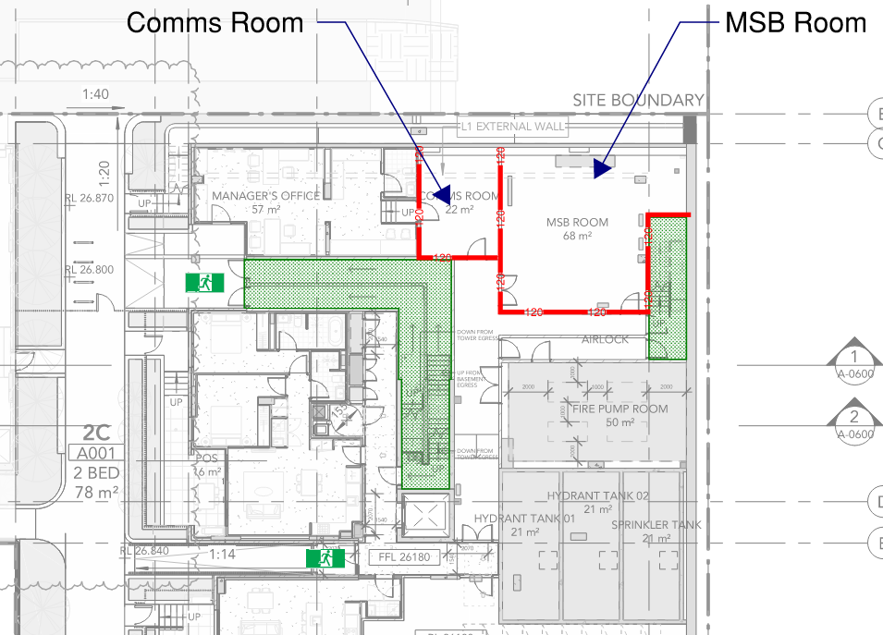
Figure 45: Location of Comms Room and MSB – Lower Ground floor plan – Building A

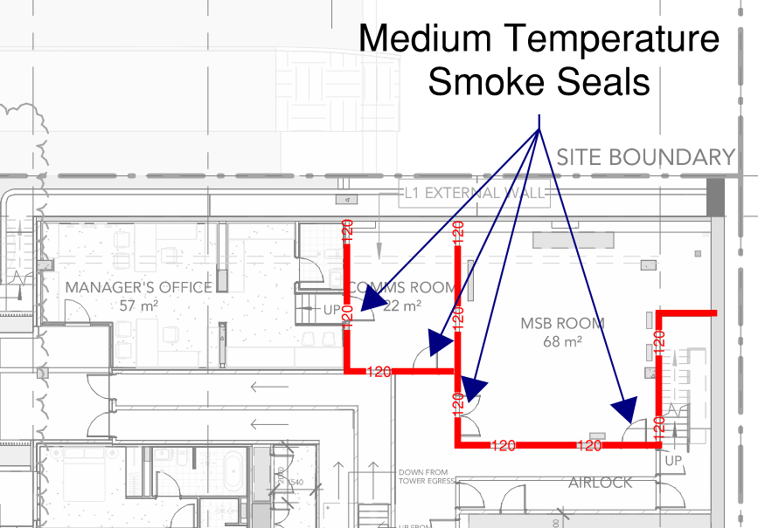
Figure 46: Medium Temperature Smoke Seals - Comms Room and MSB

The proposed solution aims to demonstrate that a fire is unlikely to spread from the Communications Room and MSB room to the surrounding areas, or from the surrounding areas into the Communications/MSB room. In the event of a fire initiating within the areas surrounding these compartments, fire spread to the non-sprinkler protected compartment is unlikely due to the provision of sprinkler protection systems throughout the proposed building, as well as the fire-resistant bounding construction (to be rated with an FRL of 120 minutes).
It is noted that the surrounding areas are considered low fuel load, being back of house circulation areas. It is considered that the main fire risk is the sprinkler protected manager’s office adjacent to the Comms Room. This hazard is addressed by the proposed solution by the requirement for automatically closing fire door fitted with medium temperature smoke seals between the compartments. This door will prevent the passage of fire and smoke between sprinkler protected and non-sprinkler protected areas. It is also noted that the Comms/MSB rooms are provided with two exits respectively, which provide alternate egress for occupants inside the room.
Additionally, given the low fuel load that is expected to be housed within the Comms/MSB room (namely cabling and network/electronic equipment), a fire within the Comms/MSB room is not expected to be able to grow to a size that would defeat the fire rated construction of the bounding walls, effectively containing the fire to within these compartments.
It is reasonable to expect that the Comms/MSB rooms could potentially store high voltage electric equipment; the provision of sprinklers within the room could pose a risk of electrocution to the fire brigade, or any other occupants that come in to contact with the water dispersed by the sprinklers. It should also be noted that the omission of sprinklers in rooms containing high voltage equipment is in accordance with AS 2118.1 – 2017 as it recognises hazards associated with the suppression of electrical equipment using the spray of water.
In order to further mitigate the risk of fire spread associated with the omission of sprinklers to the Comms/MSB room, it is proposed to install a detection system within the compartment compliant to AS 1670.1 – 2018 Amendment 1. In the event of a fire within these compartments, the detection system and the fire-safety systems discussed above will alert occupants to a fire within the building, and allow them to safely evacuate from the building. A dry chemical powder ABE portable fire extinguisher is to be provided within the subject compartments in order to provide occupants with a means of supressing a fire in the early stages of fire growth, if safe to do so.
The provision of the fire-resistant bounding construction, the sprinkler system provided throughout the building (except for areas detailed in this proposed solution), and the additional fire-safety items detailed above, it is reasonable to conclude that the spread of fire will be sufficiently limited to achieve compliance with the intent of the BCA. It is therefore considered that the proposed design complies with Performance Requirement E1P4.
Performance solution:
 A2G2(1)(a) or A2.2(1)(a) - Comply with all relevant performance requirements
 A2G2(1)(b) or A2.2(1)(b) - Be at least equivalent to the DtS provisions
Assessment methods:
 A2G2(2)(a) or A2.2(2)(a) - Evidence of suitability
 A2G2(2)(b)(i) or A2.2(2)(b)(i) - Verification methods provided in the NCC
 A2G2(2)(b)(ii) or A2.2(2)(b)(ii) - Other verification methods accepted by the appropriate authority
 A2G2(2)(c) or A2.2(2)(c) - Expert judgement
 A2G2(2)(d) or A2.2(2)(d) - Comparison with the DtS provisions
Assessment approach:
 Comparative  Qualitative  Deterministic
 Absolute  Quantitative  Probabilistic
AFEG sub-systems used in the analysis:
 A – Fire initiation and development and control  D – Fire detection, warning and suppression
 B – Smoke development and spread and control  E – Occupant evacuation and control
 C – Fire spread and impact and control  F – Fire services intervention
Acceptance criteria and factor of safety:
The solution is considered acceptable if it is shown that by removing the sprinkler requirements from the Comms Room and MSB Room will not increase the risk of fire spread.
Fire scenarios and design fire parameters:
A fire within the both the MSB and Comms Room has been considered, as has a fire located in the areas surrounding these compartments.
Describe how fire brigade intervention will be addressed or considered:
Given that the proposed design suppresses the spread of fire to the degree necessary to conform with all relevant performance requirements, the proposed Performance Solution is not considered to impact fire brigade intervention.
Verification/validation analyses:
 Sensitivity studies  Redundancy studies  Uncertainty studies  None
Assessment is qualitative in nature.
Provide details on proposed modelling/assessment tools:
Assessment is qualitative in nature.
FRNSW Comment: In principle support is provided subject to the analysis in the FER demonstrating compliance with the performance requirements of the NCC.

- Title: Non-fire-rated Roof Hatches
Details of departures from DtS provisions:
Permit the installation of the non-combustible roof hatch in lieu of a fire rated hatch at the top of the fire isolated stairs throughout the development.
Applicable DtS provisions (including clause excerpt): | Specification 5 | Applicable Performance Requirements: | C1P2, C1P4
List key fire safety measures:
- The fire stair access hatches at roof level are required to be constructed from non-combustible materials.
Proposed performance solution:
BCA Comparison
BCA Specification 5 states that the fire-isolated stairs be rated with a fire resistance of at least 90 minutes. Furthermore, S5C8 states that shafts required to have an FRL must be enclosed at the top and bottom by construction having an FRL not less than the required FRL of the shaft. Hence, the roof of the fire isolated stairs must maintain a fire resistance of 90 minutes.
Performance Requirement C1P2 states that a building must have elements which will to the degree necessary, avoid the spread of fire to exits, between buildings and in a building.
Performance Requirement C1P4 states that to maintain tenable conditions during occupant evacuation, a material and an assembly must to the degree necessary resist the spread of fire and limit generation of smoke, heat and toxic gases appropriate to evacuation time, occupant characteristics, building function and active fire safety systems in the building.
Qualitative Analysis
The subject non-fire rated stair access hatches are depicted in Figure 47 below.
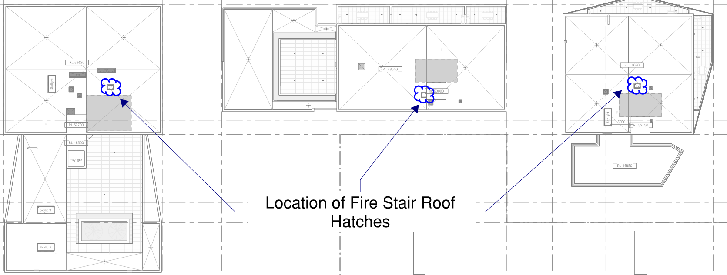
Figure 47: Location of fire stair access hatches – Roof level
The fire hazard associated with the roof hatches being constructed with non-combustible materials in lieu of having a compliant fire-resistance is that the spread of fire from the roof area may spread via the roof hatches, potentially impacting on the tenability within the fire-isolated stairs.
It should be noted that the spread of fire from within the fire-isolated stairs to the roof is not considered as feasible, as the fire-isolated stairs are expected to be maintained as a sterile space, hence the initiation and growth of a significant fire is not considered as a credible scenario.
Figure 47 illustrates the roof level in which the hatches are located. This area is not intended to be accessible to the general population of the building, instead only being used for certain building equipment such as air conditioning equipment, exhaust stacks, etc. These items are spread sporadically across the extent of the roof area, and there is to be no high density of fuel loads exist in close proximity to the roof hatches.
Furthermore, a fire on the roof is open to the atmosphere, meaning that the products of combustion from any credible fire scenario will vent upward and outward to atmosphere, given the natural buoyancy of hot gases. Significant temperatures capable of impinging on the roof hatches are not expected to develop, meaning that roof hatches constructed of non-combustible materials are expected be sufficient in preventing the transmission of heat into the fire isolated stairs.
The roof hatches are similarly expected to prevent the spread of smoke into the fire-isolated stairs. Given any fire on the roof will be open to atmosphere, large volumes of smoke are not expected to impinge on the top surface of the roof hatches, hence the hatches are expected to prevent the spread of smoke. Furthermore, the BCA does not require that smoke seals be provided to a roof hatch, therefore it is reasonable to conclude that a non-combustible roof hatch will offer a comparable level of smoke protection to a compliant fire-resistant hatch.
As such, it is considered reasonable to conclude that roof hatches constructed with non-combustible materials, in lieu of a compliant fire-resistance, will be sufficient in preventing the spread of fire into the fire-isolated stairs, therefore allowing occupants of the building to safely evacuate through the subject stairways.
Conclusion
The Fire Engineering assessment has demonstrated the use of non-combustible roof hatches within the fire-isolated stairs will not facilitate the spread of fire into the stair shafts. Hence, occupants are afforded a means of evacuation that is sufficiently protected against the spread of fire and untenable conditions. It is therefore reasonable to conclude that performance requirements C1P2 and C1P4 can be deemed as having been met.
Performance solution:
 A2G2(1)(a) or A2.2(1)(a) - Comply with all relevant performance requirements
 A2G2(1)(b) or A2.2(1)(b) - Be at least equivalent to the DtS provisions
Assessment methods:
 A2G2(2)(a) or A2.2(2)(a) - Evidence of suitability
 A2G2(2)(b)(i) or A2.2(2)(b)(i) - Verification methods provided in the NCC
 A2G2(2)(b)(ii) or A2.2(2)(b)(ii) - Other verification methods accepted by the appropriate authority
 A2G2(2)(c) or A2.2(2)(c) - Expert judgement
 A2G2(2)(d) or A2.2(2)(d) - Comparison with the DtS provisions
Assessment approach:
 Comparative  Qualitative  Deterministic
 Absolute  Quantitative  Probabilistic
AFEG sub-systems used in the analysis:
 A – Fire initiation and development and control  D – Fire detection, warning and suppression
 B – Smoke development and spread and control  E – Occupant evacuation and control
 C – Fire spread and impact and control  F – Fire services intervention
Acceptance criteria and factor of safety:
The acceptance criteria of the performance solution shall pertain to the tenability of evacuating occupants. The performance solution shall be deemed as acceptable upon demonstration that the spread of fire into the fire-isolated stairs is not a credible scenario, hence allowing occupants to safely evacuate under tenable conditions.
Fire scenarios and design fire parameters:
The assessment considers a fire on the roof space and inside the building.
Describe how fire brigade intervention will be addressed or considered:
As the spread of fire is considered as limited to the degree necessary, it is considered that the fire brigade will be able to traverse through the fire-isolated stairs in the event of a fire scenario. Hence, the impact to the attending fire brigade is considered as negligible by the subject non-compliance
Verification/validation analyses:
 Sensitivity studies  Redundancy studies  Uncertainty studies  None
Assessment is qualitative in nature.
Provide details on proposed modelling/assessment tools:
Assessment is qualitative in nature.
FRNSW Comment: FRNSW does not support the proposal and provides the following comments:
- Consideration should be given to any equipment located adjacent to the stair hatches. In the event of a fire involving the equipment, there is a risk that the stair roof hatches may be compromised if they are not fire-rated.
- For a Class 2 building such as the subject building or a building protected with a sprinkler system (other than a FPAA 101D or 101H system), Clause S5C15 gives a concession which allows the roof to not comply with Table S5C11g if its covering is non-combustible. Where this concession is applied to the design of the subject building, the stair roof hatches may be exposed to a fire from a SOU which breaks the roof.
- As the fire hydrant is to be located within the fire stairs, provision of a non-fire-rated roof hatch will not provide adequate protection to attending fire fighters. This could potentially delay fire brigade intervention.

- Title: Rationalisation of Shelf Angles Fire Resistance Level (FRLs)
Details of departures from DtS provisions:
Where a part of a building required to have a FRL depends upon direct vertical or lateral support from another part to maintain its FRL, that supporting part must have an FRL not less than that required by other provisions of this Specification. It is proposed to omit the fire rating to the shelf angle supporting the external brick façade.
Applicable DtS provisions (including clause excerpt): | C2D2 and S5C2 | Applicable Performance Requirements: | C1P2
List key fire safety measures:
- Automatic Fire Suppression System, fitted with fast response sprinkler heads is to be installed within the building, designed and installed in accordance with AS 2118.1 – 2017, except where modified by this document.
Proposed performance solution:
The Deemed-to-Satisfy Compliant Building external façade wall may be located 3 m or more from a fire source feature (i.e. whether being from the property boundary or from another building on the same allotment) and therefore under Specification 5, would not be required to be protected with fire rated construction if it is considered non-loadbearing.
The subject buildings external façade walls are located more than 3 m from a fire source feature and are not required to be provided with fire rated construction. However, due to the proposed shelf angle being mechanically fixed to the floor slab which requires a fire rating, any supporting element providing vertical or lateral support from another part is to be maintained with the same FRL. However, it is proposed to not provide fire rated shelf angle achieving a 120-minute FRL. The subject building is required to be provided with a sprinkler system fitted with fast response sprinkler heads in accordance with AS 2118.1-2017. Fire rated sealant is to be provided to any gaps between the steel shelf angle and the concrete slab. The schematic below depicts the intended design.
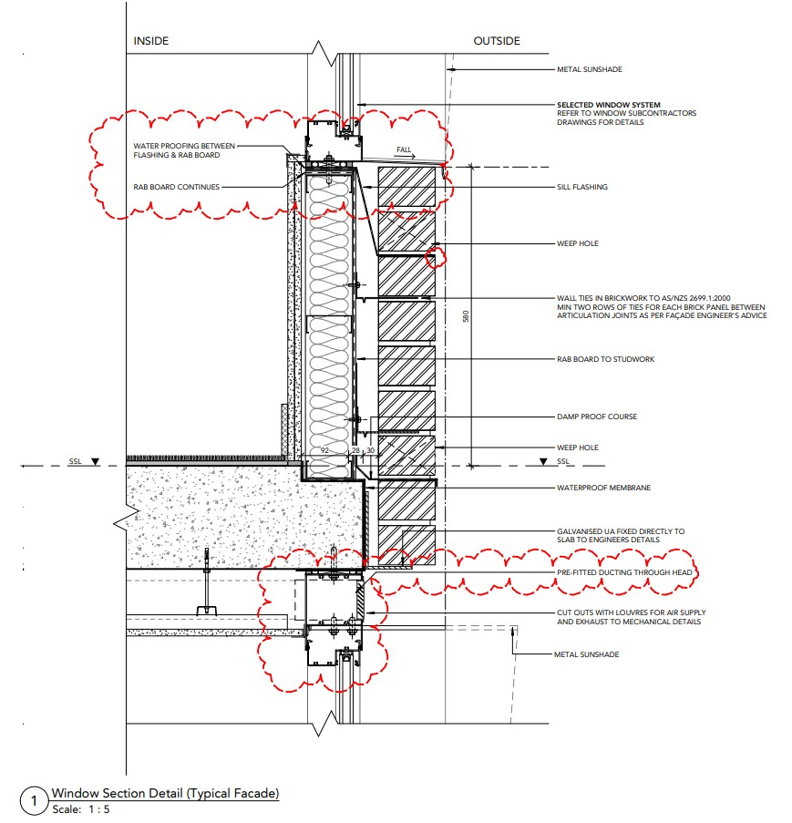
Figure 48: Shelf Angle Detail - Indicative
For the assessment's scope, it's important to consider the potential impact of fire on unprotected steel shelf angles. In the event of a fire, the sprinkler system is expected to contain and often extinguish it. Research by Notarianni, K. ("NISTIR 5240 Measurement of Room Conditions and Response of Sprinklers and Smoke Detectors During a Simulated Two-bed Hospital Patient Room Fire," NIST, 1993) and Rakic, J. ("The Performance of Unit Entry Doors When Exposed to Simulated Sprinkler Controlled Fires," Fire Australia, 2000) shows that in sprinkler-protected areas, temperatures generally remain low, around 100 °C – 200 °C. According to Standards Australia ("AS 4100, Steel Structures," Standards Australia International Ltd, 1998), under such controlled temperatures, unprotected structural steel retains 100% of its strength. Therefore, it can be inferred that the structural integrity and fire resistance of the steel shelf angles would be maintained effectively under these conditions.
Performance solution:
 A2G2(1)(a) or A2.2(1)(a) - Comply with all relevant performance requirements
 A2G2(1)(b) or A2.2(1)(b) - Be at least equivalent to the DtS provisions
Assessment methods:
 A2G2(2)(a) or A2.2(2)(a) - Evidence of suitability
 A2G2(2)(b)(i) or A2.2(2)(b)(i) - Verification methods provided in the NCC
 A2G2(2)(b)(ii) or A2.2(2)(b)(ii) - Other verification methods accepted by the appropriate authority
 A2G2(2)(c) or A2.2(2)(c) - Expert judgement
 A2G2(2)(d) or A2.2(2)(d) - Comparison with the DtS provisions
Assessment approach:
 Comparative  Qualitative  Deterministic
 Absolute  Quantitative  Probabilistic
AFEG sub-systems used in the analysis:
 A – Fire initiation and development and control  D – Fire detection, warning and suppression
 B – Smoke development and spread and control  E – Occupant evacuation and control
 C – Fire spread and impact and control  F – Fire services intervention
Acceptance criteria and factor of safety:
The construction of the external brick façade is to be provided with an equivalent level of structural adequacy and fire spread resistance when compared to the Deemed-to-Satisfy Compliant Building.
Fire scenarios and design fire parameters:
One fire, one location at one time will be assumed to occur.
Multiple fires are not considered.
Fires are assumed to occur within the residential apartments.
In the event of a occupants do not intervene during the early stages of fire growth, the sprinkler system is expected to either extinguish or control the fire in its origin.
Describe how fire brigade intervention will be addressed or considered:
Not applicable to this assessment. Fire brigade intervention has not been relied upon.
Verification/validation analyses:
 Sensitivity studies  Redundancy studies  Uncertainty studies  None
N/A
Provide details on proposed modelling/assessment tools:
N/A
FRNSW Comment: The performance solution heavily relies on the sprinkler system in its effect on fire. However, it is noted that the NCC generally does not differentiate the FRL requirements between a sprinklered building and a non-sprinklered building when prescribing the FRLs of building elements, indicating that NCC assumes a sprinkler failure scenario where a sprinkler system is provided. Therefore, FRNSW recommends the steel shelf angles be adequately fire protected as per DtS provisions of the NCC. Where they are not protected, they would fail in a fully developed fire in the event of a sprinkler failure scenario.
- Title: Smoke Proof Construction - Corridor Length
Details of departures from DtS provisions:
The public corridor on Lower Ground Floor of Building B and Level 1 of Building C is approximately 43 m and is not proposed to be smoke separated in accordance with BCA Clause C3D15.
Applicable DtS provisions (including clause excerpt): | C3D15, Specification 11 | Applicable Performance Requirements: | E2P2
List key fire safety measures:
- The building is to be sprinkler protected throughout in accordance with AS2118.1-2017 with fast response heads throughout, except where modified in this document.
- Thermal detectors are to be located with 1.5 m of the SOU and service room entry doors in accordance with AS 1670.1-2018.
- Lining materials serving the public corridors are to meet the requirements of Group 1 materials.
- Management in use requirement is to be developed to maintain the public corridors as sterile spaces and not permitted to be used for the storage of combustible items.
  - Signage is to be provided within the public corridor stating: “NO STORAGE THROUGHOUT THIS AREA”. The signage is to be at a height of 1.75 – 2 m FFL, with the wording not less than 20 mm high on a colour contrasting background. This is to be noted in the fire safety schedule.
- Provide all doors serving public corridor with medium temperature smoke seals, capable of withstanding temperatures of 200°C for 30 minutes and tested in accordance with AS 1530.7.
Proposed performance solution:
BCA Comparison
BCA Clause C3D15 states that in a Class 2 or 3 building, a public corridor, if more than 40 m in length, must be divided at internals of not more than 40 m with smoke-proof walls complying with S11C2.
BCA Specification 11 sets out requirements for the construction of smoke-proof walls in Class 9a Health-care buildings and Class 9c buildings.
Performance Requirement E2P2 states that in the event of a fire in a building the conditions in any evacuation route must be maintained for the period of time occupants take to evacuate the part of the building so that occupants have the opportunity to evacuate under tenable conditions.
It is proposed that the public corridor on Lower Ground Floor of Building B and Level 1 of Building C is approximately 43 m and is not proposed to be smoke separated in accordance with BCA Clause C3D15. The intent of the BCA requirements regarding corridor length in residential corridors is to minimise the number of occupants exposed to a fire. The risk of increasing corridor length is that more SOUs are connected via the same corridor that could potentially become smoke logged, exposing a larger number of occupants to untenable conditions during egress. The assessment herein will demonstrate that the proposed design meets the intent of the Performance Requirements by preventing the residential corridors from becoming smoke logged by considering the fire safety measures provided.
Qualitative Analysis
The subject corridor is located on Level 1 of Building B and depicted in Figure 7 below. See attached fire compartmentation plans for details regarding the proposed compartmentation layout and bounding construction serving the corridor.
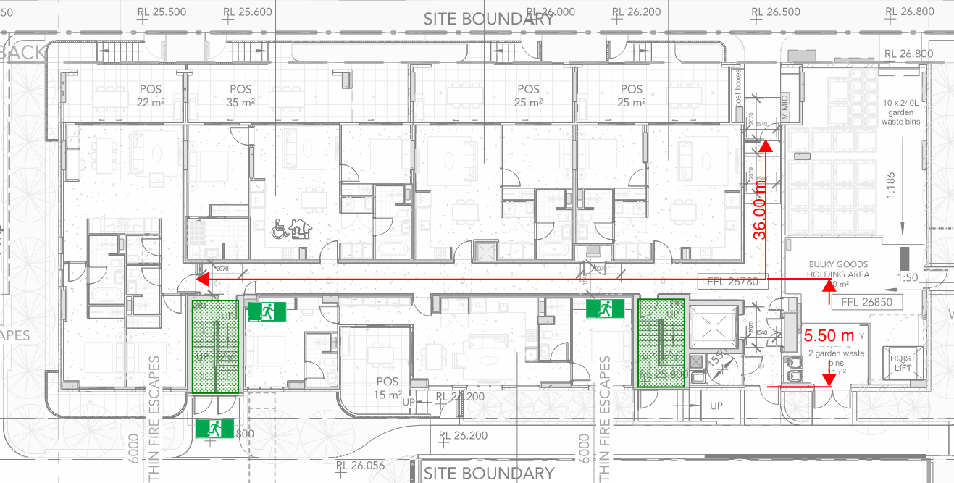
Figure 49: Public Corridor Length – Building B
Sprinkler Protection
As will be further discussed in the FER, the building is provided with an automatic Fire Suppression System with fast response heads is to be installed throughout the building, designed and installed in accordance with AS2118.1 – 2017, except where modified in this document. The sprinkler system is expected to suppress if not control a fire in its infancy. The FER will contain further analysis of the efficacy of sprinkler systems.
Quantitative Assessment
In addition to the 60/60/60 bounding construction required to each SOU, including -/60/30 fire doors, it is proposed to provide entry doors and fire stair entry doors with medium temperature smoke seals, capable of withstanding temperatures of 200°C for 30 minutes and tested in accordance with AS 1530.7. The provision of the smoke seals is expected to significantly reduce smoke leakage into the common corridors, ensuring they remain tenable for longer periods of time in comparison with a DtS compliant design.
Research by Rakic suggests that fire doors compliant with BCA Clause C4D5 are not sufficient in preventing the leakage of smoke at elevated temperatures. The results from his findings are tabulated below:
Table 12: Leakage rates of fire doors with and without smoke seals
Pressure Differential | Leakage Without Smoke Seals | Leakage With Smoke Seals | Percentage of DtS Leakage
12.5 | 172.2 m³/hour | 5.1 m³/hour | 2.96 %
25 | 214.84 m³/hour | 8.31 m³/hour | 3.87 %
50 | 254.28 m³/hour | 12.43 m³/hour | 4.88 %
75 | 307.69 m³/hour | 16.52 m³/hour | 5.36 %

It is noted that the above results were conducted with one particular kind of smoke seals and smoke leakage rates are expected to differ between brands and makes of seals. However, AS 6905 requires a maximum leakage rate of 40m³/hour in single leaf smoke doors when tested at 200˚C for 30 minutes. Even assuming a high pressure differential, it is still clear that the provision of medium temperature smoke seals reduces smoke leakage rates by large amounts, leaving the common corridor area with higher tenability than expected in a DtS compliant building.

Table 13: Amount of smoke leaking into a corridor with and without smoke seals, assuming a pressure differential of 25Pa
Time (Minutes) | Smoke Volume (No Seals) | Smoke Volume (Seals)
10 | 35.8 m³ | 1.39 m³
20 | 71.6 m³ | 2.77 m³
30 | 107.4 m³ | 4.16 m³
60 | 214.8 m³ | 8.31 m³
It can be seen in the table above, the total amount of smoke leaking into the corridor is significantly reduced by provision of medium temperature smoke seals. The additional fire safety provision of smoke seals is therefore expected to offset the maximum additional 3m of corridor length on Level 1.
Additionally, the extended corridor length provides an additional length and therefore and additional volume for which smoke to fill, resulting in a larger quantity of smoke in the corridor required in order for the smoke layer to descend to a level that results in untenable conditions in the corridor.
Robustness or Safety Factor
In the event that the entrance door to an SOU is kept open while a fire is present in the subject SOU, it is credible that smoke could freely flow into the corridor space. The entrance doors are proposed to be self-closing, and therefore the only credible reason the door would be kept open is either the self-mechanism fails or the door is wedged open. Such a scenario could also occur in a DtS compliant design, and in both cases may present hazardous conditions, however, it is expected that the proposed design would not cause a greater hazard. In fact, the larger corridor in the proposed design would require additional time to fill with smoke and hence the proposed design may present improved conditions when compared to a short corridor in a BCA DtS compliant design.
Conclusion
This analysis demonstrates that the inclusion of the additional fire protection measures provided offset the variations from BCA clause D1.4 and D1.5 and that occupant evacuation and fire brigade intervention will be facilitated to a degree that is better than or at least equivalent to that of a BCA DtS compliant design. As such, BCA Performance Requirement EP2 is considered to be met.
Performance solution:
 A2G2(1)(a) or A2.2(1)(a) - Comply with all relevant performance requirements
 A2G2(1)(b) or A2.2(1)(b) - Be at least equivalent to the DtS provisions
Assessment methods:
 A2G2(2)(a) or A2.2(2)(a) - Evidence of suitability
 A2G2(2)(b)(i) or A2.2(2)(b)(i) - Verification methods provided in the NCC
 A2G2(2)(b)(ii) or A2.2(2)(b)(ii) - Other verification methods accepted by the appropriate authority
 A2G2(2)(c) or A2.2(2)(c) - Expert judgement
 A2G2(2)(d) or A2.2(2)(d) - Comparison with the DtS provisions
Assessment approach:
 Comparative  Qualitative  Deterministic
 Absolute  Quantitative  Probabilistic
AFEG sub-systems used in the analysis:
 A – Fire initiation and development and control  D – Fire detection, warning and suppression
 B – Smoke development and spread and control  E – Occupant evacuation and control
 C – Fire spread and impact and control  F – Fire services intervention
Acceptance criteria and factor of safety:
The solution is considered to have met the acceptance criteria if it is demonstrated that the residential corridors facilitate the egress of occupants under tenable conditions in accordance with Performance Requirement E2P2.
Fire scenarios and design fire parameters:
The Assessment considers a fire inside the corridor on Level 1 of Building B, and inside the connected SOUs.
Describe how fire brigade intervention will be addressed or considered:
As corridor tenability has been demonstrated to be maintained through occupant evacuation, it is considered that the increase in residential corridor length does not impact fire brigade intervention.
Verification/validation analyses:
 Sensitivity studies  Redundancy studies  Uncertainty studies  None
The assessment considers sprinkler failure scenarios and where self-closing doors fail to close during a fire event.
Provide details on proposed modelling/assessment tools:
Hand calculations within Performance Solution.
FRNSW Comment: In principle support is provided subject to all analysis inputs and assumptions being detailed in the FER and agreed upon by all relevant stakeholders, and the analysis demonstrating compliance with the Performance Requirements of the NCC.

- Title: Levels served by a Single Exit
Details of departures from DtS provisions:
Proposed to provide residential areas on Levels 6 and 7 of Building B (i.e. which has an effective height of less than 25 m ~ approximately 23 m) to not be provided with access to two exits from each storey as per the requirements of BCA Clause D2D3.
Applicable DtS provisions (including clause excerpt): | D2D3  See Clause excerpt below | Applicable Performance Requirements: | D1P4, E2P2
List key fire safety measures:
- The building is to be sprinkler protected throughout in accordance with AS2118.1-2017 with fast response heads throughout, except where modified in this document.
- A detection system is to be provided, compliant to AS 1670.1 – 2018 Amendment 1.
  - Additional smoke detectors will be located in public corridors throughout.
- Thermal detectors will be provided within SOUs, connected to the AS 1670.1 detection system.
- Building C, which has an effective height of greater than 25m, is to provided with 2 exits from all levels in accordance with BCA Clause D2D3. It is also noted the Building A is provided with 2 exits per level in accordance with BCA Clause D2D3.
- Provide all doors serving public corridor with medium temperature smoke seals, capable of withstanding temperatures of 200°C for 30 minutes and tested in accordance with AS 1530.7.
- Management in use provision to maintain the residential corridors as sterile spaces not for the storage of materials will be developed.
Proposed performance solution:
BCA Comparison
BCA Clause D2D3 states that in Class 2 to 8 buildings, in addition to any horizontal exit, not less than 2 exits must be provided from each storey if the building has an effective height of more than 25m.
Performance Requirement D1P4 states that exits must be provided from a building to allow occupants to evacuate safely, with their number, location and dimensions being appropriate to-
- The travel distance; and
- The number, mobility and other characteristics of occupants; and
- The function or use of the building; and
- The height of the building; and
- Whether the exit is from above or below ground level.
Performance Requirement E2P2 states that in the event of a fire in a building the conditions in any evacuation route must be maintained for the period of time occupants take to evacuate the part of the building so that occupants have the opportunity to evacuate under tenable conditions.
The building is technically 25 m in height thereby requiring all levels to be served by two (2) exits. This is due to the effective height of Building C and A, and the shared basement carpark levels. The hazard associated with this non-compliance is that a single exit could be blocked in the event of a fire, preventing occupants from evacuating.
The qualitative assessment proposed herein will demonstrate the proposed design facilitates occupant egress under tenable conditions to a degree at least equivalent to that of a BCA DtS compliant design. This will be demonstrated by considering Building B in isolation, and the additional fire safety measures and hazard profile of the subject levels in Building B.

Qualitative Assessment
It is proposed to permit Level 6 and Level 7 of Building B to be served by a single exit, as depicted in Figure 50 and Figure 51 below. Each level serves 3 SOUs with a maximum travel distance of 8m from B601 and B701 respectively. See assessment in Issue number: 10 for further discussion regarding this extended travel distance.
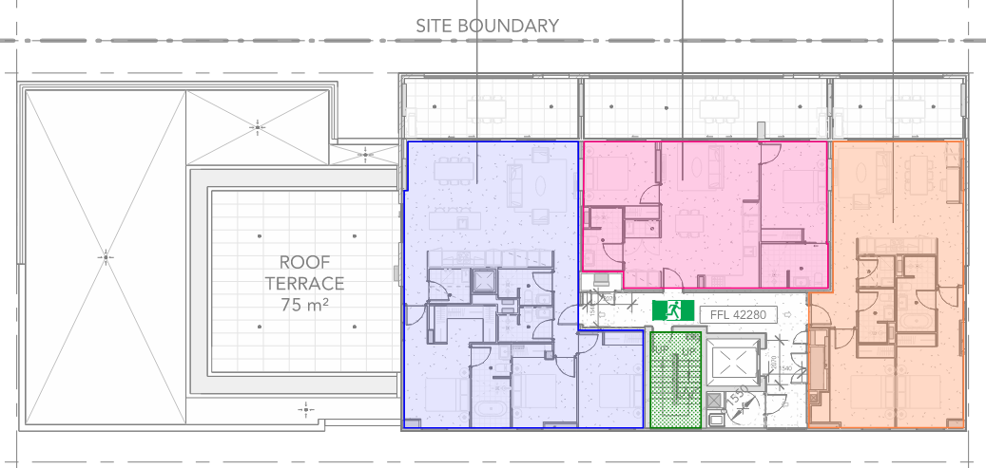
Figure 50: Building B Single Exit – Level 6
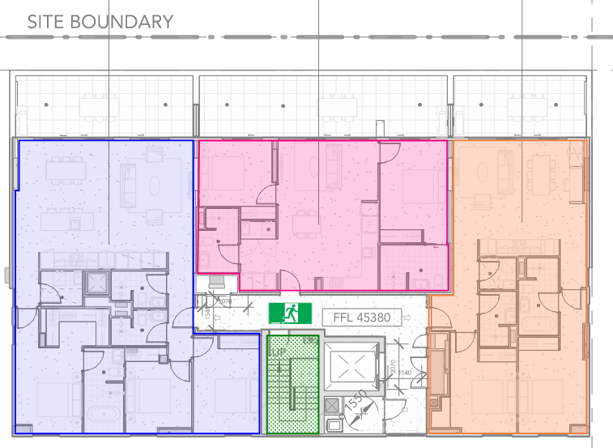
Figure 51: Building B Single Exit – Level 7
Effective Height
Buildings exceeding 25m in effective height require two exits per level in accordance with BCA Clause D2D3.
The effective heights of the three buildings serving the development are depicted in Figure 52 and Figure 53 below. It is noted that the buildings are located on a sloping site, with Building A discharging to open space on Lower Ground, while Building B and C discharge to open space on Level 1. These effective heights are reflected in Section 4.3.
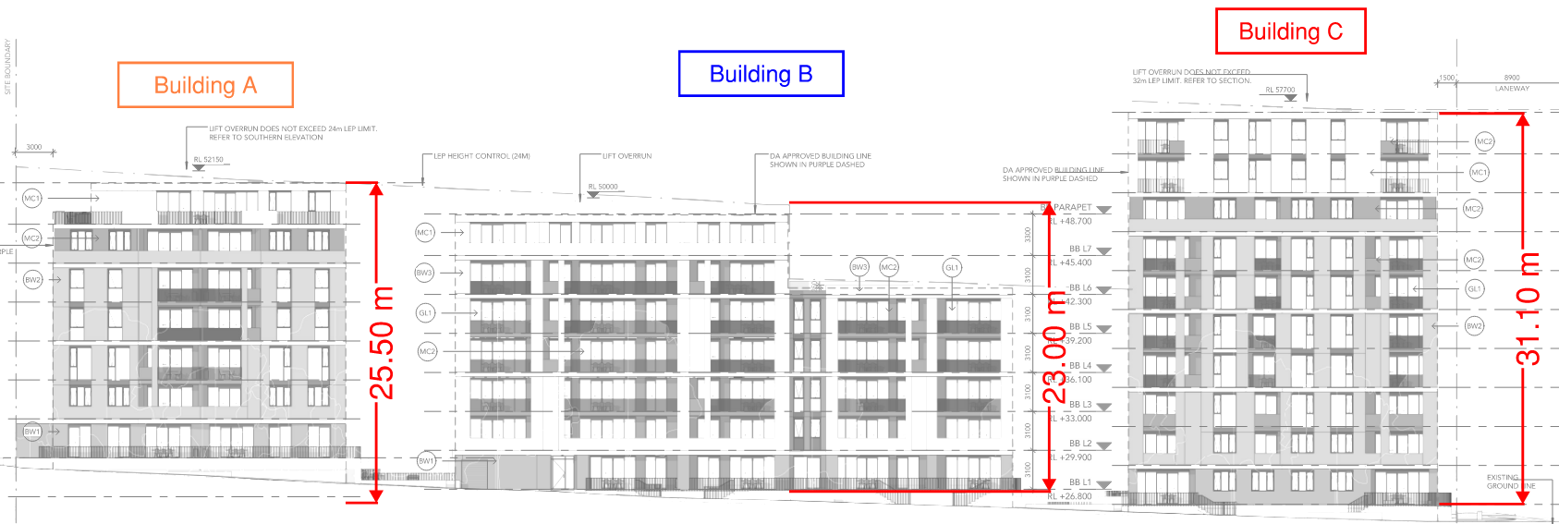
Figure 52: Building Heights – Northern Elevation
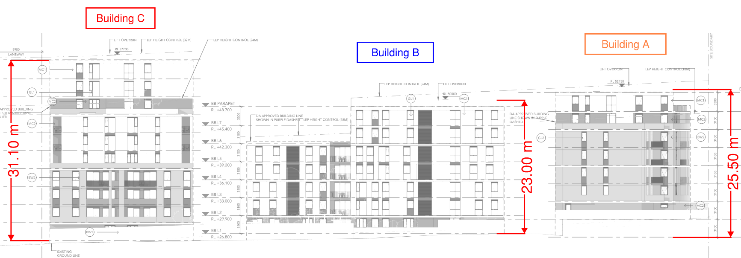
Figure 53: Building Heights – Southern Elevation
It is noted that Building B has an effective height of 23 m. Building C and Building A exceeds 25 m in height, thereby triggering the requirement for each level to be served by at least 2 exits. It is noted the Building A and Building C are provided with 2 exits per level in accordance with BCA Clause D2D3.
Fire Separation
The buildings are classified as a united building by way of the shared basement carpark levels which are shared between the three buildings served. It is noted that the buildings are separated from the shared basement carpark by way of compliant separation at the carpark slab, which achieves an FRL of 120/120/120. This is depicted in Figure 54 below. It is also noted that the three buildings are located more than 6 m apart, and thereby comply with the separation requirements of BCA Clause C4D4.
Therefore, for a fire within the tower portions, each tower could be considered an independent / isolated building for the purpose of this assessment. In the event of a fire within the carpark portions, it is considered that the minor increase in height over the 25 m effective height line, would not increase the risk associated with such a scenario given the substantial fire separation provided.
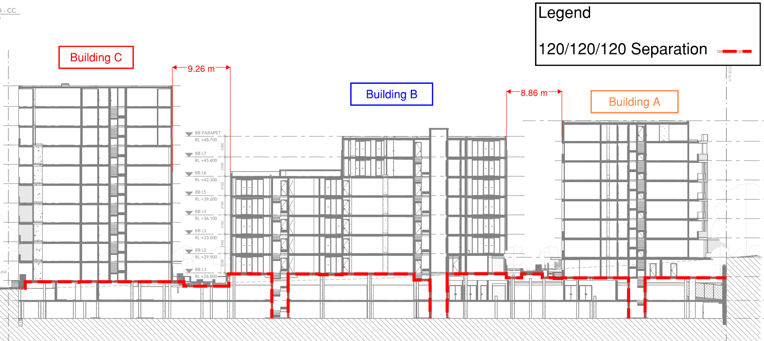
Figure 54: Carpark Separation – Building Section

Openings and shafts in the carpark slab are depicted in Figure 55 below. Shafts openings are to achieve compliant separation from the three towers, except where modified in this document.
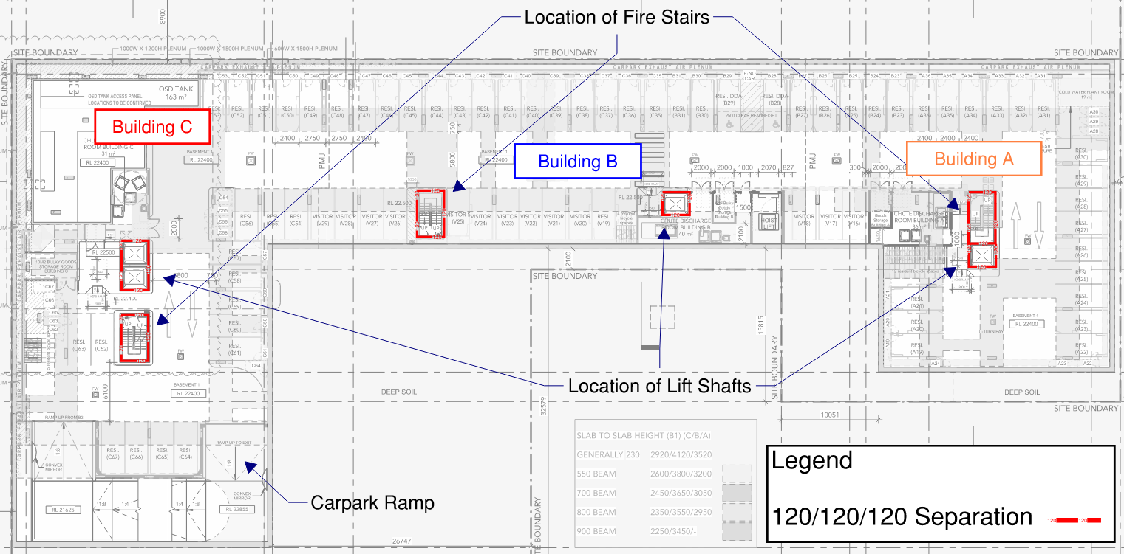
Figure 55: Carpark Separation – Basement 1 Plan
With regards to separation via the floor slab in lieu of separation via fire rated walls, it is considered that both exposures are equivalent. The horizontal slab is tested in a horizontal position to achieve an FRL of 120/120/120. A fire wall in accordance with C3D8 is tested in a vertical configuration to achieve an FRL of 90/90/90. Both tests are subjected to the same temperatures. All elements supporting both the subject carpark floor slab or a C3D8 fire wall are to achieve an equivalent FRL to that which it is supporting.
In terms of fire spread between the towers, a fire would have to travel downwards through the 120/120/120 slab through the carpark and then up again through the 120/120/120 slab in order for it to spread between buildings. This is considered more robust than a single 90/90/90 FRL fire wall separating the towers. Penetrations would be limited to those within the central core areas (i.e. lift shafts, stair shafts and services shaft), all of which achieve the required FRLs to maintain the separation. To provide additional robustness, a penetration register will be developed to certify and tag each penetration and provide a detailed register for ongoing maintenance. Furthermore, it is noted that the towers above the carpark separation are either separated by a physical distance that do not warrant a fire wall or will be provided with a fire wall in accordance with C3D8.
Fire Safety Provisions
In addition to the assessment above, it is considered that the fire safety measures provided to the residential corridors significantly increase the fire safety conditions in the event of a fire, with the intent to protect the corridors from the ingress of smoke to maintain tenable conditions. Quantitative analysis in Issue number: 17 Corridor Length has demonstrated that the provision of smoke seals to SOU doors serving the residential corridors will prevent the passage of smoke into the corridor. Furthermore, additional smoke detectors will be located within public corridors throughout, which due to the length of the subject corridor, will effectively be on reduced spacing. Thermal detectors will be provided within the SOUs, connected to the AS 1670.1 detection system. Finally, a management in use requirement will be developed to maintain the residential corridors as sterile areas, not for the storage of materials. These provisions should ensure that a fire does not initiate in the residential corridors, and that fire and smoke from a fire within an adjoining SOU is contained within the compartment of fire origin.
Conclusion
It is therefore considered that the proposed separation of buildings and additional fire safety measures will be installed to degree necessary to prevent the spread of fire between the towers such that Building B can be treated in isolation for the purpose of this non-compliance. Therefore, it is considered that the proposed design is consistent with the intent of Performance Requirements D1P4 and E2P2.
Performance solution:
 A2G2(1)(a) or A2.2(1)(a) - Comply with all relevant performance requirements
 A2G2(1)(b) or A2.2(1)(b) - Be at least equivalent to the DtS provisions
Assessment methods:
 A2G2(2)(a) or A2.2(2)(a) - Evidence of suitability
 A2G2(2)(b)(i) or A2.2(2)(b)(i) - Verification methods provided in the NCC
 A2G2(2)(b)(ii) or A2.2(2)(b)(ii) - Other verification methods accepted by the appropriate authority
 A2G2(2)(c) or A2.2(2)(c) - Expert judgement
 A2G2(2)(d) or A2.2(2)(d) - Comparison with the DtS provisions
Assessment approach:
 Comparative  Qualitative  Deterministic
 Absolute  Quantitative  Probabilistic
AFEG sub-systems used in the analysis:
 A – Fire initiation and development and control  D – Fire detection, warning and suppression
 B – Smoke development and spread and control  E – Occupant evacuation and control
 C – Fire spread and impact and control  F – Fire services intervention
Acceptance criteria and factor of safety:
The solution is considered to have met the acceptance criteria if it is demonstrated that the Level 6 and 7 residential corridors of Building B facilitate the egress of occupants under tenable conditions in accordance with Performance Requirements D1P4 and E2P2.
Fire scenarios and design fire parameters:
The assessment considers a fire on Level 6 and 7 of Building B, and in shared building areas.
Describe how fire brigade intervention will be addressed or considered:
It is considered that fire brigade intervention will not be impacted by the proposed design given that the solution has demonstrated occupant evacuation is facilitated. The attending brigade will connect to a hydrant within the fire stairs on this level, where they will have access to each of the SOUs with a single length of hose.
Verification/validation analyses:
 Sensitivity studies  Redundancy studies  Uncertainty studies  None
The assessment is qualitative in nature.
Provide details on proposed modelling/assessment tools:
The assessment is qualitative in nature. See quantitative assessment in Issue number: 17 regarding smoke seals.
FRNSW Comment: In principle support is provided subject to the analysis in the FER demonstrating compliance with the performance requirements of the NCC.

- Title: Occupant Discharge into a Covered Area
Details of departures from DtS provisions:
Permit occupants to discharge into an open space or into a covered area that is open for at least 1/3 of its perimeter and which has an unobstructed height of no less than 3 m, in the following areas:

- Occupants within Building A discharge into a covered area on Lower Ground, and within the public corridor that is not within these requirements.
- Occupants within Building C discharge into a covered area on Level 1 and within the public corridor that is not within these requirements.
Applicable DtS provisions (including clause excerpt): | D2D12(2)(c)(ii)  (clause excerpt below) | Applicable Performance Requirements: | D1P5, E2P2
List key fire safety measures:
- The building is to be sprinkler protected throughout in accordance with AS2118.1-2017 with fast response heads throughout, except where modified in this document.
- A detection system is to be provided, compliant to AS 1670.1 – 2018 Amendment 1.
  - Additional smoke detectors will be located in public corridors throughout.
- Thermal detectors will be provided within SOUs, connected to the AS 1670.1 detection system.
- A 4.5kg ABE portable fire extinguisher is to be provided serving the residential lobbies in Building A Lower Ground, and Building C Level 1.
- Lining materials serving the public corridors are to meet the requirements of Group 1 materials.
- Management in use requirement is to be developed to maintain the public corridors as sterile spaces and not permitted to be used for the storage of combustible items.
  - Signage is to be provided within the public corridor stating: “NO STORAGE THROUGHOUT THIS AREA”. The signage is to be at a height of 1.75 – 2 m FFL, with the wording not less than 20 mm high on a colour contrasting background. This is to be noted in the fire safety schedule.
  - The mail boxes in the covered discharge path of Building C are required to be construction from non-combustible materials.
- Provide all doors serving public corridor with medium temperature smoke seals, capable of withstanding temperatures of 200°C for 30 minutes and tested in accordance with AS 1530.7.
- Illuminated wayfinding and exit signage is to be provided to residential corridors throughout the development.
Proposed performance solution:
BCA Comparison
BCA Clause D2D12(2)(c)(ii) states that each fire-isolated stairway or fire-isolated ramp must provide independent egress from each storey served and discharge directly, or by way of its own fire-isolated passageway into a covered area that is open for at least 1/3 of its perimeter.
The intent of the above requirement is that should fire-isolated exits discharge within a covered space, occupant egress will not be blocked by a fire or smoke during occupant egress.
Performance Requirement D1P5 state that to protect evacuating occupants from a fire in the building exits must be fire-isolated, to the degree necessary, appropriate to the number of storeys connected by the exits, the fire safety system installed in the building, the function or use of the building, the number of storeys passed through by the exits and fire brigade intervention.
Performance Requirement E2P2 states that in the event of a fire in a building the conditions in any evacuation route must be maintained for the period of time occupants take to evacuate the part of the building so that occupants have the opportunity to evacuate under tenable conditions.
The qualitative assessment herein will demonstrate that the fire safety measures provided and limitations on combustible materials and storage are expected to provide an equivalent level of safety for occupants discharging from fire-isolated exits.
Qualitative Assessment
The following occupant discharge into covered areas are to be assessed, depicted in Figure 56 and Figure 57 below.
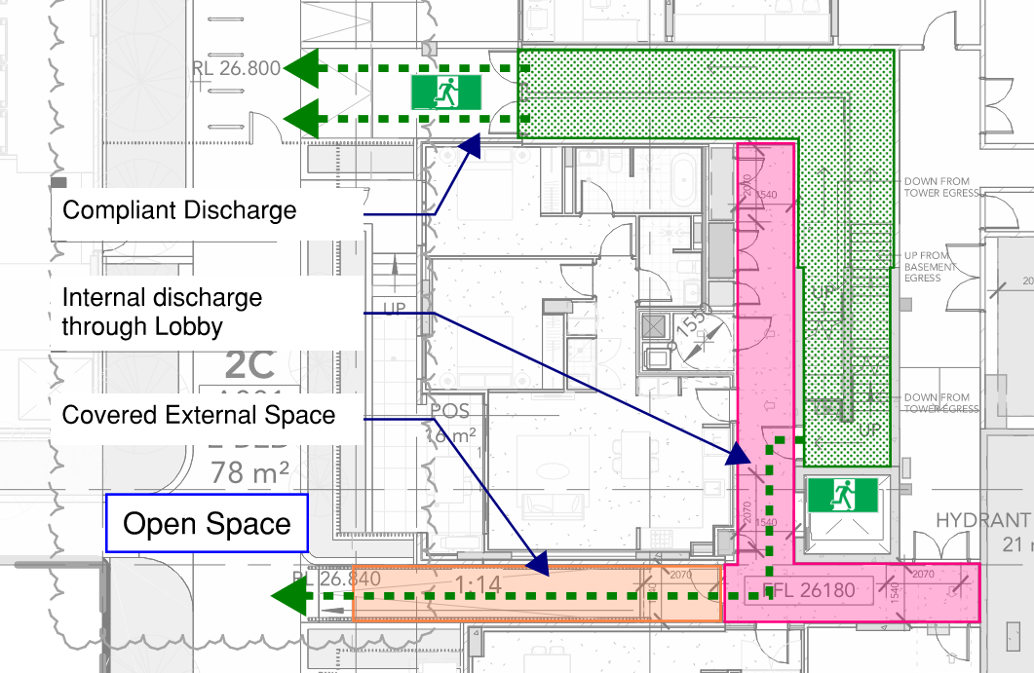
Figure 56: Discharge to Covered Space – Building A Lower Ground

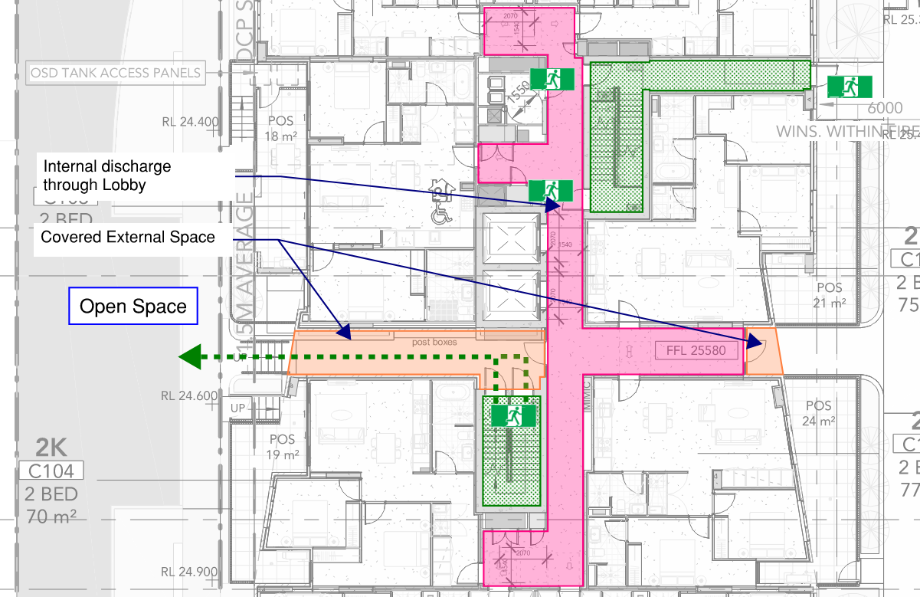
Figure 57: Discharge to Covered Space – Building C Level 1
Fire Safety Measures
The basis of the proposed solution is to provide fire safety measures to the residential lobbies depicted above, with the intent to provide an equivalent level of safety when compared to a Demmed-to Satisfy comparison building.
The building will be sprinkler protected throughout in accordance with AS2118.1-2017 with fast response heads throughout, except where modified in this document. In addition, a sprinkler head is required within 500 mm away from toughed glazed window with minimum 6mm thickness, serving the lobby exit door on Building C Level 1, as depicted in Figure 58 below. The sprinkler system is expected to contain if not supress a fire in its infancy. The sprinkler head adjacent to the door will provide protection to the opening in the unlikely event of a fire in the lobby space, protecting occupants egressing from the fire stair. The FER will contain additional information regarding the effectiveness of sprinklers, and further discussion is provided in Issue number: 20.
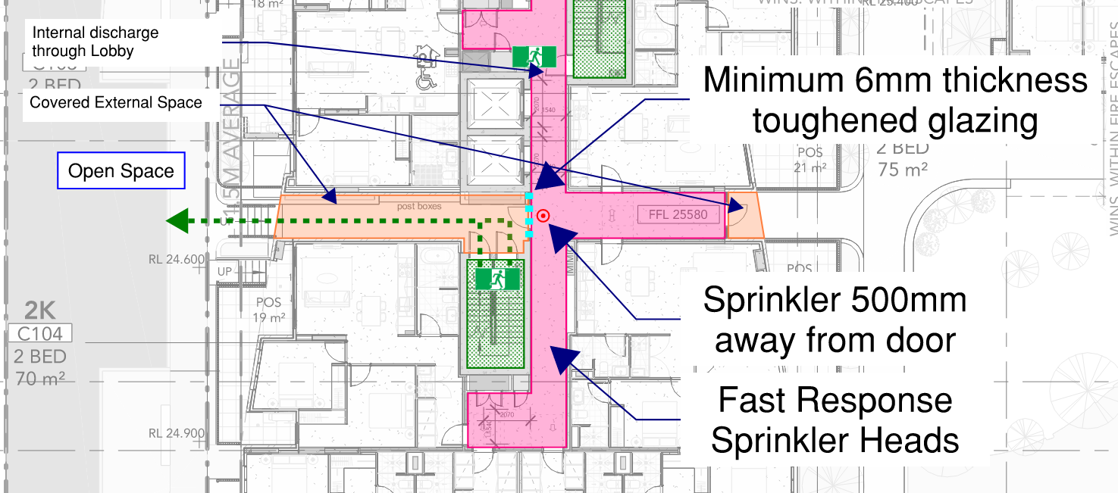
Figure 58: Discharge to Covered Space – Building C Level 1
A detection system is to be provided in accordance with AS 1670.1-2018 Amendment 1, with additional smoke detectors to be provided in public corridors above and beyond the requirements of AS 1670.1. Furthermore, thermal detectors will be provided within SOUs, connected to the AS 1670.1 detection system. These systems will provide early notification in the event of a fire, resulting in occupant egress occurring at an earlier time in comparison to a DtS design.
FRNSW Comment: It is considered that fast response sprinklers are provided within SOUs in a DtS design. As such, sprinkler heads will activate at a time similar to a thermal detector. Additional information should be provided to justify that the provision of thermal detectors in SOUs will provide early warning to occupants than a DtS design.
A 4.5kg portable fire extinguisher is to be provided within the residential lobbies depicted above to provide occupants with a means to undertake immediate attack on a fire.
Doors serving the bounding construction of the residential lobbies are to be self-closing -/60/30 fire doors, provided with medium temperature smoke seals, capable of withstanding temperatures of 200°C for 30 minutes and testing in accordance with AS 1530.7. This includes cupboard doors serving services within the residential lobbies. As discussed in Issue number: 17, given the combustibility and fuel load restrictions within the residential lobbies, it is considered that the more likely fire scenario is within one of the SOUs bounding the residential lobbies. The provision of bounding construction and smoke seals serving fire rated door sets will prevent fire and smoke from impacting the residential lobbies, thereby providing tenable conditions for occupant egress.
Fuel Load Restrictions
The primary use of the corridors is for the circulation of occupants, and is therefore expected to have low fuel loads. The low hazard nature of the egress path implies a low danger to occupants in the event of a fire. In the event of a fire it is extremely unlikely that a significant hazard will be present in the corridor area, as this area consists of minimal combustible fuels. It is more likely that a fire will occur inside an SOU adjoining the corridor. This will be enforced by a management in use provision to require the residential corridors to be sterile spaces not for the storage of combustible materials throughout the development, and signage that restricts the storage of combustible materials. It is a requirement of the Performance Solution that the mail-boxes within the covered discharge path of Building C are to be construction from non-combustible materials.

Multiple Egress Paths
Occupants discharging from Building C are provided with multiple egress paths to reach open space via the residential lobby. It is noted that one side of the scissor stair compliantly discharges directly to outside, and one side discharges into the lobby. From there, occupants can choose to egress back into the fire isolated exits, or egress via the lobby to outside, as depicted in Figure 59 below. These egress paths will be demonstrated to occupants with illuminated egress signage within the lobby space.
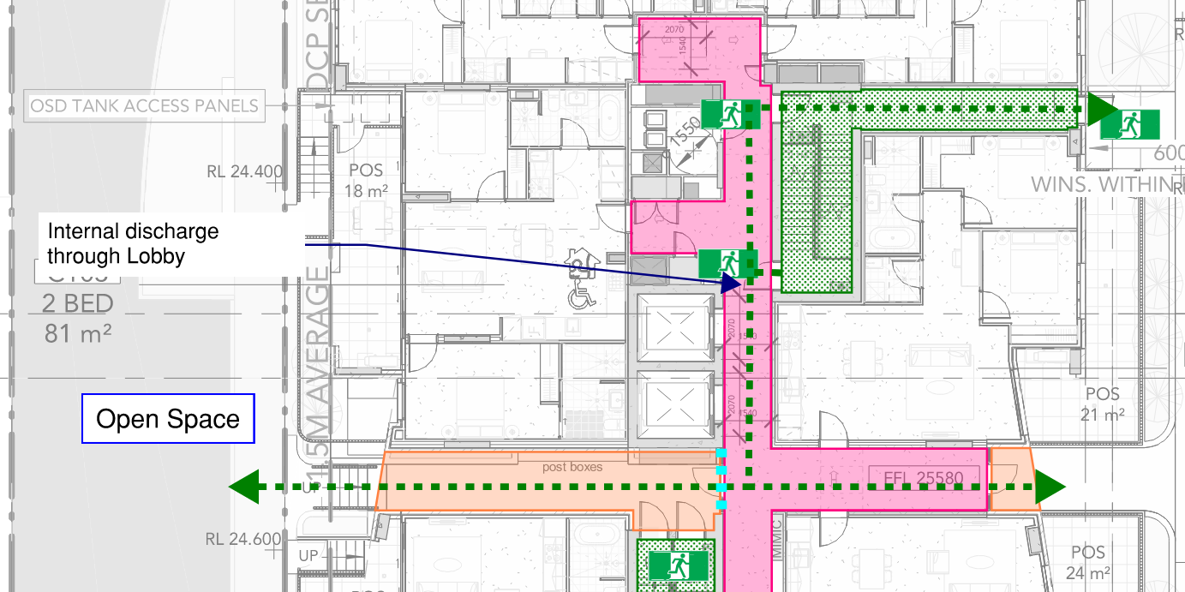
Figure 59: Discharge to Covered Space – Building C Level 1
Quantitative Assessment
The assessment in the FER will consider the impact of ceiling height on smoke layer height in comparison to a comparable DtS design, with the intent to demonstrate that the height of the proposed ceiling provides additional smoke reservoir volume, and therefore requires more time for the smoke layer to descend and cause untenable conditions for occupants during egress when compared to a DtS design.
FRNSW Comment: FRNSW considers that an appropriate DtS comparative analysis is unlikely in this situation. Under the current building layout, it is unlikely to provide the required opening for natural ventilation for an internal corridor to which the fire stairs discharge. That is to say, a DtS compliant design does not exist at all.
Conclusion
It is therefore concluded that the provision of fire safety measures within the lobby spaces and the restriction of fuel loads and storage of combustible materials throughout the lobby space and covered discharge areas will result in a design that protects occupants during egress in accordance with Performance Requirements D1P5 and E2P2. The comparative quantitative assessment will demonstrate tenable conditions during egress via the covered discharge routes to a degree at least equivalent to a DtS comparable design.
Performance solution:
 A2G2(1)(a) or A2.2(1)(a) - Comply with all relevant performance requirements
 A2G2(1)(b) or A2.2(1)(b) - Be at least equivalent to the DtS provisions
Assessment methods:
 A2G2(2)(a) or A2.2(2)(a) - Evidence of suitability
 A2G2(2)(b)(i) or A2.2(2)(b)(i) - Verification methods provided in the NCC
 A2G2(2)(b)(ii) or A2.2(2)(b)(ii) - Other verification methods accepted by the appropriate authority
 A2G2(2)(c) or A2.2(2)(c) - Expert judgement
 A2G2(2)(d) or A2.2(2)(d) - Comparison with the DtS provisions
Assessment approach:
 Comparative  Qualitative  Deterministic
 Absolute  Quantitative  Probabilistic
AFEG sub-systems used in the analysis:
 A – Fire initiation and development and control  D – Fire detection, warning and suppression
 B – Smoke development and spread and control  E – Occupant evacuation and control
 C – Fire spread and impact and control  F – Fire services intervention
Acceptance criteria and factor of safety:
The Performance Solution will have met the acceptance criteria if it is demonstrated that occupants are provided with tenable conditions during egress via the covered discharge routes to a degree at least equivalent to a DtS comparable design, to be demonstrated through a quantitative comparable assessment.
The qualitative assessment described above will be said to have met the acceptance criteria if it is demonstrated that the proposed provision of fire safety measures within the lobby spaces and the restriction of fuel loads and storage of combustible materials throughout the lobby space and covered discharge areas will result in a design that protects occupants during egress in accordance with Performance Requirements D1P5 and E2P2.
Fire scenarios and design fire parameters:
The assessment considers a fire in the lobbies, covered external discharge paths and inside an SOU adjoining the residential lobbies.
Describe how fire brigade intervention will be addressed or considered:
As is has been demonstrated that occupants can evacuate under tenable conditions to a degree at least equivalent to that of a DtS design, it is considered that fire brigade intervention will not be impacted by the proposed design. It is considered that the attending fire brigade will access the building via the fire isolated exit serving Building C, while they can approach Building A from the protection of external hoses at the level of open space.
Verification/validation analyses:
 Sensitivity studies  Redundancy studies  Uncertainty studies  None
The assessment is qualitative in nature. The quantitative assessment in the FER will consider sprinkler failure scenarios.
Provide details on proposed modelling/assessment tools:
The quantitative assessment in the FER will use a zone model to determine smoke layer height behaviour in comparison to a comparable DtS design.
FRNSW Comment: FRNSW does not support the performance solution and provides the following comments:
- FRNSW considers the proposed DtS comparative analysis inappropriate. See above comments.
- It is acknowledged that the SOU entry doors at the discharge level are provided with smoke seals. However, there are still possibilities that these doors are kept open due to malfunction or be wedged open by residents on purpose. Such events were occasionally reported in previous fire incidents causing fatalities. In addition, there are multiple other leakage paths for smoke spreading into the internal corridor, for example, through the lift shaft, the garbage shaft and the service cupboards within the corridors. Therefore, in the event of a fire at the discharge level, the internal corridor may be filled with smoke and not suitable for safe occupant egress.

Based on the above, FRNSW does not agree with a building design which potentially leads occupants to a smoke-filled corridor before they can egress to outside. This risk should be appropriately addressed by either revising the design to comply or the provision of additional fire safety measures.

- Title: Occupants Passing Unprotected Openings upon Discharge
Details of departures from DtS provisions:
Occupants travelling via the path of travel from Building B and C on Level 1 fire-isolated stairs to the road requires occupants to pass within 6 m of openings in the external wall, however these openings are not proposed to be protected in accordance to the clause.
Applicable DtS provisions (including clause excerpt): | D2D12(3)(a)(ii) | Applicable Performance Requirements: | D1P5, E2P2
List key fire safety measures:
- The building is to be sprinkler protected throughout in accordance with AS2118.1-2017 with fast response heads throughout, except where modified in this document.
- A detection system is to be provided, compliant to AS 1670.1 – 2018 Amendment 1.
  - Additional smoke detectors will be located in public corridors throughout.
- A 4.5kg ABE portable fire extinguisher is to be provided serving the residential lobbies in Building A Lower Ground, and Building C Level 1.
- Lining materials serving the public corridors are to meet the requirements of Group 1 materials.
- Management in use requirement is to be developed to maintain the public corridors as sterile spaces and not permitted to be used for the storage of combustible items.
  - Signage is to be provided within the public corridor and external covered area serving Building C stating: “NO STORAGE THROUGHOUT THIS AREA”. The signage is to be at a height of 1.75 – 2 m FFL, with the wording not less than 20 mm high on a colour contrasting background. This is to be noted in the fire safety schedule.
  - The mail boxes in the covered discharge path of Building C are required to be construction from non-combustible materials.
Proposed performance solution:
BCA Comparison
BCA Clause D2D12 outlines the safe egress from fire exits with section (3)(a)(ii) requiring that openings within 6m of a path of travel be protected by an FRL of 60/60/60 or protection compliant with Clause C4D5. The reason for these requirements is to provide building occupants trying to evacuate with protection from radiant heat and flames whilst egressing from the building.
Performance requirement D1P5 requires that fire-isolated exits be provided to the degree necessary. Performance requirement E2P2 outlines that any evacuation route must maintain a temperature, visibility and toxicity level such that human harm or loss of consciousness will not occur during the time taken for egress.
Qualitative Analysis
The subject openings are to be addressed under Performance Solution. The unprotected openings serving Building B level 1, and Building C Level 1 Northern Stair, depicted in Figure 60 and Figure 61 below, are to be addressed by demonstrating that alternative egress is provided to occupants discharging from the fire stairs, who will be able to choose to discharge away from the unprotected openings in the event of a fire. The unprotected opening serving the southern stair of Building C Level 1, depicted in Figure 62, will be addressed through the provision of additional fire safety measures and fuel load restrictions.
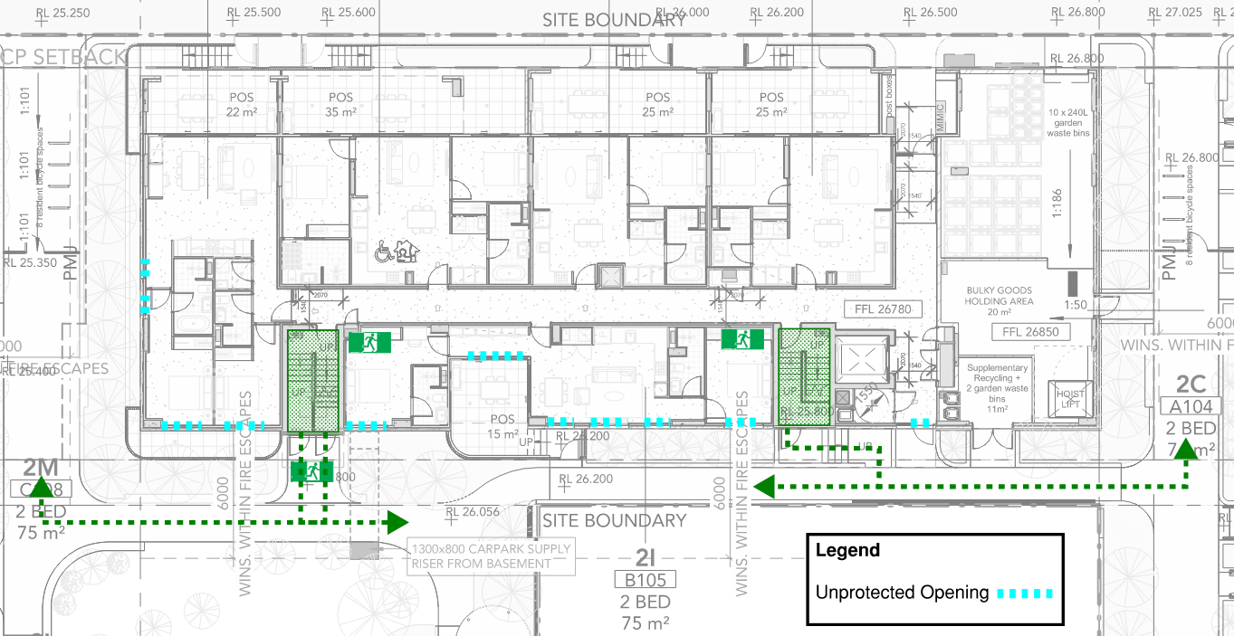
Figure 60: Discharge Past Openings – Building B Level 1

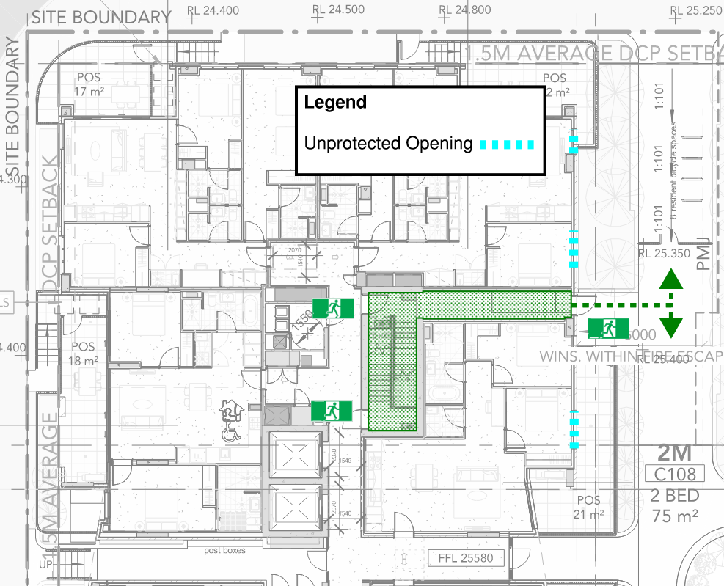
Figure 61: Discharge Past Openings – Building C Level 1 Northern Stair

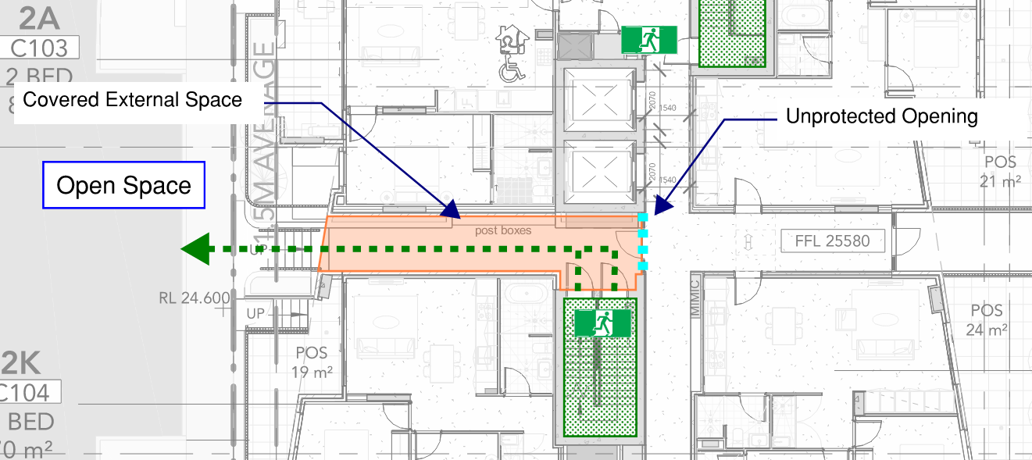
Figure 62: Discharge Past Openings – Building C Level 1 Southern Stair

Sprinkler Protection
As discussed throughout this FEBQ, the building is to be provided with sprinkler protection throughout in accordance with AS 2118.1-2017 with fast response heads throughout. In the event of a fire, the sprinkler system is expected to control, if not suppress the fire. The sprinkler system acts to cool the upper smoke layer and wet adjacent combustibles and partitions helping to prevent the fire from spreading beyond the area of origin. The reliability and efficacy of sprinkler systems has been well researched.
Statistics from the National Fire Protection Association (NFPA), as published by Hall , provides recorded statistics on buildings fitted with automatic fire sprinkler systems between the years 2003-2007 in the United States. Based on the NFPA data, when sprinklers operate, they are effective 97 % of the time, resulting in a combined performance of operating effectively in 89 % of all reported fires where sprinklers were present in the fire area and the fire was large enough to activate them. The reliability of sprinkler system in Australia and New Zealand is generally significantly higher than in the US as researched by Marryatt. The FER will contain further details of sprinkler system performance.
Furthermore, by controlling the fire size, the amount of smoke produced is correspondingly also limited. Hence the provision of sprinklers in a building dramatically enhances life safety, property protection and fire brigade intervention. Where the sprinkler system operates successfully, the risk to occupants, fire brigade, and building property is significantly reduced. The high reliability and efficiency of fire sprinklers is also supported by fire tests and statistics on structural building fires.

Discharge with Point of Choice
It is considered that occupants discharging from fire-isolated exits serving Building B and Building C northern fire stair are provided with a choice of alternate egress options upon discharging. In the event of a fire in an SOU or residential lobby, occupants will be aware of the location of a large fire that causes radiant heat transfer to the egress path. Occupants will then choose to egress away from the fire, travelling in the opposite direction with the fire at their back. This will cause the radiant heat transfer received to decrease as occupants egress away from the fire affected compartment to reach the road. This scenario is depicted in Figure 63 below, indicative of all exits with alternate egress. It is therefore considered that occupants discharging from these exits are provided with the opportunity to egress under tenable conditions, equivalent to that of the DtS provisions.
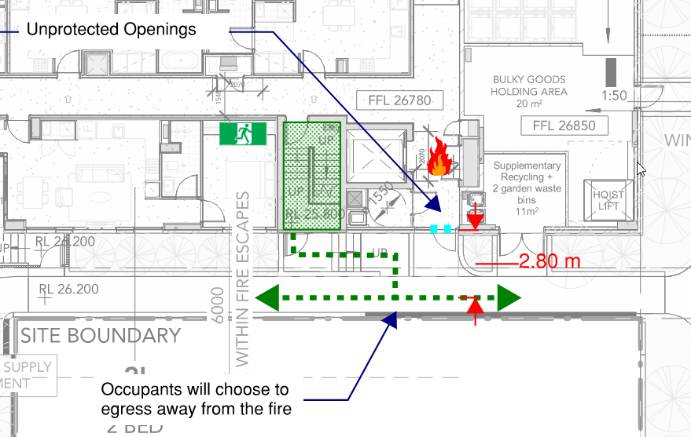
Figure 63: Discharge Past Openings – Alternate egress options
Discharge past Building C Lobby
Occupants discharging from Building C southern fire-isolated stairs are required to egress past the opening serving the lobby. It is a requirement of this Performance Solution that the glazing is a minimum of 6mm thick toughened glazing, provided with a sprinkler head within 500 mm away from the glazing as depicted in Figure 64 below. Furthermore, as discussed previously, the lobby space is to be maintained as sterile with fuel load restrictions and signage in place to limit the storage of combustible materials. It is therefore considered that a fire is unlikely to occur within the lobby space. In the unlikely event that a fire did occur, the sprinkler head located adjacent to the toughened glazing will provide protection to the egress path by wetting the surrounding area and cooling hot combustion products. The toughened glazing will resist breakage, thereby providing a surface for a film of water discharging from the adjacent sprinkler head. It is also noted that occupants will be discharging away from the subject opening, and will therefore be exposed to a decreasing magnitude of radiant heat transfer. Furthermore, it is a requirement of this performance solution that that post boxes within the covered egress path are constructed from non-combustible materials, and that additional signage will be provided under the covered space to restrict the storage of combustible materials. It is therefore considered that the spread of fire from a fire in the lobby space to the external covered area via the unprotected opening is unlikely.
Figure 64: Discharge to Covered Space – Building C Level 1

Conclusion
It is therefore considered that given the fire safety measures provided, the fuel load and storage restrictions, and the behaviour of occupants during a fire where provided with multiple alternate egress will result in occupants not being exposed to untenable conditions during egress. Therefore, it is considered that occupants are provided with a level of safety during egress that is at least equivalent to a DtS design. Furthermore, for occupants discharging from Building C southern fire stair, it is considered that the additional fire safety measures and fuel load restrictions provide occupants with tenable conditions during egress in accordance with Performance Requirements D1P5 and E2P2.
Performance solution:
 A2G2(1)(a) or A2.2(1)(a) - Comply with all relevant performance requirements
 A2G2(1)(b) or A2.2(1)(b) - Be at least equivalent to the DtS provisions
Assessment methods:
 A2G2(2)(a) or A2.2(2)(a) - Evidence of suitability
 A2G2(2)(b)(i) or A2.2(2)(b)(i) - Verification methods provided in the NCC
 A2G2(2)(b)(ii) or A2.2(2)(b)(ii) - Other verification methods accepted by the appropriate authority
 A2G2(2)(c) or A2.2(2)(c) - Expert judgement
 A2G2(2)(d) or A2.2(2)(d) - Comparison with the DtS provisions
Assessment approach:
 Comparative  Qualitative  Deterministic
 Absolute  Quantitative  Probabilistic
AFEG sub-systems used in the analysis:
 A – Fire initiation and development and control  D – Fire detection, warning and suppression
 B – Smoke development and spread and control  E – Occupant evacuation and control
 C – Fire spread and impact and control  F – Fire services intervention
Acceptance criteria and factor of safety:
The Performance Solution will have met the acceptance criteria if it is demonstrated that occupants are provided with a level of safety during egress that is at least equivalent to a DtS design where alternative egress provisions are provided. For occupants discharging from Building C southern fire stair, the acceptance criteria will be to demonstrate that occupants are provided with tenable conditions in accordance with Performance Requirements D1P5 and E2P2.
Fire scenarios and design fire parameters:
The assessment considers a fire inside an SOU and residential lobby adjacent to the discharge path from fire-isolated exits.
Describe how fire brigade intervention will be addressed or considered:
It is considered that fire brigade intervention will not be impacted by the proposed design if it is demonstrated that occupants will not be exposed to untenable conditions during egress. It is noted that the subject openings are located at the level of discharge, and therefore the attending brigade will be able to fight a fire in these areas externally from the building.
Verification/validation analyses:
 Sensitivity studies  Redundancy studies  Uncertainty studies  None
The assessment is qualitative in nature.
Provide details on proposed modelling/assessment tools:
The assessment is qualitative in nature.
FRNSW Comment: In principle support is provided subject to the analysis in the FER demonstrating compliance with the performance requirements of the NCC.

- Title: Location of Fire Hydrant and Sprinkler Booster Assemblies
Details of departures from DtS provisions:
The Fire Hydrant and Sprinkler Booster assemblies located off Croydon Street is proposed to be located not technically within sight from entrances to all buildings.
Applicable DtS provisions (including clause excerpt): | E1D2, AS 2419.1 – 2021 Clause 7.3, E1D4, AS 2118.1-2017 | Applicable Performance Requirements: | E1P3, E1P4
List key fire safety measures:
- Site block plans are required to note the location of the hydrant booster and sprinkler booster at the building’s main Fire Indicator Panel in Building A, as well as the mimic panels in Buildings B and C.
- A strobe light is required to identify the location of the hydrant booster assembly along Croydon Street. The strobe light is to activate upon activation of the building alarm.
Proposed performance solution:
BCA Comparison
BCA Clause E1D2 outlines the requirements for the installation of a fire hydrant system. The intent of this clause is to ensure the fire brigade are provided with suitable firefighting equipment in a suitable location. AS 2419.1 states that the booster assembly is to be provided within line of site of the main entrance to the building.
BCA Clause E1D4 outlines the requirements for the installation of a sprinkler system. The intent of this clause is to ensure the building is sprinkler protected to the degree necessary. Clause 4.14.4 of AS 2118.1-2017 requires the sprinkler booster assembly to be located within sight of the principal pedestrian entrance of the building.
BCA Performance Requirement E1P3 states that a fire hydrant system must be provided to the degree necessary to facilitate the needs of the fire brigade appropriate to fire-fighting operations; and the floor area of the building; and the fire hazard.
BCA Performance Requirement E1P4 states that an automatic fire suppression system must be installed to the degree necessary to control the development and spread of fire appropriate to the size of the fire compartment; and the function or use of the building and the fire hazard and the height of the building.
The intent of Performance Requirement E1P3 and E1P4 is to ensure that the hydrant and sprinkler booster assemblies are appropriately sized and positioned, to facilitate efficient firefighting operations by the attending fire brigade.
The proposed design has the hydrant and sprinkler booster assemblies located along Building A, which is not visible from the main entrance into Building B and Building C (as per the requirements of the BCA). The proposed assessment will demonstrate that the provision of block plans and strobe light installed on the booster assembly will mitigate the risk of delays faced by the fire brigade.
Qualitative Assessment
The proposed location of the booster assembly is depicted in Figure 65 below.
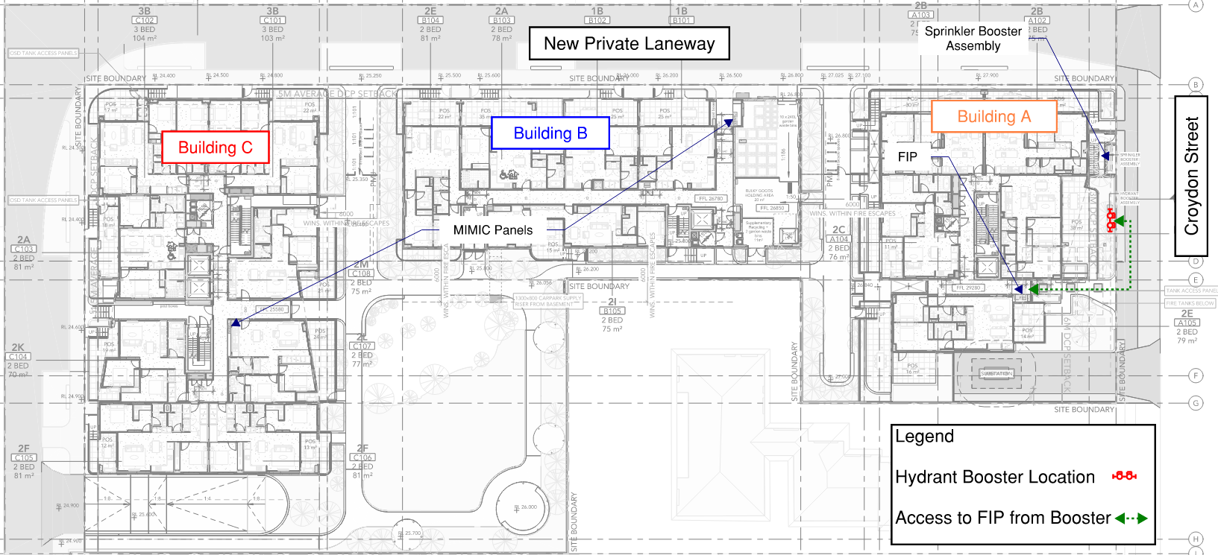
Figure 65: Location of Hydrant and Sprinkler Boosters – Level 1
It is proposed to provide a site block plan noting the location of the hydrant and sprinkler boosters at the building’s main Fire Indicator Panel in Building A, as well as the mimic panels in Buildings B and C.
It is noted that Building A is the primary street location of the development, with the other buildings being served by entrances off newly constructed private laneways in lieu of public road access.
Upon notification of a fire scenario the attending fire brigade will be directed to the booster location via Croydon Street, where the call out address will direct them to the booster assembly, allowing them to then undertake the necessary fire-fighting operations. As highlighted in the figure above, the hydrant booster assembly is located approximately 20 metres from the main entrance of Building A, where the FIP is located. If the fire brigade does not immediately identify the booster assembly on approach, they will be notified of the location once they have reached the FIP, only a small distance must be traversed in order to reach the booster assembly.
In order to further facilitate the quick identification of the booster assembly by the fire brigade, it is required that a strobe light be installed to identify the location of the hydrant booster assembly. The strobe light will activate upon activation of the building alarm, allowing for the quick identification by the fire brigade upon arriving on site by providing visual identification of the boosters, further mitigating the time delay that could potentially occur.
As such, the fire brigade will not be significantly delayed in reaching the booster assemblies, and will be able to promptly undertake firefighting operations. Therefore, it is considered that compliance with Performance Requirement E1P3 is achieved.
Conclusion
It has been demonstrated that the proposed design where the booster assemblies are not technically installed within sight of all entrances to the building will not hinder the ability of the fire brigade to undertake firefighting operations, given the installation of block plans on the Fire Indicator Panels in buildings A, B, C and D. The installation of the strobe light will further mitigate the risk of a delay caused by the fire brigade not immediately identifying the location of the hydrant booster, highlighting the location from both the street and the main entrance of the building. Consequently, compliance with performance requirement EP1.3 has been met.
Performance solution:
 A2G2(1)(a) or A2.2(1)(a) - Comply with all relevant performance requirements
 A2G2(1)(b) or A2.2(1)(b) - Be at least equivalent to the DtS provisions
Assessment methods:
 A2G2(2)(a) or A2.2(2)(a) - Evidence of suitability
 A2G2(2)(b)(i) or A2.2(2)(b)(i) - Verification methods provided in the NCC
 A2G2(2)(b)(ii) or A2.2(2)(b)(ii) - Other verification methods accepted by the appropriate authority
 A2G2(2)(c) or A2.2(2)(c) - Expert judgement
 A2G2(2)(d) or A2.2(2)(d) - Comparison with the DtS provisions
Assessment approach:
 Comparative  Qualitative  Deterministic
 Absolute  Quantitative  Probabilistic
AFEG sub-systems used in the analysis:
 A – Fire initiation and development and control  D – Fire detection, warning and suppression
 B – Smoke development and spread and control  E – Occupant evacuation and control
 C – Fire spread and impact and control  F – Fire services intervention
Acceptance criteria and factor of safety:
The location of the hydrant and sprinkler boosters shall not impede fire brigade intervention.
Fire scenarios and design fire parameters:
Fire within the subject building.
Describe how fire brigade intervention will be addressed or considered:
As per the assessment above. The proposed performance solution requires additional signage and Block Plans indicating the location of the hydrant and sprinkler boosters, minimising the time required by the fire brigade to access necessary firefighting equipment.
Verification/validation analyses:
 Sensitivity studies  Redundancy studies  Uncertainty studies  None
The assessment will consider a scenario whereby the attending fire brigade are unable to immediately identify the location of the hydrant and sprinkler boosters as they enter the building.
Provide details on proposed modelling/assessment tools:
N/A
FRNSW Comment: In principle support is provided subject to the analysis in the FER demonstrating compliance with the performance requirements of the NCC.

- Title: Omission of Atrium Requirements – Building C
Details of departures from DtS provisions:
Propose the lightwell serving Building C to not comply with the requirements of BCA Part G3. Furthermore, it is proposed to omit the insulation rating of the required FRL for the construction serving the lightwell.
Applicable DtS provisions (including clause excerpt): | Part G3, and Specification 31, C2D2, Specification 5 Clause 8 | Applicable Performance Requirements: | C1P2, and E2P2
List key fire safety measures:
- Automatic Fire Suppression System is to be installed within the building, designed and installed in accordance with AS 2118.1 – 2017, except where modified by this document.
- A detection system is to be provided, compliant to AS 1670.1 – 2018 Amendment 1.
  - Additional smoke detectors will be located in public corridors throughout.
- Thermal detectors will be provided within SOUs, connected to the AS 1670.1 detection system.
- Management in use requirement is to be developed to maintain the public corridors as sterile spaces and not permitted to be used for the storage of combustible items.
- Lining materials serving the public corridors are to meet the requirements of Group 1 materials.
Proposed performance solution:
BCA Comparison
The BCA defines a section of a building as an atrium if it falls under the following criteria:
- It is enclosed at the top by a floor or roof (including a glazed roof structure); and
- It includes any adjacent part of the building not separated by an appropriate barrier to fire; but
- Does not include a stairwell, rampwell or the space within a shaft; and
- A space is considered enclosed if the area of the enclosing floor or roof is greater than 50% of the area of the space, measured in plan, of any of the storeys connected by the space.
A building that is to be constructed with an atrium section is subject to a number of additional fire safety requirements, as an atrium has the potential to facilitate the rapid spread of smoke and fire across multiple stories throughout the building, given the large open nature of a typical atrium.
Part G3 of the BCA details these requirements, which pertains to fire-resistance, atrium dimensions, and other aspects of construction. Part G3 also states that additional fire and smoke control systems be provided to the building in compliance with Specification 31.
BCA Clause C2D2 states that the minimum type of fire-resisting construction of a building must be in accordance with those detailed in BCA Specification 5.
Specification 5 Clause 8 sets the requirements for the enclosure of shafts, and states that shafts required to have an FRL must be enclosed at the top and bottom by construction having an FRL not less than that required for walls of a non-loadbearing shaft in the same building.
Performance Requirement C1P2 states that a building must have elements which will, to the degree necessary, avoid the spread of fire to exits, SOUs and public corridors, between buildings and in a building. Avoidance of the spread of fire must be appropriate to the building they serve.
Performance requirement E2P2 outlines that any evacuation route must maintain a temperature, visibility and toxicity level such that human harm or loss of consciousness will not occur during the time taken for egress.
The proposed design has a light well serving Building C that does not meet the requirements of an Atrium in accordance with BCA Part G3. It will be demonstrated that the risk of fire and smoke spread into habitable portions of the building is addressed through the provision of fire separating construction, which separates the light well from the remainder of the building in its own fire compartment. Furthermore, the solution will address the construction of the lightwell and the hazard of fire spread. Therefore, the following proposed solution will demonstrate that the construction of the atrium within the subject development adequately prevents the spread of fire between compartments and provides occupants with tenable conditions in accordance with Performance Requirements C1P2 and E2P2.
Qualitative Assessment
The proposed location of the light well is depicted in Figure 66 and Figure 67 below. The light well is served by a skylight on the Level 8 roof terrace, and runs down the building, terminating at Level 2.
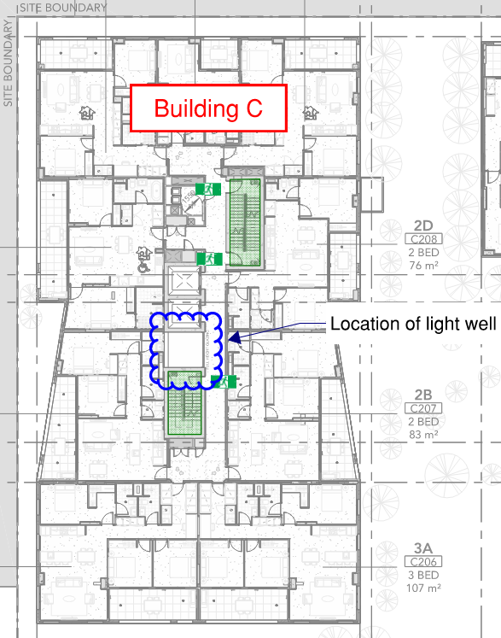 | 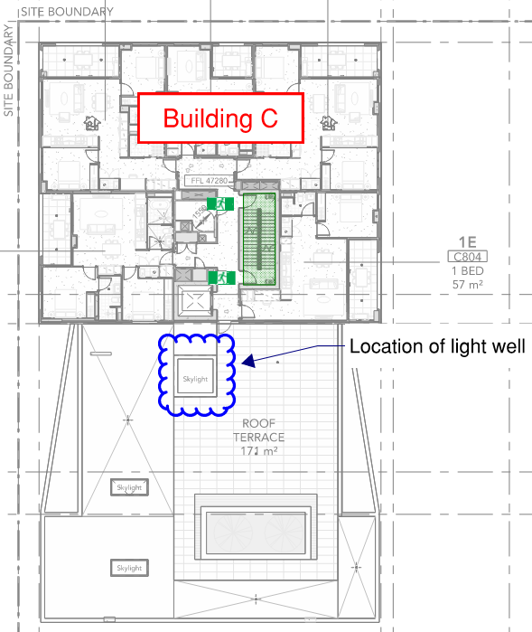
Figure 66: Location of Light well – Level 2 Building C | Figure 67: Location of Light well – Level 8 Building C
The light well is separated from the remainder of the building by fire rated construction achieving an FRL of 90 minutes on the back and sides, with glass blocks separating the space from the residential corridor achieving an FRL of -/60/-. These provisions effectively form the lightwell in its own fire compartment. The fire rated construction is full height at each level, and will thereby prevent the spread of fire and smoke between levels via the light well, as depicted in Figure 69. The fuel load within the light well is considered to be negligible, with no combustible storage, and is completely un-accessible. It is considered that the likelihood of a fire occurring in the lightwell is negligible given the sterile nature of the area. Furthermore, the lightwell does not contain ignition sources such as lighting or other electrical ignition sources.

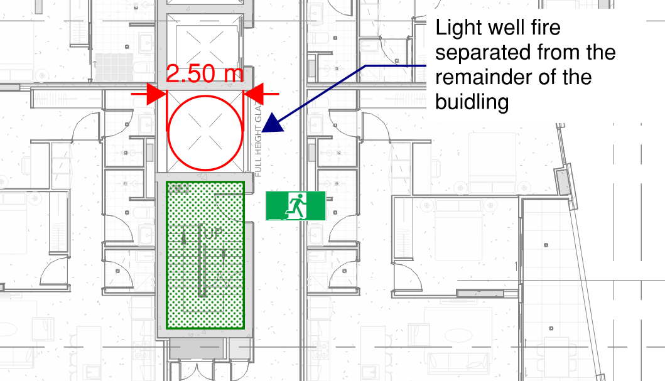
Figure 68: Separation of Light Well – Building C
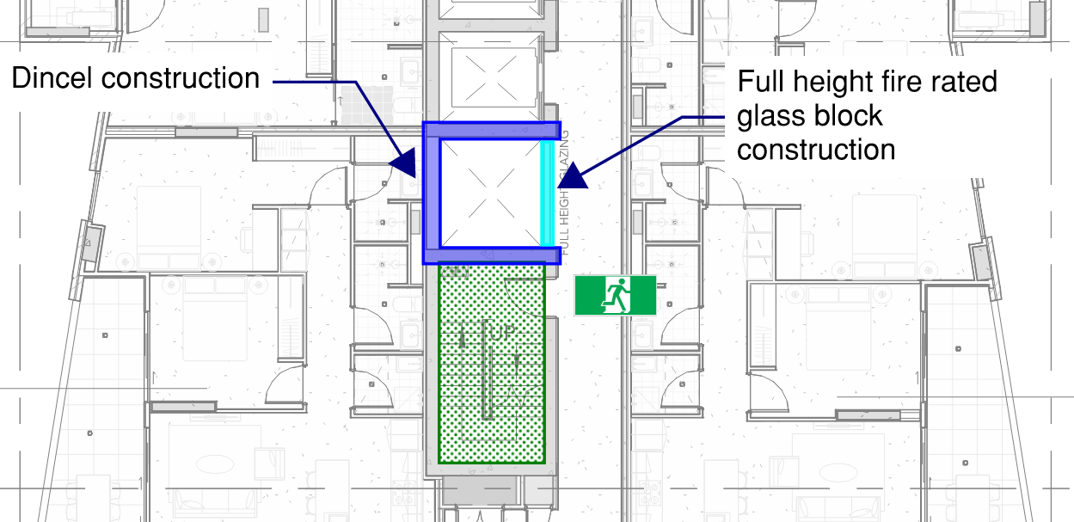
Figure 69: Construction of Light Well – Building C
Glass Blocks
The proposed construction of the lightwell is depicted in Figure 69 above, noting that the back and sides of the shaft are constructed with Dincel walls achieving the required FRL. The glass block construction facing the corridor achieves an FRL of -/60/-. It is noted that the glass block construction does not achieve the required insulation rating. This will be addressed in the FER by considering the following fire safety measures previously discussed in this document:
- Group 1 lining requirement for corridors
- Sprinkler system with fast response heads throughout, except where modified in this document.
- Fuel load restrictions within the corridor, enforced by signage within the corridor.
- Public area smoke detectors and thermal detectors serving the SOUs, providing detection to the adjacent spaces to the lightwell above the requirements of the BCA.
- Smoke seals serving all doors to the residential corridors.
Furthermore, as discussed above, it is noted that the lightwell contains negligible fuel load and ignition sources.
It is also noted that the glass block walls are stacked on top of each other and therefore have no direct exposure to a fire on a level above/below. The FRL achieved by the blocks will maintain the integrity rating of the wall such that smoke cannot spread into the lightwell. It is considered that in the worst-case scenario where the glass block wall did fail on a fire affected level, smoke would spill into the lightwell but be unable to spread to the levels above and below. It is considered that the skylight on the inaccessible roof terrace would be more likely to fail in this scenario given its location at the top of the shaft. Therefore, smoke would vent into the surrounding atmosphere in lieu of throughout the building. However, it is noted that this scenario is very unlikely given the provisions discussed above, and the low fuel load in both the residential corridors and the lightwell.
Conclusion
The above assessment has demonstrated that although the ‘lightwell’ which is technically considered an atrium under the definition in the BCA, the proposed design complies with Performance Requirements C1P2 and E2P2 by providing separation at each level from the lightwell space, which will prevent the spread of fire and smoke via the lightwell to the connected stories. The assessment also considers the hazard of fire spread via the glass block construction between he corridor and lightwell, which is mitigated through the provision of fire safety measures and fuel load restrictions. It is therefore considered that the proposed design complies with Performance Requirements C1P2 and E2P2.
Performance solution:
 A2G2(1)(a) or A2.2(1)(a) - Comply with all relevant performance requirements
 A2G2(1)(b) or A2.2(1)(b) - Be at least equivalent to the DtS provisions
Assessment methods:
 A2G2(2)(a) or A2.2(2)(a) - Evidence of suitability
 A2G2(2)(b)(i) or A2.2(2)(b)(i) - Verification methods provided in the NCC
 A2G2(2)(b)(ii) or A2.2(2)(b)(ii) - Other verification methods accepted by the appropriate authority
 A2G2(2)(c) or A2.2(2)(c) - Expert judgement
 A2G2(2)(d) or A2.2(2)(d) - Comparison with the DtS provisions
Assessment approach:
 Comparative  Qualitative  Deterministic
 Absolute  Quantitative  Probabilistic
AFEG sub-systems used in the analysis:
 A – Fire initiation and development and control  D – Fire detection, warning and suppression
 B – Smoke development and spread and control  E – Occupant evacuation and control
 C – Fire spread and impact and control  F – Fire services intervention
Acceptance criteria and factor of safety:
The Performance Solution will have met the acceptance criteria if it demonstrated that the light well does not facilitate the spread of fire between fire compartments.
Fire scenarios and design fire parameters:
The assessment considers a fire inside the light well and adjacent fire compartments.
Describe how fire brigade intervention will be addressed or considered:
As it has been demonstrated that fire spread will not occur, it is considered that fire brigade intervention is not impacted by the proposed design.
Verification/validation analyses:
 Sensitivity studies  Redundancy studies  Uncertainty studies  None
The assessment is qualitative in nature.
Provide details on proposed modelling/assessment tools:
The assessment is qualitative in nature.
FRNSW Comment: In principle support is provided subject to the analysis in the FER demonstrating compliance with the performance requirements of the NCC.

Construction, commissioning, management, use and maintenance
What considerations does the performance solution require during the construction phase?
No specific requirements.
How will the performance solution affect commissioning of the systems (e.g. listed on fire safety schedule as essential or critical measure, combined new and old installations)?
No affect.
Fire Engineering Report to be listed on AFSS.
How will the performance solution be addressed for ongoing building management and use (e.g. details to be provided in a ‘fire safety management plan’ for the building manager)?
Fire services to be maintained in accordance with the latest relevant maintenance standards.
How will any restrictions on fuel load/use/populations within the performance solution be managed and enforced (e.g. details to be provided in ‘fire safety management plan’)?
No restrictions required.
How will the performance solution be addressed for maintenance (e.g. details included on fire safety schedule, location of fire engineering report on site, plain English summary adjacent to FIP)?
Fire Engineering Report to be listed on AFSS.
Fire Panel Permanent Notice to be installed adjacent to FDCIE.

Additional comments
N/A
Note: Any in principle support extended for performance solution issues through consultation is contingent upon all assumptions, analyses and conclusions in the fire engineering report being fully justified, and referenced as appropriate, to demonstrate how the relevant performance requirements have been satisfied to the extent required by the agreed acceptance criteria.

Scheduled charges
FRNSW charge for the provision of services performed in connection with statutory fire safety as per the schedule of charges identified in clause 46 and schedule 3 of the Fire Brigades Regulation 2014.
The charge applicable is $2,600 for each day (or part of a day) spent by the Commissioner or a fire brigade member providing advisory, assessment or consultancy services.
Note: For a full description of the charges applicable including terms, payment options, applying for a waiver or reduction of the charges, please refer to the FRNSW website at firesafety.fire.nsw.gov.au.

Submission of this form
This completed form is to be emailed to firesafety@fire.nsw.gov.au.
All plans and specifications required by FRNSW for assessment are to be attached to the email (or sent separately if necessary due to file size). Refer to Submitting plans and specifications to FRNSW for further information.

Contact us
For further information contact the Fire Safety Branch on (02) 9742 7434 or email firesafety@fire.nsw.gov.au.

J. Hall, “U.S. Experience with sprinklers and other automatic fire extinguishing equipment.,” National Fire Protection Association, p. 102, 2010.
H. W. Marryatt, Fire: A Century of Automatic Sprinkler Protection in Australia and New Zealand 1886-1986, Australian Fire Protection Association, 1988.
SPFE, Handbook of Fire Protection Engineering 5th Edition, Society of Fire Protection Engineers, 2016.
J. Hall, “U.S. Experience with sprinklers and other automatic fire extinguishing equipment.,” National Fire Protection Association, p. 102, 2010.

